**Table of Contents**

Introduction 3

Skip Patterns4

Survey Introduction19

Demographics21

Family Structure25

Word Association26

Verb Generation27

Word Association (Image)30

Word Association (Slogan)35

Brand Recognition37

Tobacco Brand Recognition47

25% Update49

Single Target Implicit Association Task50

Flicker Paradigm66

Disposable Income73

Store Visit Frequency77

Tobacco Initiation – Part 1199

Cigarette Use200

Tobacco Initiation – Part 2201

Tobacco Initiation – Part 3204

Recent Tobacco Use – Part 1206

Recent Tobacco Use – Part 2208

Tobacco Quantity – Part 1209

Modified Fagerstrom Tolerance Questionnaire (mFRQ) for Adolescents210

Tobacco Quantity – Part 2212

Access to Tobacco Products – Part 1213

Tobacco Cessation214

Tobacco Use Willingness215

Tobacco Initiation – Part 4216

Access to Tobacco Products – Part 2217

Perception of Peer Tobacco Use218

Tobacco Brand Preference219

Second-Hand Smoke Exposure221

Health Professional Warnings222

General Health Perceptions223

Symmetry Span Task224

Go/No-Go Task234

65% Update237

Short Form Smoking Consequences Questionnaire (S-SCQ)238

Family and Peer Smoking242

Injunctive Norms245

Media Exposure247

Prevention Program Exposure252

75% Update254

Drug Use Frequency Scale255

Sensations Seeking261

Depression Anxiety Stress Scale (DASS-21)264

Acculturation, Habits, and Interests Multicultural Scale for Adolescents268

Head Injury269

Electronic Cigarette Commercials270

Point-of-Sale Sensitivity277

Sale Proneness278

90% Update279

Tobacco Pricing280

Perceived Stress PSS-10282

Enrollment In The Military284

Attrition285

Final Screen286

**Introduction**

All measures were administered to participants using a web-based survey programmed with Inquisit 4 Software. At the beginning of each survey, a whole number between 1 and 4 was assigned automatically in the field *Subject*. This number determined which version of the survey the participant received.

|  |  |  |
| --- | --- | --- |
| **Version** | **Initial Categories for Single Target Implicit Association Test** | **Go/No-Go Task Versus Symmetry Span Task** |
| 1 | Unpleasant or Tobacco vs. Neutral | Symmetry Span Task |
| 2 | Pleasant vs. Neutral or Tobacco | Go/No-Go Task |
| 3 | Pleasant or Tobacco vs. Neutral | Symmetry Span Task |
| 4 | Unpleasant vs. Neutral or Tobacco | Go/No-Go Task |

The data from the survey was divided by Inquisit into 10 groups. A separate dataset was generated from each group. Three fields within each dataset permitted participant responses to be linked across groups. The first field, *ID_Wave*, indicated which of three waves the participant completed. The second field, *ID_School,* indicated which of 37 school locations the participant was from. This number was also used to trigger school-specific items, such as the stores near each school displayed in the Store Visit Frequency measure. The third field, *ID_Participant*, was a unique value assigned to each student from a school that expressed interest in the study. Not all students that initially expressed interest completed the online survey. Collectively, these three fields were merged to create a *Survey ID* code that was unique for each survey completed by each participant. *ID_School* and *ID_Participant* remained constant for each individual participant across all three waves of the study.

*Variable Names*

All variables were labeled with a five-character prefix. The first two characters denoted the wave. For example, *W1* indicated that the variable was from the first wave. The next two characters denoted the measure the item was associated with. In the first wave these variables were labeled in sequence, i.e. the first measure was labeled *AA*, the second measure was labeled *AB*, and the final measure was labeled *BY*. These variable names were then retained in all waves regardless of their placement within the survey. Measures added to the second wave were assigned the character *C*, e.g. *CA*, *CB*, etc. Measures added to the third wave were assigned the character *D*, e.g. *DA*, *DB*, etc. The last character in the five-character prefix was *Q*. It was followed by the question number. This number was sequential in the first wave and then remained constant in all subsequent waves. Thus, the variable *W1AAQ15* in the first wave was labeled *W2AAQ15* in the second wave even though it was the fifteenth question presented in the first wave and the third question presented in the second wave.

*Negative Values*

In the data generated from the online survey, negative values denote unique forms of data. The definition of each value is provided below:

* (Blank) = Participant chose not to answer the question or selected a response in a prior question that caused the question to be skipped.
* -7 = Participant selected ‘Don’t Know’, ‘Not Sure’, etc.
* -5 = Participant selected a fictional product brand or program.

***Skip Patterns***

During the survey, certain measures contained skip patterns. **Questions and responses that triggered a skip pattern in the survey are depicted below in red.** Questions that could be skipped as a result of a skip pattern are depicted below in blue.

***Demographics***

**Are you Hispanic or Latino?**

Yes

**No**

If you are Hispanic or Latino, which group BEST describes you?

Mexican American

Central American

South American

Cuban American or Cuban

Puerto Rican American

Mixed Hispanic or Latino

Other (please specify) ____________

***Tobacco Use***

**How old were you when you first tried…**

|  |  |  |  |  |  |  |  |  |  |  |  |  |  |
| --- | --- | --- | --- | --- | --- | --- | --- | --- | --- | --- | --- | --- | --- |
|  | **Never**  **tried** | Younger than 8 years old | 9 | 10 | 11 | 12 | 13 | 14 | 15 | 16 | 17 | 18 | 19 |
| ***Cigarettes***  ***(Marlboro, Camel, Newport, American Spirit, etc.)*** | **❑0** | ❑8 | ❑9 | ❑10 | ❑11 | ❑12 | ❑13 | ❑14 | ❑15 | ❑16 | ❑17 | ❑18 | ❑19 |
| ***Electronic Cigarettes, Vaporizers, or Vape Pens***  ***(Blu, NJOY, MarkTen, etc.)*** | **❑0** | ❑8 | ❑9 | ❑10 | ❑11 | ❑12 | ❑13 | ❑14 | ❑15 | ❑16 | ❑17 | ❑18 | ❑19 |
| ***Cigars, Cigarillos, or Little Cigars***  ***(Black and Milds, Swisher Sweets, Dutch Masters, etc.)*** | **❑0** | ❑8 | ❑9 | ❑10 | ❑11 | ❑12 | ❑13 | ❑14 | ❑15 | ❑16 | ❑17 | ❑18 | ❑19 |
| ***Chewing Tobacco, Snuff, or Dip***  ***(Copenhagen, Grizzly, Skoal, etc.)*** | **❑0** | ❑8 | ❑9 | ❑10 | ❑11 | ❑12 | ❑13 | ❑14 | ❑15 | ❑16 | ❑17 | ❑18 | ❑19 |

When was the last time you used…

|  |  |  |  |  |  |  |  |  |
| --- | --- | --- | --- | --- | --- | --- | --- | --- |
|  | Never  tried | 5 or more years ago | 1 to 4 years ago | 6 to 12  months ago | 1 to 5  months ago | 7 to 30  days ago | 1 to 6  days ago | Earlier  today |
| *Cigarettes* | ❑0 | ❑1 | ❑2 | ❑3 | ❑4 | ❑5 | ❑6 | ❑7 |
| *Electronic Cigarettes, Vaporizers, or Vape Pens* | ❑0 | ❑1 | ❑2 | ❑3 | ❑4 | ❑5 | ❑6 | ❑7 |
| *Cigars, Cigarillos, or Little Cigars* | ❑0 | ❑1 | ❑2 | ❑3 | ❑4 | ❑5 | ❑6 | ❑7 |
| *Chewing Tobacco, Snuff, or Dip* | ❑0 | ❑1 | ❑2 | ❑3 | ❑4 | ❑5 | ❑6 | ❑7 |
| *Pipe Tobacco* | ❑0 | ❑1 | ❑2 | ❑3 | ❑4 | ❑5 | ❑6 | ❑7 |
| *Hookah or Shisha* | ❑0 | ❑1 | ❑2 | ❑3 | ❑4 | ❑5 | ❑6 | ❑7 |

During the past 30 days, on how many days did you use each of the tobacco products below?

|  |  |  |  |  |  |  |  |
| --- | --- | --- | --- | --- | --- | --- | --- |
|  | 0  days | 1 or 2  days | 3 to 5  days | 6 to 9  days | 10 to 19  days | 20 to 29  days | All 30 days |
| *Cigarettes* | ❑0 | ❑1 | ❑2 | ❑3 | ❑4 | ❑5 | ❑6 |
| *Electronic Cigarettes, Vaporizers, or Vape Pens* | ❑0 | ❑1 | ❑2 | ❑3 | ❑4 | ❑5 | ❑6 |
| *Cigars, Cigarillos, or Little Cigars* | ❑0 | ❑1 | ❑2 | ❑3 | ❑4 | ❑5 | ❑6 |
| *Chewing Tobacco, Snuff, or Dip* | ❑0 | ❑1 | ❑2 | ❑3 | ❑4 | ❑5 | ❑6 |
| *Pipe Tobacco* | ❑0 | ❑1 | ❑2 | ❑3 | ❑4 | ❑5 | ❑6 |
| *Hookah or Shisha* | ❑0 | ❑1 | ❑2 | ❑3 | ❑4 | ❑5 | ❑6 |

On a typical day, which tobacco products do you use? (Check all that apply)

Cigarettes

Electronic Cigarettes, Vaporizers, or Vape Pens

Cigars, Cigarillos, or Little Cigars

Chewing Tobacco, Snuff, or Dip

Pipe Tobacco

Hookah or Shisha

How many cigarettes a day do you smoke?

1-Over 26 cigarettes a day (2)

2-About 16-25 cigarettes a day (1)

3-About 1-15 cigarettes a day (0)

4-Less than 1 a day (0)

Do you inhale?

1-Always (2)

2-Quite often (1)

3-Seldom (1)

4-Never (0)

How soon after you wake up do you smoke your first cigarette?

1-Within the first 30 minutes (1)

2-More than 30 minutes after waking but before noon (0)

3-In the afternoon (0)

4-In the evening (0)

0-I currently don’t smoke cigarettes

Which cigarette would you hate to give up?

1-First cigarette in the morning (1)

2-Any other cigarette before noon (0)

3-Any other cigarette after noon (0)

4-Any other cigarette in the evening (0)

0-I currently don’t smoke cigarettes

Do you find it difficult to refrain from smoking in places where it is forbidden (church, library, movies etc.)?

1-Yes, very difficult (1)

2-Yes, somewhat difficult (1)

3-No, not usually difficult (0)

4-No, not at all difficult (0)

Do you smoke if you are so ill that you are in bed most of the day?

1-Yes, always (1)

2-Yes, quite often (1)

3-No, not usually (0)

4-No, never (0)

Do you smoke more during the first 2 hours than during the rest of the day?

1-Yes (1)

2-No (0)

On a typical day when you smoke, how many puffs do you take from each tobacco product?

|  |  |  |  |  |  |
| --- | --- | --- | --- | --- | --- |
|  | 0 | 1-10 puffs | 11-50 puffs | 51-200 puffs | 201+ puffs |
| ***Cigarettes*** | ❑0 | ❑1 | ❑2 | ❑3 | ❑4 |
| ***Electronic Cigarettes, Vaporizers, or Vape Pens*** | ❑0 | ❑1 | ❑2 | ❑3 | ❑4 |
| ***Cigars, Cigarillos, or Little Cigars*** | ❑0 | ❑1 | ❑2 | ❑3 | ❑4 |

On a typical day when you have chewing tobacco, snuff, or dip, how much do you use?

None

About 10% of a tin

About a quarter of a tin

About half of a tin

About three-quarters of a tin

A full tin

More than one tin

During the past 30 days, where did you get your own tobacco products? (Check all that apply)

A gas station

A convenience store

A grocery store

A drugstore or pharmacy

A vending machine

Over the Internet

Through the mail

A friend

A family member

None of the above

Other (please specify):

During the past 30 days, did anyone ever refuse to sell you a tobacco product (cigarettes, cigars, electronic cigarettes, chewing tobacco, etc.) because of your age?

I did not try to buy a tobacco product in a store during the past 30 days

Yes, someone refused to sell me a tobacco product because of my age

No, no one refused to sell me a tobacco product because of my age

If you bought or tried to buy a tobacco product in a store during the past 30 days, were you ever asked to show proof of age?

I did not try to buy a tobacco product in a store during the past 30 days

Yes, I was asked to show proof of age

No, I was not asked to show proof of age

Have you ever thought about quitting or planning to quit using tobacco?

No

I thought about it but did not want to

I thought about it have not made up my mind

I plan to quit in the next 30 days

I plan to quit in the next 6 months

How many times during the past 12 months have you stopped using tobacco for one day or longer because you were trying to quit?

I have not tried to quit

1 time

2 times

3 to 5 times

6 to 9 times

10 or more times

When you last tried to quit tobacco, how long did you last?

Less than a day

1 to 7 days

More than 7 days but less than 30 days

30 days or more but less than 6 months

6 months or more but less than a year

1 year or more

***Media Exposure***

**During the past 30 days, about how often have you seen ads online FOR tobacco products?**

**None**

1-3 times in the past 30 days

1-3 times per week

Daily or almost daily

More than once a day

During the past 30 days, where did you see ads online FOR tobacco products? (Check all that apply)

Social Networks (Facebook, myspace, Instagram, etc.)

Email (Gmail, Yahoo mail, Hotmail, etc.)

Forums (Xual, Ultimate Teen Forums, All About Goldfish, etc.)

Search Engine (Google, Yahoo, Ask, etc.)

Online Shopping (Amazon, Ebay, Overstock, etc.)

Video Streaming (YouTube, Vimeo, DailyMotion, etc.)

Music Streaming (Pandora, Spotify, Grooveshark, etc.)

Download sites (Vertor, Take.FM, ThePirateBay, etc.)

Blogs (Blog.com, Wordpress, Blogger, etc.)

Wikis (Wikipedia, Wiktionary, ZineWiki, etc.)

Podcasts (Teen Talk, TBTL, NLCast, etc.)

***Electronic Cigarette Commercials***

**Have you ever seen a commercial for electronic cigarettes on television?**

Yes

**No**

**Have you ever seen a commercial for electronic cigarettes online (YouTube, Hulu, Netflix etc.)?**

Yes

**No**

Think of the last time you saw a commercial for electronic cigarettes either on TV or online.

Try to form a picture of this commercial in your mind.

What were you doing when you saw the electronic cigarette commercial?

Watching television

Watching a video online at a website like YouTube, Hulu, Netflix, etc.

Using a social network like Facebook, Instagram, etc.

Other (please specify): _____________

When did you last see this electronic cigarette commercial?

1-2 days ago

3-6 days ago

1-2 weeks ago

3-4 weeks ago

1-2 months ago

3-6 months ago

More than 6 months ago

What brand was being advertised in the electronic cigarette commercial?

Blu

Green Smart Living

MarkTen

NJOY

Xcite*

Square

Vuse

V2

I don’t know

Another brand (please specify):________________

For each numbered item below answer the following question.

How did the electronic cigarette commercial make you feel?

Very Unhappy Unhappy Neutral Happy Very Happy

Very Unpleasant Unpleasant Neutral Pleasant Very Pleasant

Very Bad Bad Neutral Good Very Good

Very Uncool Uncool Neutral Cool Very Cool

Were there people in the electronic cigarette commercial?

Yes

No

How old were the people in the electronic cigarette commercial? (Check all that apply)

Under 18

18 to 25

26 to 30

1. or older

There were no people in the advertisement

What was the gender of the people in the electronic cigarette commercial?

One male only

Two or more males (no females)

One female only

Two or more females (no males)

A mix of males and females

There were no people in the advertisement

What was the race/ethnicity of the people in the electronic cigarette commercial? (Check all that apply)

White

Hispanic

Black or African American

Asian

Native Hawaiian or Other Pacific Islander

American Indian or Alaska Native

There were no people in the advertisement

Other (please specify): __________________

When you see electronic cigarettes commercials on TV or online…

Do you think they are funny?

Yes, always

Yes, usually

No, usually not

No, never

Do you think they are sexy?

Yes, always

Yes, usually

No, usually not

No, never

Do you wish you were like the people in the commercials?

Yes, always

Yes, usually

No, usually not

No, never

When you see electronic cigarette commercials, how often do you pay attention to them?

Always

Most of the time

Some of the time

Never

Of all the commercials you see, how much do you like electronic cigarette commercials?

I like electronic cigarette commercials the most

I like electronic cigarette commercials a little more than the other commercials

I like electronic cigarette commercials a little less than the other commercials

I like electronic cigarette commercials the least

How often do you talk to other people about electronic cigarette commercials you saw on TV or online?

Very Often

Often

Sometimes

Never

Think back to the electronic cigarette commercials you have seen in the past month. What brand of electronic cigarette was advertised the most?

Blu

Green Smart Living

MarkTen

NJOY

Xcite*

Square

Vuse

V2

I don’t know

Another brand (please specify):________________

What is the name of the brand of your favorite electronic cigarette commercial?

Blu

Green Smart Living

MarkTen

NJOY

Xcite*

Square

Vuse

V2

I don’t know

Another brand (please specify):________________

About how often did you see an electronic cigarette commercial in the last six months?

Every day

2-6 times a week

Once a week

2-3 times a month

Once a month

Less than once a month

Never

In the past week, how many commercials have you seen for electronic cigarettes?

0

1

2

3

4

5

6 or more

***Enrollment In The Military***

**Are you a member of the...**

**Army**

**Navy**

**Marine Corps**

**Air Force**

**Coast Guard**

None of the above

Are you thinking about enlisting in the...

Army

Navy

Marine Corps

Air Force

Coast Guard

None of the above

***Tobacco Pricing***

**Have you ever bought a pack of cigarettes from a store near your school?**

Yes

**No**

How much did you pay for the last pack you bought near your school? $___________

What brand did you buy?

American Spirit

Camel

GPC, Basic, or Doral

Kool

Lucky Strike

Marlboro

Newport

Parliament

Summit*

Virginia Slims

Another brand (please specify): _________

What is the maximum price you would pay for your favorite brand? $___________

How much would you pay for a pack of cigarettes if it wasn’t your favorite brand? $_________

**Have you ever bought electronic cigarettes, vaporizers, or vape pens from a store near your school?**

Yes

**No**

What brand did you buy?

Blu

Green Smart Living

MarkTen

NJOY

Xcite*

Square

Vuse

V2

Another brand (please specify): _________

**Survey Introduction**

[*Introduction – First Screen*]

Thank you for participating in CHAMP.

The following survey asks about your thoughts, feelings, background, and health.

You will also be asked to perform some computer tasks.

Before you get started, make sure you are sitting comfortably in a quiet location and that you have plenty of time.

The survey may take up to two hours. It must be completed in one sitting.

Please select one of the options below and then click CONTINUE

[*Introduction – Second Screen*]

This survey includes audio. You may need to adjust the volume to hear it.

Please check the volume of your computer now by clicking the text below.

[*Introduction – Third Screen*]

During the survey, you will sometimes be asked to press the SPACE BAR to move to the next screen.

When the audio ends, press the SPACE BAR to continue

[*Introduction – Fourth Screen*]

From time to time, you will need to use the mouse to select an answer.

Let’s practice this.

Type in your date of birth.

Then use the mouse to point and click on one of the gender options below.

What is your date of birth?

_______________

Example: 11/09/1996

What is your gender?

Male

Female

[*Introduction – Fifth Screen*]

If you need any assistance or have any questions,

don’t hesitate to call or text your Study Coordinator.

They are glad you are taking part in the

study and will be happy to help you.

[*Introduction – Sixth Screen*]

Now let’s begin the survey.

Please enter the code that was emailed to you.

[*Introduction – Seventh Screen*]

If the number shown above is incorrect, please go back and re-enter the code.

If you use the wrong code, you will not receive a gift card.

## Demographics

**Source:** Items 13-19 were adapted from:

Ensminger, M.E., Forrest, C.B., Riley, A.W., Kang, M., Green, B.F., Starfield, B., & Ryan, S.A. (2000). The validity of measures of socioeconomic status of adolescents. *Journal Of Adolescent Research, 15*(3), 392-419.

Hollingshead, A.B., Redlich, F.C. (1958). Social class and mental illness: A community study. New York, NY: Wiley.

**Designed For:** Adolescents

**Psychometrics:** Not provided

**Codebook:**

The following questions ask about your general background.

1. What is your date of birth? (MM/DD/YYYY) _____ W1AAQA1 W1DemDOBMM1 / _____ W1AAQB1 W1DemDOBDD1 /_____ W1AAQC1 W1DemDOBYYYY1
2. What is your gender? W1AAQ2 W1DemGender2

Male 1

Female 2

1. Are you Hispanic or Latino? W1AAQ3 W1DemHispanicA3

Yes 1

No 0

1. If you are Hispanic or Latino, which group BEST describes you? W1AAQ4 W1DemHispanicB4

Mexican American 1

Central American 2

South American 3

Cuban American or Cuban 4

Puerto Rican American 5

Mixed Hispanic or Latino 6

Other (please specify) 7 ____________ W1AAQ4other W1DemHispanicotherB4

1. How do you describe yourself? Check all that apply. W1AAQ5 W1DemRace5, 0 When Not Selected, 1 When Selected

White W1AAQ5option1 W1DemRaceWhite5

Black or African American W1AAQ5option2 W1DemRaceBlack5

Asian W1AAQ5option3 W1DemRaceAsian5

Native Hawaiian or Other Pacific Islander W1AAQ5option4 W1DemRacePacIs5

American Indian or Alaska Native W1AAQ5option5 W1DemRaceNative5

Other (please specify) W1AAQ5option6 W1DemRaceOther6____________ W1AAQ5other W1DemRaceOtherSpecify5

1. Which one of these groups BEST describes you? (Choose only one answer) W1AAQ6 W1DemMainRace6

White 1

Black or African American 2

Asian 3

Native Hawaiian or Other Pacific Islander 4

American Indian or Alaska Native 5

Other 6

1. Where were you born? W1AAQ7 W1DemTeenBorn7

United States 1

Mexico 2

Central America 3

Other Latin American Country 4

Middle East 5

Africa 6

Asia 7

Pacific Islands 8

Europe 9

Other (please specify) 10 ____________ W1AAQ7other W1DemTeenBornOther7

1. About how many years have you lived in the United States? W1AAQ8 W1DemTeenUSYears8

_____

1. Where was your father born? W1AAQ9 W1DemDadBorn9

United States 1

Mexico 2

Central America 3

Other Latin American Country 4

Middle East 5

Africa 6

Asia 7

Pacific Islands 8

Europe 9

Other (please specify) 10 ____________ W1AAQ9other W1DemDadBornOther9

1. Where was your mother born? W1AAQ10 W1DemMomBorn10

United States 1

Mexico 2

Central America 3

Other Latin American Country 4

Middle East 5

Africa 6

Asia 7

Pacific Islands 8

Europe 9

Other (please specify) 10 ____________ W1AAQ10other W1DemMomBornOther10

1. What is the highest grade completed by your father or male guardian? W1AAQ11 W1DemDadGrade11

Did not finish high school 1

Completed high school (received a diploma or GED) 2

Some college (1 to 3 years) 3

Finished college (4 Years) 4

Finished graduate school, law school, or medical school 5

Don’t know -7

1. What is the highest grade completed by your mother or female guardian? W1AAQ12 W1DemMomGrade12

Did not finish high school 1

Completed high school (received a diploma or GED) 2

Some college (1 to 3 years) 3

Finished college (4 Years) 4

Finished graduate school, law school, or medical school 5

Don’t know -7

1. What is your father's main job? W1AAQ13 W1DemDadJob13

Major professional (doctor, lawyer, large business owner) 9

Minor professional (teacher, engineer, nurse, pilot, military officer 8

Small business owner, manager 7

Clerk, salesperson, flight attendant 6

Skilled laborer (electrician, plumber, tailor, mechanic, truck driver, military enlisted) 5

Semi-skilled laborer (machine operator, cook, waiter) 4

Manual labor 3

Unemployed, welfare 2

Househusband 1

Don’t know -7

1. What is your mother's main job? W1AAQ14 W1DemMomJob14

Major professional (doctor, lawyer, large business owner) 9

Minor professional (teacher, engineer, nurse, pilot, military officer 8

Small business owner, manager 7

Clerk, salesperson, flight attendant 6

Skilled laborer (electrician, plumber, tailor, mechanic, truck driver, military enlisted) 5

Semi-skilled laborer (machine operator, cook, waitress) 4

Manual labor 3

Unemployed, welfare 2

Housewife 1

Don’t know -7

1. Is your father or male guardian currently... W1AAQ15 W1DemDadWork15

Working full-time 2

Working part-time 1

Not working 0

Don’t know -7

1. Is your mother or female guardian currently… W1AAQ16 W1DemMomWork16

Working full-time 2

Working part-time 1

Not working 0

Don’t know -7

1. Does your family receive a welfare check? W1AAQ17 W1DemWelfare17

Yes 1

No 0

1. Does your family receive food stamps? W1AAQ18 W1DemFoodStamps18

Yes 1

No 0

1. Do you or any of your siblings receive free or reduced lunches at school? W1AAQ19 W1DemFreeLunch19

Yes 1

No 0

## Family Structure

**Source:** Items 1-3 adapted from Smith, C. & Denton, M.L. (2003). Methodological Design and Procedures for the National Survey of Youth and Religion (NSYR). <http://www.thearda.com/Archive/Files/Codebooks/NSYRW3_CB.asp>.

**Designed For:** Adolescents

**Psychometrics:** Not provided

**Codebook:**

1. Where do you live now? W1ABQ1 W1FamLivNow1

Your parent’s home 1

Another person’s home 2

Your own place 3

Group home 4

Other (please specify) 5 W1ABQ1other W1FamLivNowOther1

1. Do you live alone or with others? W1ABQ2 W1FamLivAlone2

Alone 1

With others 2

1. Who lives with you most of the time? (Check all that apply) W1ABQ3 W1FamLivMem3, 0 When Not Selected, 1 When Selected

Father W1ABQ3option1 W1FamLivMemDad3

Mother W1ABQ3option2 W1FamLivMemMom3

Stepfather W1ABQ3option3 W1FamLivMemStepDad3

Stepmother W1ABQ3option4 W1FamLivMemStepMom3

Foster Parent(s) W1ABQ3option5 W1FamLivFosterParent3

Brother(s) W1ABQ3option6 W1FamLivBro3

Sister(s) W1ABQ3option7 W1FamLivMemSis3

Grandfather(s) W1ABQ3option8 W1FamLivMemGranddad3

Grandmother(s) W1ABQ3option9 W1FamLivMemGrandma3

Other Relatives (Aunt, Uncle, Cousin) W1ABQ3option10 W1FamLivMemRel3

Wife/Husband W1ABQ3option11 W1FamLivMemSpouse3

Girlfriend/Boyfriend W1ABQ3option12 W1FamLivMemGirlBoyFriend3

Daughter(s) W1ABQ3option13 W1FamLivMemDaughter3

Son(s) W1ABQ3option14 W1FamLivMemSon3

Roommate(s)/Friend(s) W1ABQ3option15 W1FamLivMemRoommate3

Other People (please specify) W1ABQ3option16 W1FamLivMemOther3____________ W1ABQ3other W1FamLivOtherSpecify3

1. How many people under the age of 18 live with you most of the time? W1ABQ4 W1FamLiv18Under4

___________

1. How many people who are 18 or older live with you most of the time? W1ABQ5 W1FamLiv18andOver5

___________

**Word Association**

**Source:** Grenard, J.L., Ames, S.L., Thush, C., Sussman, S., Wiers, R., & Stacy, A.W. (2008). Working memory capacity moderates the predictive effects of drug-related associations on substance use. *Psychology of Addictive Behaviors, 22*(3): 426-432.

Rooke, S.E., Hine, D.W., & Thorsteinsson, E.B. (2008). Implicit cognition and substance use: A meta-analysis. *Addictive Behaviors, 33*, 1314-1328.

Stacy, A.W. (1997). Memory activation and expectancy as prospective predictors of alcohol and marijuana use. *Journal of Abnormal Psychology*, 106 (1), 61-73.

Stacy, A.W. (1995) Memory association and ambiguous cues in models of alcohol and marijuana use. *Experimental and Clinical Psychopharmacology*, 3 (2), 183-194.

Stacy, A.W., Ames, S.L. Sussman, S., Dent, C. (1996) Implicit cognition in adolescent drug use. *Psychology of Addictive Behaviors, 10* (3), 190-203.

Stacy, A.W., Galaif, E.R., Sussman, S., & Dent, C.W. (1996). Self-generated drug outcomes in high risk adolescents. *Psychology of Addictive Behaviors, 10*(1), 18-27.

Stacy, A.W, Leigh, B.C. & Weingardt, K., (1997). An individual-difference perspective applied to word association. *Personality and Social Psychology Bulletin*, 3, 229-237.

Sussman, S., Stacy, A.W., Ames, S.L., & Freedman, L.B. (1998). Self-reported high-risk locations of adolescent drug use. *Addictive Behaviors, 23*, 405-11.

Dosher, B., & Rosedale, G.S. (1997). Configural processing in memory retrieval: Multiple cues and ensemble representations.*Cognitive Psychology*, *33*(3), 209-265

**Designed For:** Adolescents

**Codebook:**

**Verb Generation**

**Task Instructions:**

[*Screen One*]

For the next set of questions, please type the very first behavior or action that comes to mind when you read a phrase on the screen. Behaviors, activities, or actions are 'things to do'. If you can’t think of a behavior or action, then type the first word that 'pops to mind'. If you still can't think of anything, type the word 'none'.

[*Screen Two*]

For example, suppose that the phrase was 'tasting something sweet'

Type the behavior or action that ‘pops to mind'.

When you see the words ‘tasting something sweet’: 'eating ice cream’

could be the first behavior that comes to mind.

[*Screen Three*]

Read the phrase below, and then type the first behavior or action that comes to mind.

tasting something sweet

First behavior or action

[*Text*]

[*Screen Four*]

Remember, if you can’t think of a behavior or action, then you can type the first word that 'pops to mind'. If you still can't think of anything, you can type the word 'none'.

[*Screen Five*]

Work quickly.

There is a time limit for each screen.

[*Header*]

Read the phrase below, and then type the first behavior or action that comes to mind

First behavior or action

[*Text*]

**Cues:** W1ACQ W1WAOBCue

1. feeling relaxed
2. feeling dreamy
3. forgetting problems
4. being sociable
5. went outside
6. laughing
7. feeling happy
8. **showing courage**
9. **being helpful**
10. being peaceful
11. at a party
12. having fun
13. **showing respect**
14. **making money**
15. feeling good
16. **inside a church, being quiet**
17. parking lot, looking cool
18. after school, walking home
19. outdoors, at school
20. going home, feeling stressed
21. **on the bus, being nice**
22. with friends, had a rough day
23. at home, feeling down
24. friday night, friends house, having fun
25. **weeknight, school library, pleasing family**

**Coding Instructions:**

[*Self-Coding Introduction*]

Please help us understand what you were thinking about during this task. Each of the following screens will show one of your typed responses and a list of categories. Check all of the categories that are close to the meaning of your typed response.

[*Self-Coding Header*]

Please tell us what you mean by checking all of the categories that apply to your typed response.

**Coding Categories:** 1 When Selected

caffeine (energy drinks, soda, coffee drinks) W1ACQCaf_1_W1ACQ1 W1WAOBCaf1

food or snacks W1ACQSnack_1_W1ACQ1 W1WAOBSnack1

cigarettes or cigars W1ACQTobCigCigar_1_W1ACQ1 W1WAOBTobCigCigar1

smokeless tobacco (chew, snuff, dip) W1ACQTobChew_1_W1ACQ1 W1WAOBTobChew1

electronic cigarettes, vaporizers, or vape pens W1ACQTobECig_1_W1ACQ1 W1WAOBTobECig1

marijuana (weed, pot, grass, chronic) W1ACQPot_1_W1ACQ1 W1WAOBPot1

alcohol (beer, wine, wine coolers, liquor) W1ACQAlco_1_W1ACQ1 W1WAOBAlco1

speed (crystal, meth, ice, amp) W1ACQMeth_1_W1ACQ1 W1WAOBMeth1

other drugs W1ACQOthDrug_1_W1ACQ1 W1WAOBOthDrug1

exercise, workout, or sports W1ACQExer_1_W1ACQ1 W1WAOBExer1

school W1ACQSch_1_W1ACQ1 W1WAOBSch1

party W1ACQParty_1_W1ACQ1 W1WAOBParty1

sleeping W1ACQSleep_1_W1ACQ1 W1WAOBSleep1

none of the above W1ACQNone_1_W1ACQ1 W1WAOBNone1

**Word Association (Image)**

**Instructions:**

[*Screen One*]

For the next set of questions, please type the very first word that comes to mind when you see a picture on the screen. If you can't think of anything type the word 'none'.

[*Screen Two*]

For example, suppose that the picture was

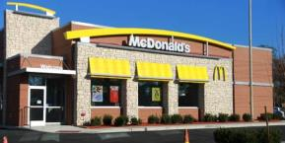

Type the first word that ‘pops to mind'.

‘Hamburger’ could be the first word that comes to mind.

[*Screen Three*]

Look at the picture below, and then type the first word that comes to mind

**

First word

[*Text*]

[*Screen Four*]

Remember, if you can't think of anything you can type the word 'none'.

[*Screen Five*]

Work quickly.

There is a time limit for each screen.

[*Header*]

Look at the picture below, and then type the first word that comes to mind

[*Cue*]

First word

[*Text*]

**Cues:** W1ADQ W1WAICue

(picture 2C_NoTobStore_WholeFoods)

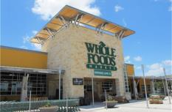

(picture 3C_NoTobStore_Target)

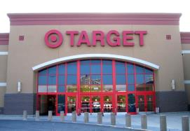

(picture 4T_TobStore_CircleK)

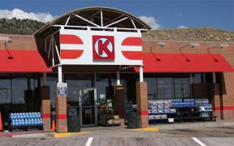

(picture 5T_TobStore_711)

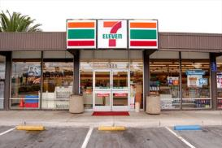

(picture 6C_NoTobStore_FreshEasy)

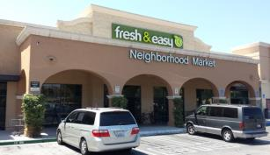

(picture 7T_TobStore_AMPM)

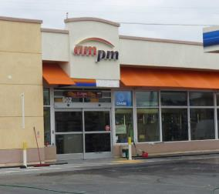

**Coding Instructions:**

[*Self-Coding Introduction*]

Please help us understand what you were thinking about during this task. Each of the following screens will show one of your typed responses and a list of categories. Check all of the categories that are close to the meaning of your typed response.

[*Self-Coding Header*]

Please tell us what you mean by checking all of the categories that apply to your typed response.

**Coding Categories:** 1 When Selected

caffeine (energy drinks, soda, coffee drinks) W1ADQCaf_1_W1ADQ1 W1WAIBCaf1

food or snacks W1ADQSnack_1_W1ADQ1 W1WAIBSnack1

cigarettes or cigars W1ADQTobCigCigar_1_W1ADQ1 W1WAIBTobCigCigar1

smokeless tobacco (chew, snuff, dip) W1ADQTobChew_1_W1ADQ1 W1WAIBTobChew1

electronic cigarettes, vaporizers, or vape pens W1ADQTobECig_1_W1ADQ1 W1WAIBTobECig1

marijuana (weed, pot, grass, chronic) W1ADQPot_1_W1ADQ1 W1WAIBPot1

alcohol (beer, wine, wine coolers, liquor) W1ADQAlco_1_W1ADQ1 W1WAIBAlco1

speed (crystal, meth, ice, amp) W1ADQMeth_1_W1ADQ1 W1WAIBMeth1

other drugs W1ADQOthDrug_1_W1ADQ1 W1WAIBOthDrug1

exercise, workout, or sports W1ADQExer_1_W1ADQ1 W1WAIBExer1

school W1ADQSch_1_W1ADQ1 W1WAIBSch1

party W1ADQParty_1_W1ADQ1 W1WAIBParty1

sleeping W1ADQSleep_1_W1ADQ1 W1WAIBSleep1

none of the above W1ADQNone_1_W1ADQ1 W1WAIBNone1

**Word Association (Slogan)**

**Instructions:**

[*Screen One*]

For the next set of questions, please type the very first PRODUCT or BRAND that comes to mind when you see a phrase on the screen. Products and brands are ‘things you can buy at a store’. If you can’t think of a product or brand, then type the first word that 'pops to mind'. If you still can't think of anything, type the word 'none'.

[*Screen Two*]

For example, suppose that the phrase was 'Do The Dew'

Type the PRODUCT or BRAND that ‘pops to mind'.

When you see the words

Do The Dew: ‘Soda’ or ‘Mountain Dew’ could be the first PRODUCT or BRAND that comes to mind.

[*Screen Three*]

Read the phrase below, and then type the first PRODUCT or BRAND that comes to mind

Do The Dew

First PRODUCT or BRAND

[*Text*]

[*Screen Four*]

Remember, if you can’t think of a product or brand, then you can type the first word that 'pops to mind'. If you still can't think of anything, you can type the word 'none'.

[*Screen Five*]

Work quickly.

There is a time limit for each screen.

[*Header*]

Read the phrase below, and then type the first PRODUCT or BRAND that comes to mind

[*Cue*]

First PRODUCT or BRAND

[*Text*]

**Cues (Slogans):** W1AEQ W1WAPCue

1. Here we go.
2. Come to where the flavor is.
3. Be Bold. Get Black.
4. Enjoy ice cold.
5. Grab and go.
6. Bold Flavor. Distinct Edge.

**Coding Instructions:**

[*Self-Coding Introduction*]

Please help us understand what you were thinking about during this task. Each of the following screens will show one of your typed responses and a list of categories. Check all of the categories that are close to the meaning of your typed response.

[*Self-Coding Header*]

Please tell us what you mean by checking all of the categories that apply to your typed response.

**Coding Categories:** 1 When Selected

food or snacks (sandwiches, chips, candy, ice cream) W1AEQSnack_1_W1AEQ1 W1WAPSnack1

drinks (energy drinks, soda, coffee drinks) W1AEQDrink_1_W1AEQ1 W1WAPDrink1

alcohol (beer, wine, wine coolers, liquor) W1AEQAlco_1_W1AEQ1 W1WAPAlco1

tobacco (cigarettes, cigars, cigarillos) W1AEQCigCigar_1_W1AEQ1 W1WAPCigCigar1

smokeless tobacco (chew, snuff, dip) W1AEQChew_1_W1AEQ1 W1WAPChew1

electronic cigarettes, vaporizers, or vape pens W1AEQEcig_1_W1AEQ1 W1WAPEcig1

clothes W1AEQClothes_1_W1AEQ1 W1WAPClothes1

electronic devices (cell phone, MP3 player, tablet) W1AEQEdev_1_W1AEQ1 W1WAPEdev1

none of the above W1AEQNone_1_W1AEQ1 W1WAPNone1

**Brand Recognition**

**Source:** Hanewinkel, R., Isensee, B, Sargent, J.D., & Morgenstern, M. (2011). Cigarette advertising and teen smoking initiation. *Pediatrics, 127*, e271-278.

Similar measures were also utilized in Dauphinee, A.L., Doxey, J.R., Schleicher, N.C., Fortmann, S.P., & Henriksen, L. (2013). Racial differences in cigarette brand recognition and impact on youth smoking. *BMC Public Health, 13*, 170-177.

**Designed For:** Adolescents

**Psychometrics**: Chronbach’s alpha = 0.74

**Cigarette Advertisements Found At Tobacco**

**Retail Outlets with Brand Name Removed**

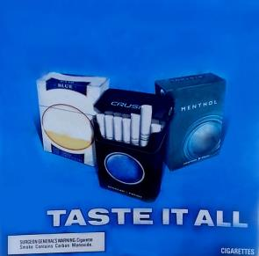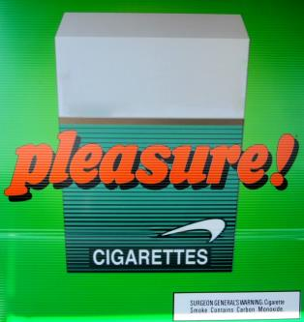

**Other Advertisements Found At Tobacco Retail**

**Outlets with Brand Name Removed**

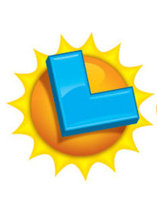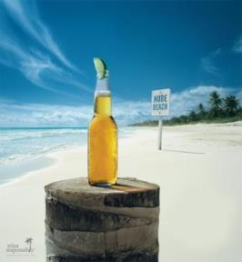



**Other Advertisements Found At Other Stores**

**with Brand Name Removed**

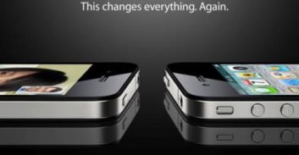

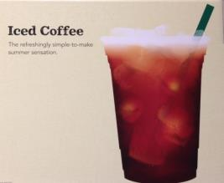

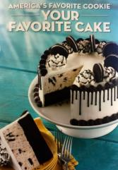

**Order:**







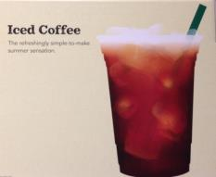

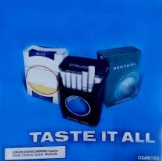

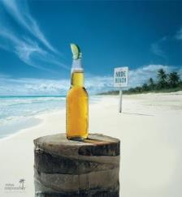

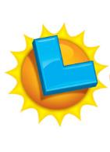

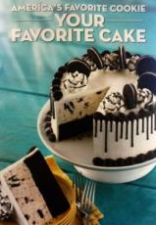

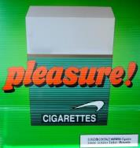

**Codebook:**

(picture 1C_NoTobStore_Apple.jpg)

1. How many times have you seen this advertisement? W1AFQ1 W1BrandRecogNoTobStoreAppleSeen1

Never 0

1-4 times 1

5-10 times 2

More than 10 times 3

1. What brand is being advertised? ____________________ W1AFQ2 W1BrandRecogNoTobStoreAppleName2

(picture 2C_TobStore_Good_Humor.jpg)

1. How many times have you seen this advertisement? W1AFQ3 W1BrandRecog1TobStoreNoTobGoodHumorSeen3

Never 0

1-4 times 1

5-10 times 2

More than 10 times 3

1. What brand is being advertised? ____________________ W1AFQ4 W1BrandRecogTobStoreNoTobGoodHumorName4

(picture 3T_TobStore_Marlboro.jpg)

1. How many times have you seen this advertisement? W1AFQ5 W1BrandRecogTobStoreTobMarlboroSeen5

Never 0

1-4 times 1

5-10 times 2

More than 10 times 3

1. What brand is being advertised? ____________________ W1AFQ6 W1BrandRecogTobStoreTobMarlboroName6

(picture 4C_NoTobStore_Starbucks.jpg)

1. How many times have you seen this advertisement? W1AFQ7 W1BrandRecogNoTobStoreStarbucksSeen7

Never 0

1-4 times 1

5-10 times 2

More than 10 times 3

1. What brand is being advertised? ____________________ W1AFQ8 W1BrandRecogNoTobStoreStarbucksName8

(picture 5T_TobStore_Camel.jpg)

1. How many times have you seen this advertisement? W1AFQ9 W1BrandRecogTobStoreTobCamelSeen9

Never 0

1-4 times 1

5-10 times 2

More than 10 times 3

1. What brand is being advertised? ____________________ W1AFQ10 W1BrandRecogTobStoreTobCamelName10

(picture 6C_TobStore_Corona.jpg)

1. How many times have you seen this advertisement? W1AFQ11 W1BrandRecogTobStoreNoTobCoronaSeen11

Never 0

1-4 times 1

5-10 times 2

More than 10 times 3

1. What brand is being advertised? ____________________ W1AFQ12 W1BrandRecogTobStoreNoTobCoronaName12

(picture 7C_TobStore_CalLotto.jpg)

1. How many times have you seen this advertisement? W1AFQ13 W1BrandRecogTobStoreNoTobCalLottoSeen13

Never 0

1-4 times 1

5-10 times 2

More than 10 times 3

1. What brand is being advertised? ____________________ W1AFQ14 W1BrandRecogTobStoreNoTobCalLottoName14

(picture 8C_NoTobStore_BaskinRobbins.jpg)

1. How many times have you seen this advertisement? W1AFQ15 W1BrandRecogNoTobStoreBaskinRobbinsSeen15

Never 0

1-4 times 1

5-10 times 2

More than 10 times 3

1. What brand is being advertised? ____________________ W1AFQ16 W1BrandRecogNoTobStoreBaskinRobbinsName16

(picture 9T_TobStore_Newport.jpg)

1. How many times have you seen this advertisement? W1AFQ17 W1BrandRecogTobStoreTobNewportSeen17

Never 0

1-4 times 1

5-10 times 2

More than 10 times 3

1. What brand is being advertised? ____________________ W1AFQ18 W1BrandRecogTobStoreTobNewportName18

**Tobacco Brand Recognition**

**Source:** Adapted from:

Centers for Disease Control and Prevention (CDC). (2014a). 2012 National youth tobacco survey (NYTS). Retrieved from: <http://www.cdc.gov/TOBACCO/data_statistics/surveys/NYTS/index.htm>

Centers for Disease Control and Prevention (CDC). (2014b). 2011 Youth tobacco survey (YTS). Retrieved from: <http://www.cdc.gov/tobacco/data_statistics/surveys/yts/index.htm>

**Designed For:** Adolescents

**Psychometrics**: Not provided

**Codebook**:

1. Which of the following cigarette brands have you heard of? (Check all that apply) W1AGQ1, W1TobBrandRecogCig1, 0 When Not Selected, 1 When Selected

American Spirit W1AGQ1option1 W1TobBrandRecogCigSpirit1

Camel W1AGQ1option2 W1TobBrandRecogCigCamel1

GPC, Basic, or Doral W1AGQ1option3 W1TobBrandRecogCigGPC1

Kool W1AGQ1option4 W1TobBrandRecogCigKool1

Lucky Strike W1AGQ1option5 W1TobBrandRecogCigLucky1

Marlboro W1AGQ1option6 W1TobBrandRecogCigMarlboro1

Newport W1AGQ1option7 W1TobBrandRecogCigNewport1

Parliament W1AGQ1option8 W1TobBrandRecogCigParliament1

Summit W1AGQ1option9 W1TobBrandRecogCigFake1

Virginia Slims W1AGQ1option10 W1TobBrandRecogCigVirginia1

None of the above W1AGQ1option11 W1TobBrandRecogCigNone1

1. Which of the following electronic cigarette, vaporizer, or vape pen brands have you heard of? (Check all that apply) W1AGQ2, W1TobBrandRecogECig2, 0 When Not Selected, 1 When Selected

Blu W1AGQ2option1 W1TobBrandRecogECigBlu2

Green Smart Living W1AGQ2option2 W1TobBrandRecogECigGreen2

MarkTen W1AGQ2option3 W1TobBrandRecogECigMarkTen2

NJOY W1AGQ2option4 W1TobBrandRecogECigNJOY2

Xcite W1AGQ2option5 W1TobBrandRecogECigFake2

Square W1AGQ2option6 W1TobBrandRecogECigSquare2

Vuse W1AGQ2option7 W1TobBrandRecogECigVuse2

V2 W1AGQ2option8 W1TobBrandRecogECigVTwo2

None of the above W1AGQ2option9 W1TobBrandRecogECigNone2

1. Which of the following cigar, cigarillo, or little cigar brands have you heard of? (Check all that apply) W1AGQ3, W1TobBrandRecogCigar3, 0 When Not Selected, 1 When Selected

Al Capone W1AGQ3option1 W1TobBrandRecogCigarCapone3

Backwoods W1AGQ3option2 W1TobBrandRecogCigarBackwoods3

Black and Mild W1AGQ3option3 W1TobBrandRecogCigarBlackMild3

Colonials W1AGQ3option4 W1TobBrandRecogCigarFake3

Dutch Masters W1AGQ3option5 W1TobBrandRecogCigarDutch3

Phillies W1AGQ3option6 W1TobBrandRecogCigarPhillies3

Prime Time W1AGQ3option7 W1TobBrandRecogCigarPrime3

Royal Comfort W1AGQ3option8 W1TobBrandRecogCigarRoyal3

Splitarillos W1AGQ3option9 W1TobBrandRecogCigarSplit3

Swisher Sweets W1AGQ3option10 W1TobBrandRecogCigarSwisher3

White Owl W1AGQ3option11 W1TobBrandRecogCigarOwl3

None of the above W1AGQ3option12 W1TobBrandRecogCigarNone3

1. Which of the following chewing tobacco, snuff, or dip brands have you heard of? (Check all that apply) W1AGQ4, W1TobBrandRecogChew4, 0 When Not Selected, 1 When Selected

Beechnut W1AGQ4option1 W1TobBrandRecogChewBeechnut4

Back Country W1AGQ4option2 W1TobBrandRecogChewFake4

Copenhagen W1AGQ4option3 W1TobBrandRecogChewCopen4

Grizzly W1AGQ4option4 W1TobBrandRecogChewGrizzly4

Kodiak W1AGQ4option5 W1TobBrandRecogChewKodiak4

Levi Garrett W1AGQ4option6 W1TobBrandRecogChewLevi4

Longhorn W1AGQ4option7 W1TobBrandRecogChewLonghorn4

Red Man W1AGQ4option8 W1TobBrandRecogChewRedman4

Skoal W1AGQ4option9 W1TobBrandRecogChewSkoal4

None of the above W1AGQ4option10 W1TobBrandRecogChewNone4

**25% Update**

[*A 25% Progress Bar Will Be Shown Here*]

Your Progress

Well done! You are making excellent progress.

Now we will ask you to complete a series of computer tasks. These can be challenging. Do the best that you can.

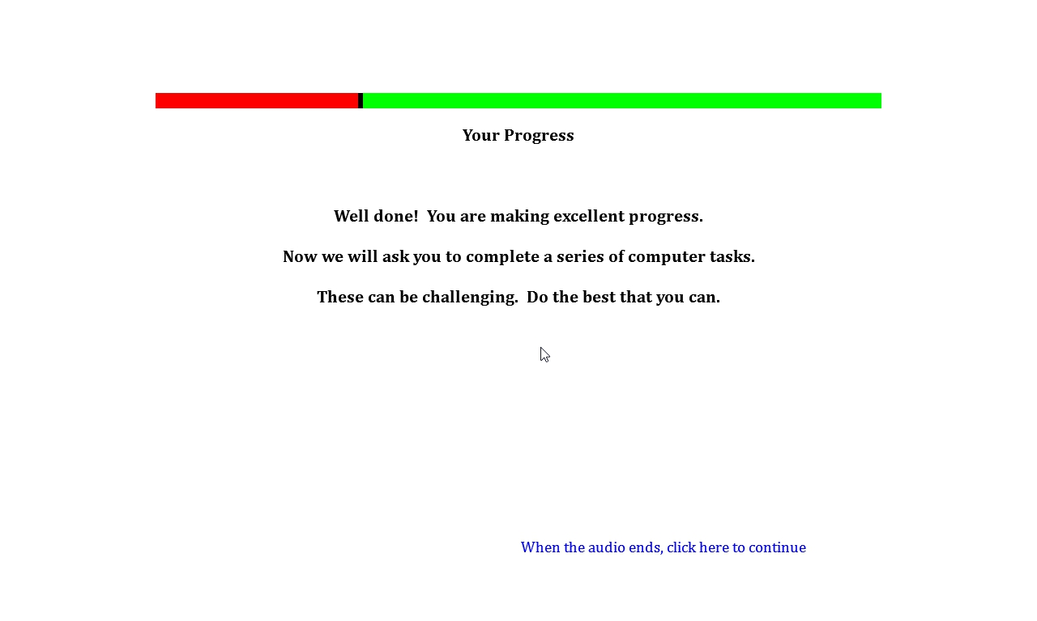

**Single Target Implicit Association Task**

**Source:** Bluemke, M., Friese, M. (2008). Reliability and validity of the single-target IAT (ST-IAT): Assessing automatic affect towards multiple attitude objects. *European Journal of Social Psychology, 38*, 977-997.

Greenwald, A.G., McGhee, D.E., & Schwartz, J.K. (1998). Measuring individual differences in implicit cognition: The implicit association test. *Journal Of Personality And Social Psychology*,*74*(6), 1464-1480.

Greenwald, A.G., Nosek, B.A., & Banaji, M.R. (2003). Understanding and using the Implicit Association Test: I. An improved scoring algorithm. *Journal Of Personality And Social Psychology*, *85*(2), 197-216

Karpinski, A., & Steinman, R.B. (2006). The single category implicit association test as a measure of implicit social cognition. *Journal of Personality and Social Psychology, 91*(1):16-32.

Conrey, F.R., Sherman, J.W., Gawronski, B., Hugenberg, K. & Groom, C.J. (2005). Separating multiple processes in implicit social cognition: The quad model of implicit task performance. *Journal of Personality and Social Psychology, 89*(4): 469-87.

Sherman, J. W., Gawronski, B., Gonsalkorale, K., Hugenberg, K., Allen, T. J., & Groom, C. J. (2008). The self-regulation of automatic associations and behavioral impulses. *Psychology Review, 115*(2): 314-35.

**Designed For:** Adolescents

**Psychometrics:** Internal consistency (.72)**,** Test-retest stability (Kendall’s W = .75)

#### Description: The Single Target Implicit Association Test assesses associations among three categories. The first trial utilizes the categories ‘Pleasant’, ‘Neutral’, and ‘Tobacco’. The second trial utilizes the categories ‘Unpleasant’, ‘Neutral’, and ‘Tobacco’.

**Items:**

W1AHQ

**Source for Tobacco Words:**

Huijding, J., de Jong, P.J., Wiers, R.W., & Verkooijen, K. (2005). Implicit and explicit attitudes toward smoking in a smoking and nonsmoking setting. *Addictive Behaviors, 30*, 949-961 was used as the source for the following words:

Tobacco

Smoking

Cigarettes

Nicotine

Smokers

Lighter

Butt

Ames, S.L., Grenard, J.L., Stacy, A.W., Xiao, L., He, Q., Wong, S.W., Xue, G., Wiers, R.W., Bechara, A. Functional imaging of implicit marijuana associations during performance on an Implicit Association Test (IAT). *Behavioural Brain Research, 256*, 494-502 was used as the source for the following words:

Ashes

Smokes

Cigs

**Source for Neutral Words:**

Houben, K., & Wiers, R.W. (2009). Beer makes the heart grow fonder: Single-target implicit attitudes toward beer but not alcohol are related to drinking behaviour in regular beer drinkers. *Netherlands Journal of Psychology, 65*, 10-21 was used as the source for the following words:

Truck

Machine

Window

Factory

Scissors

Letter

Paper

Square

Circle

Page

Magnet

The following word was also added:

Line

**Source for Pleasant Words:** Waters, A.J., Carter, B.L., Robinson, J.D., Wetter, D.W., Lam, C.Y., & Cinciripini, P.M. (2007). Implicit attitudes to smoking are associated with craving and dependence. *Drug and Alcohol Dependence, 91*, 178-186 was used as the source for the following words:

Calm

Cool

Friendly

Nice

Peaceful

Pleasant

Positive

Relaxing

Restful

Soothing

**Source for Unpleasant Words:** Waters, A.J., Carter, B.L., Robinson, J.D., Wetter, D.W., Lam, C.Y., & Cinciripini, P.M. (2007). Implicit attitudes to smoking are associated with craving and dependence. *Drug and Alcohol Dependence, 91*, 178-186 was used as the source for the following words:

Dirty

Foul

Harmful

Nasty

Negative

Smelly

Ugly

Unhealthy

Unpleasant

Ames, S.L., Grenard, J.L., Thush, C., Sussman, S., Wiers, R.W., & Stacy, A.W. (2007). Comparison of indirect assessments of association as predictors of marijuana use among at-risk adolescents. *Experimental and Clinical Psychopharmacology, 15*, 204-218 was used as the source for the following words:

Sad

**Rank, Hits, and Reading Level for Words:**

|  |  |  |  |
| --- | --- | --- | --- |
| **Word** | **Rank out of 86,800 Words (wordcount.org)** | **Hits (Google)** | **Reading Level (www.spellingcity.com)** |
| **Tobacco** | | | |
| Tobacco | 5335 | 44700000 | 4th |
| Smoking | 3224 | 128000000 | 5th |
| Cigarettes | 5830 | 26600000 | 4th (cigarette) |
| Nicotine | 20904 | 8120000 | 4th |
| Smokers | 10890 | 14000000 | 4th (smoke) |
| Lighter | 6539 | 46900000 | 2nd |
| Butt | 12108 | 111000000 | Not Listed |
| Ashes | 10825 | 20900000 | 4th |
| Smokes | 23915 | 9050000 | 4th (smoke) |
| Cigs | 52497 | 3380000 | Not Listed |
| **Pleasant** | | | |
| Calm | 3205 | 82500000 | 4th |
| Cool | 2520 | 650000000 | 2nd |
| Friendly | 2465 | 396000000 | 3rd |
| Nice | 743 | 680000000 | 1st |
| Peaceful | 4947 | 47400000 | 3rd |
| Pleasant | 3427 | 88500000 | 4th |
| Positive | 1220 | 340000000 | 4th |
| Relaxing | 9088 | 54100000 | 4th (relax) |
| Restful | 25994 | 7920000 | 3rd |
| Soothing | 12833 | 17300000 | 6th |
| **Unpleasant** | | | |
| Dirty | 3364 | 190000000 | 4th |
| Foul | 6875 | 23500000 | 3rd |
| Harmful | 8076 | 33600000 | 3rd |
| Nasty | 4673 | 84800000 | 3rd |
| Negative | 2132 | 171000000 | 4th |
| Smelly | 16396 | 6540000 | 3rd (smell) |
| Ugly | 5716 | 78100000 | 1st |
| Unhealthy | 16048 | 12300000 | 3rd |
| Unpleasant | 5902 | 11900000 | 4th |
| Sad | 2847 | 2750000000 | 1st |
| **Neutral** | | | |
| Truck | 6325 | 225000000 | 1st |
| Machine | 1145 | 415000000 | 4th |
| Window | 960 | 1590000000 | 4th |
| Factory | 2195 | 278000000 | 4th |
| Scissors | 12220 | 22900000 | 5th |
| Letter | 722 | 225000000 | 2nd |
| Magnet | 14955 | 14500000 | 4th |
| Line | 408 | 243000000 | 2nd |
| Circle | 2761 | 212000000 | 2nd |
| Page | 931 | 4500000000 | 1st |

#### Counterbalancing:

|  |  |  |  |  |  |  |  |
| --- | --- | --- | --- | --- | --- | --- | --- |
| **Version One** | | | | | | | |
|  | **# of Trials** | **Practice/Real** | **Categories on Left** | **Categories on Right** | **Unpleasant Words** | **Neutral Words** | **Tobacco Words** |
| **Block 1** | 20 | Practice (Red X) | Unpleasant | Neutral | 10 | 10 | 0 |
| **Block 2** | 20 | Practice (No Red X) | Unpleasant | Neutral | 10 | 10 | 0 |
| **Block 3** | 30 | Real | Unpleasant+Tobacco | Neutral | 10 | 10 | 10 |
| **Block 4** | 30 | Real | Unpleasant+Tobacco | Neutral | 10 | 10 | 10 |
| **Block 5** | 30 | Real | Unpleasant | Neutral+Tobacco | 10 | 10 | 10 |
| **Block 6** | 30 | Real | Unpleasant | Neutral+Tobacco | 10 | 10 | 10 |
| **Total** | 160 |  |  |  | 60 | 60 | 40 |
|  | **# of Trials** | **Practice/Real** | **Categories on Left** | **Categories on Right** | **Pleasant Words** | **Neutral Words** | **Tobacco Words** |
| **Block 1** | 20 | Practice (Red X) | Pleasant | Neutral | 10 | 10 | 0 |
| **Block 2** | 20 | Practice (No Red X) | Pleasant | Neutral | 10 | 10 | 0 |
| **Block 3** | 30 | Real | Pleasant+Tobacco | Neutral | 10 | 10 | 10 |
| **Block 4** | 30 | Real | Pleasant+Tobacco | Neutral | 10 | 10 | 10 |
| **Block 5** | 30 | Real | Pleasant | Neutral+Tobacco | 10 | 10 | 10 |
| **Block 6** | 30 | Real | Pleasant | Neutral+Tobacco | 10 | 10 | 10 |
| **Total** | 160 |  |  |  | 60 | 60 | 40 |

|  |  |  |  |  |  |  |  |
| --- | --- | --- | --- | --- | --- | --- | --- |
| **Version Two** | | | | | | | |
|  | **# of Trials** | **Practice/Real** | **Categories on Left** | **Categories on Right** | **Pleasant Words** | **Neutral Words** | **Tobacco Words** |
| **Block 1** | 20 | Practice (Red X) | Pleasant | Neutral | 10 | 10 | 0 |
| **Block 2** | 20 | Practice (No Red X) | Pleasant | Neutral | 10 | 10 | 0 |
| **Block 3** | 30 | Real | Pleasant+Tobacco | Neutral | 10 | 10 | 10 |
| **Block 4** | 30 | Real | Pleasant+Tobacco | Neutral | 10 | 10 | 10 |
| **Block 5** | 30 | Real | Pleasant | Neutral+Tobacco | 10 | 10 | 10 |
| **Block 6** | 30 | Real | Pleasant | Neutral+Tobacco | 10 | 10 | 10 |
| **Total** | 160 |  |  |  | 60 | 60 | 40 |
|  | **# of Trials** | **Practice/Real** | **Categories on Left** | **Categories on Right** | **Unpleasant Words** | **Neutral Words** | **Tobacco Words** |
| **Block 1** | 20 | Practice (Red X) | Unpleasant | Neutral | 10 | 10 | 0 |
| **Block 2** | 20 | Practice (No Red X) | Unpleasant | Neutral | 10 | 10 | 0 |
| **Block 3** | 30 | Real | Unpleasant+Tobacco | Neutral | 10 | 10 | 10 |
| **Block 4** | 30 | Real | Unpleasant+Tobacco | Neutral | 10 | 10 | 10 |
| **Block 5** | 30 | Real | Unpleasant | Neutral+Tobacco | 10 | 10 | 10 |
| **Block 6** | 30 | Real | Unpleasant | Neutral+Tobacco | 10 | 10 | 10 |
| **Total** | 160 |  |  |  | 60 | 60 | 40 |

|  |  |  |  |  |  |  |  |
| --- | --- | --- | --- | --- | --- | --- | --- |
|  |  |  |  |  |  |  |  |
| **Version Three** | | | | | | | |
|  | **# of Trials** | **Practice/Real** | **Categories on Left** | **Categories on Right** | **Pleasant Words** | **Neutral Words** | **Tobacco Words** |
| **Block 1** | 20 | Practice (Red X) | Neutral | Pleasant | 10 | 10 | 0 |
| **Block 2** | 20 | Practice (No Red X) | Neutral | Pleasant | 10 | 10 | 0 |
| **Block 3** | 20 | Real | Neutral | Pleasant+Tobacco | 10 | 10 | 10 |
| **Block 4** | 40 | Real | Neutral | Pleasant+Tobacco | 10 | 10 | 10 |
| **Block 5** | 20 | Real | Neutral+Tobacco | Pleasant | 10 | 10 | 10 |
| **Block 6** | 40 | Real | Neutral+Tobacco | Pleasant | 10 | 10 | 10 |
| **Total** | 160 |  |  |  | 60 | 60 | 40 |
|  | **# of Trials** | **Practice/Real** | **Categories on Left** | **Categories on Right** | **Unpleasant Words** | **Neutral Words** | **Tobacco Words** |
| **Block 1** | 20 | Practice (Red X) | Neutral | Unpleasant | 10 | 10 | 0 |
| **Block 2** | 20 | Practice (No Red X) | Neutral | Unpleasant | 10 | 10 | 0 |
| **Block 3** | 20 | Real | Neutral | Unpleasant+Tobacco | 10 | 10 | 10 |
| **Block 4** | 40 | Real | Neutral | Unpleasant+Tobacco | 10 | 10 | 10 |
| **Block 5** | 20 | Real | Neutral+Tobacco | Unpleasant | 10 | 10 | 10 |
| **Block 6** | 40 | Real | Neutral+Tobacco | Unpleasant | 10 | 10 | 10 |
| **Total** | 160 |  |  |  | 60 | 60 | 40 |
|  |  |  |  |  |  |  |  |
| **Version Four** | | | | | | | |
|  | **# of Trials** | **Practice/Real** | **Categories on Left** | **Categories on Right** | **Unpleasant Words** | **Neutral Words** | **Tobacco Words** |
| **Block 1** | 20 | Practice (Red X) | Neutral | Unpleasant | 10 | 10 | 0 |
| **Block 2** | 20 | Practice (No Red X) | Neutral | Unpleasant | 10 | 10 | 0 |
| **Block 3** | 20 | Real | Neutral | Unpleasant+Tobacco | 10 | 10 | 10 |
| **Block 4** | 40 | Real | Neutral | Unpleasant+Tobacco | 10 | 10 | 10 |
| **Block 5** | 20 | Real | Neutral+Tobacco | Unpleasant | 10 | 10 | 10 |
| **Block 6** | 40 | Real | Neutral+Tobacco | Unpleasant | 10 | 10 | 10 |
| **Total** | 160 |  |  |  | 60 | 60 | 40 |
|  | **# of Trials** | **Practice/Real** | **Categories on Left** | **Categories on Right** | **Pleasant Words** | **Neutral Words** | **Tobacco Words** |
| **Block 1** | 20 | Practice (Red X) | Neutral | Pleasant | 10 | 10 | 0 |
| **Block 2** | 20 | Practice (No Red X) | Neutral | Pleasant | 10 | 10 | 0 |
| **Block 3** | 30 | Real | Neutral | Pleasant+Tobacco | 10 | 10 | 10 |
| **Block 4** | 30 | Real | Neutral | Pleasant+Tobacco | 10 | 10 | 10 |
| **Block 5** | 30 | Real | Neutral+Tobacco | Pleasant | 10 | 10 | 10 |
| **Block 6** | 30 | Real | Neutral+Tobacco | Pleasant | 10 | 10 | 10 |
| **Total** | 160 |  |  |  | 60 | 60 | 40 |

#### Instructions:

#### *First Set*

#### *Transition*

For the next task, you will be sorting words that appear in the middle of the computer screen into categories which appear on the upper left and right of the screen.

#### *Screen One*

Put your middle or index fingers on the ‘E’ and ‘I’ keys of your keyboard.

Words representing the categories at the top will appear one-by-one in the middle of the screen.

When the item belongs to a category on the left, PRESS THE ‘E’ KEY.

When the item belongs to a category on the right, PRESS THE ‘I’ KEY.

Items fit best in one of the categories.

During the practice trials we will provide feedback in the form of a red X when you make a mistake. We will not provide this feedback during the actual task trials.

This is a timed sorting task. GO AS FAST AS YOU CAN while making as few mistakes as possible.

This task will take about 5 minutes to complete.

#### *Screen Two*

There will not be any feedback (NO RED X) for the rest of this task.

Continue to keep your middle or index fingers on the ‘E’ and ‘I’ keys of your keyboard. Continue to work quickly.

#### *Screen Three*

See above, a new category now appears together with one of the previous categories you saw.

Remember, each item fits best in one group.

For example:

If the categories pleasant and tobacco appear on separate sides above – pleasant words would go in the pleasant category, not the tobacco category.

Use the ‘E’ and ‘I’ keys to categorize items into groups.

#### *Screen Four*

Sort the same items again.

Remember to go as fast as you can while making as few mistakes as possible.

Use the ‘E’ and ‘I’ keys to categorize items into the groups.

#### *Screen Five*

See above, the three categories now appear together in a new configuration.

Remember, each item fits best in one group.

Use the ‘E’ and ‘I’ keys to categorize items into groups.

#### *Screen Six*

Sort the same items again.

Remember to go as fast as you can while making as few mistakes as possible.

Use the ‘E’ and ‘I’ keys to categorize items into the groups.

#### *Second Set*

#### *Transition*

Now you will do the same task again but with different categories.

GO AS FAST AS YOU CAN while making as few mistakes as possible.

#### *Screen One*

See above, the categories have changed.

Use the ‘E’ and ‘I’ keys to categorize items into the groups.

Remember to go as fast as you can while making as few mistakes as possible.

During the practice trials we will provide feedback in the form of a red X when you make a mistake. We will not provide this feedback during the actual task trials.

This task will take about 5 minutes to complete.

#### *Screen Two*

There will not be any feedback (NO RED X) for the rest of this task.

Continue to keep your middle or index fingers on the ‘E’ and ‘I’ keys of your keyboard. Continue to work quickly.

#### *Screen Three*

See above, a new category now appears together with one of the previous categories you saw.

Remember, each item fits best in one group.

For example:

If the categories unpleasant and tobacco appear on separate sides above – unpleasant words would go in the unpleasant category, not the tobacco category.

Use the ‘E’ and ‘I’ keys to categorize items into groups.

#### *Screen Four*

Sort the same items again.

Remember to go as fast as you can while making as few mistakes as possible.

Use the ‘E’ and ‘I’ keys to categorize items into the groups.

#### *Screen Five*

See above, the three categories now appear together in a new configuration.

Remember, each item fits best in one group.

Use the ‘E’ and ‘I’ keys to categorize items into groups.

#### *Screen Six*

Sort the same items again.

Remember to go as fast as you can while making as few mistakes as possible.

Use the ‘E’ and ‘I’ keys to categorize items into the groups.

#### Example:

tobacco

*pleasant*

*neutral*

cigarette

#### Stimuli:

**Tobacco Words**

1. Tobacco
2. Smoking
3. Cigarettes
4. Nicotine
5. Smokers
6. Lighter
7. Butt
8. Ashes
9. Smokes
10. Cigs

**Pleasant Words**

1. Calm
2. Cool
3. Friendly
4. Nice
5. Peaceful
6. Pleasant
7. Positive
8. Relaxing
9. Restful
10. Soothing

**Unpleasant Words**

1. Dirty
2. Foul
3. Harmful
4. Nasty
5. Negative
6. Smelly
7. Ugly
8. Unhealthy
9. Unpleasant
10. Sad

**Neutral Words**

1. Truck
2. Machine
3. Window
4. Factory
5. Scissors
6. Letter
7. Magnet
8. Line
9. Circle
10. Page

#### Example Screens:

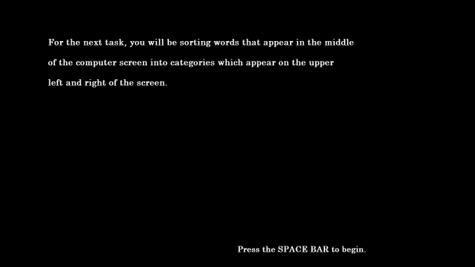

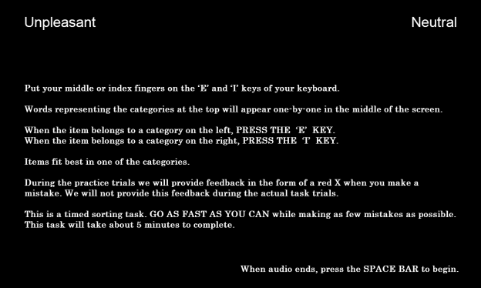

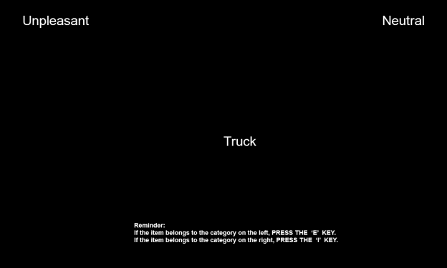

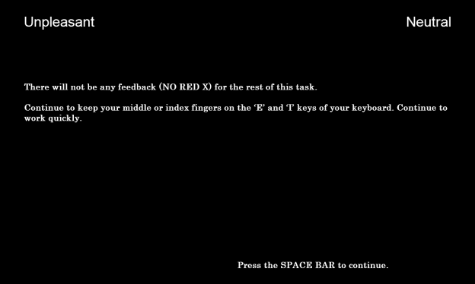

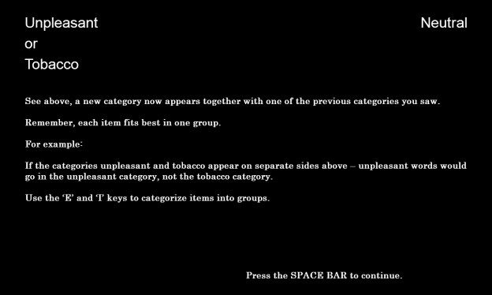

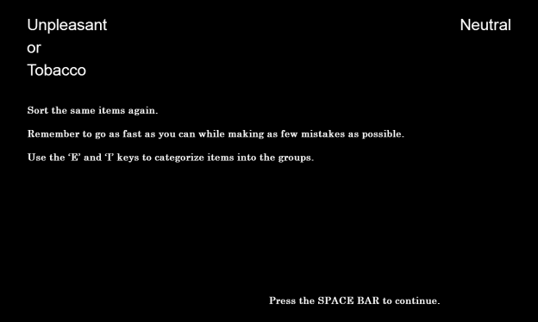

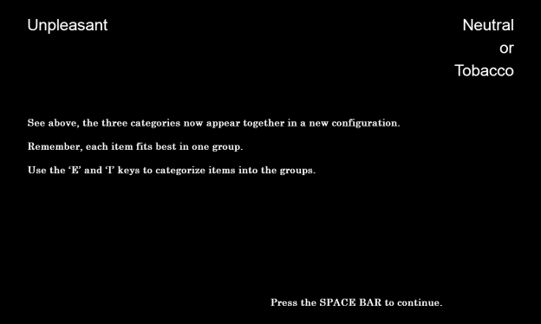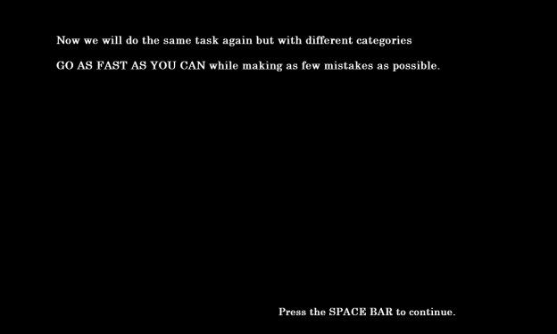

**Flicker Paradigm**

**Primary Source:**

Rensink, R.A. (1997). To see or not to see: The need for attention to perceive changes in scenes. *Psychological Science, 8*, 368-373.

**Additional Sources:**

Beck, M.R., & Levin, D.T. (2003). The role of representational volatility in recognizing pre- and postchange objects. *Perception & Psychophysics, 65*, 458-468.

Hollingworth, A., & Henderson, J.M. (2002). Accurate visual memory for previously attended objects in natural scenes. *Journal of Experimental Psychology: Human Perception and Performance, 28*, 113-136.

Hollingworth, A., Williams, C.C., & Henderson, J.M. (2001). To see and remember: Visually specific information is retained in memory from previously attended objects in natural scenes. *Psychonomic Bulletin & Review, 8*, 761-768.

Simons, D. J. & Rensink, R. A. (2005). Change blindness: past, present, and future. *TRENDS in Cognitive Sciences, 9*(1), 16-20.

**Sources for Attentional Bias:**

Chanon, V.W., Sours, C.R., & Boettiger, C.A. (2010). Attentional bias toward cigarette cues in active smokers. *Psychopharmacology, 212*, 309-320.

Hobson, J., Bruce, G., & Butler, S.H. (2012). A flicker change blindness task employing eye tracking reveals an association with levels of craving not consumption. *Journal of Psychopharmacology, 27*, 93-97.

Schoenmakers, T.M., & Wiers, R.W. (2010). Craving and attentional bias respond differently to alcohol priming: A field study in the pub. *European Addiction Research, 16*, 9-16.

Jones, B.T., Bruce, G., Livingstone, S., & Reed, E. (2006). Alcohol-related attentional bias in problem drinkers with the flicker change blindness paradigm. *Psychology of Addictive Behaviors, 20*, 171-177.

Jones, B.C., Jones, B.T., Blundell, L., & Bruce, G. (2002). Social users of alcohol and cannabis who detect substance-related changes in a change blindness paradigm report higher levels of use than those detecting substance-neutral changes. *Psychopharmacology, 165*, 93-96.

Tibboel, H., De Houwer, J., & Field, M. (2009). Reduced attentional blink for alcohol-related stimuli in heavy social drinkers. *Journal of Psychopharmacology, 0*, 1-8.

**Sources for Presenting Only One Image:**

Jones, B.T., Bruce, G., Livingstone, S., & Reed, E. (2006). Alcohol-related attentional bias in problem drinkers with the flicker change blindness paradigm. *Psychology of Addictive Behaviors, 20*, 171-177.

Jones, B.C., Jones, B.T., Blundell, L., & Bruce, G. (2002). Social users of alcohol and cannabis who detect substance-related changes in a change blindness paradigm report higher levels of use than those detecting substance-neutral changes. *Psychopharmacology, 165*, 93-96.

**Designed For:** Adults

**Instructions:**

This task will ask you to detect changes in different pictures.

Press the SPACE BAR to continue.

In a moment, you will be shown a very fast flickering picture. The same picture is shown all the time. But half the time there is one change in the picture. The change can be the addition or removal of something in the picture or the replacement of something.

Press the SPACE BAR to continue.

Press the SPACE BAR as soon as you notice the change. You will then be asked to describe the change.

If you didn't notice any change, the picture will stop flickering after one minute.

Press the SPACE BAR to begin.

**Codebook:**

[*Flickering Images*]

Original

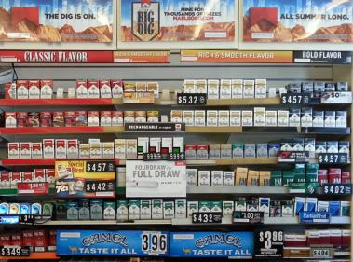

Modified

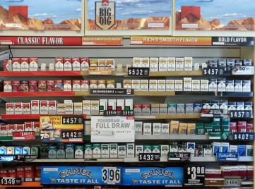

[*Page 1*]

Please describe what changed in the textbox below. Be as specific as you can.

If you didn’t notice any chance, type ‘No change.’

[*Text Box*]

W1ALQ_textboxresponse1 W1FlickerChange1

[*Page 2*]

How difficult was it to detect the change? W1AIQ2 W1FlickerDifficulty2

Very Easy 1 Somewhat Easy 2 Somewhat Difficult 3 Very Difficult 4

[*Page 3*]



How often do you visit stores that have displays that look like the one above? W1AIQ3 W1FlickerStoreVisit3

Never 0

Once a month or less 1

2-3 times a month 2

Once a week 3

2-3 times a week 4

Almost every day or every day 5

[*Page 4*]

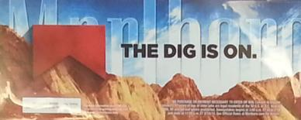

How often have you seen this advertisement at a store? W1AIQ4 W1FlickerAdvertisementSeen4

Never 0

Once a month or less 1

2-3 times a month 2

Once a week 3

2-3 times a week 4

Almost every day or every day 5

**Additional Information:**

* There will be no practice images.
* There will be one manipulated image.
* There will be no clues or suggested fixation points.
* Each image will be displayed for 240 milliseconds followed by a black screen for 80 milliseconds. This will continue for 60 seconds.
* The original image will be displayed twice followed by the manipulated image

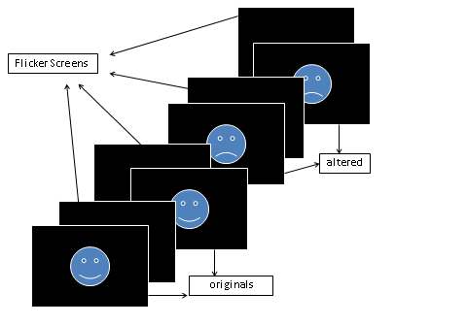

**Data Provided:**

* Date
* Time
* Count_cycles - counts the number of cycles started until a response occurs
* Responsepoint - determines the stimulus in the response cycle (the cycle that participant made a positive response) that was presented when participant made response: "StimA1", "flicker_AA", "StimA2", "flicker_AB", "StimB1", "flicker_BB", "StimB2", "flicker_BA" or "N/A" (if no response was given)
* Alternations - Determines the number of alternations between original and altered pictures until response occurs. Each switch between originals and altered pictures as well as each switch between altered pictures and original pictures is counted as an alternation. For each completed cycle, participants go through 2 alternations. If the response occurs AFTER the change from original to altered pic in the last cycle, one more alternation is added to the count.
* Cycle_rt - stores the combined trial latencies across the entire cycle until response occurs
* Textboxresponse - stores the open-ended response
* Textboxresponse_rt - stores the time it took participant to work on the openended response until pressing the button

**Disposable Income**

**Source:** Items 1-3 adapted from West, P., Sweeting, H., Young, R., & Robins, M. (2006). A material paradox: Socioeconomic status, young people's disposable income and consumer culture. *Journal Of Youth Studies, 9*(4), 437-462.

Items 4-8 adapted from Darling, H., Reeder, A.I., McGee, R., & Williams, S. (2006). Brief report: Disposable income, and spending on fast food, alcohol, cigarettes, and gambling by New Zealand secondary school students. *Journal Of Adolescence, 29*(5), 837-843.

Response options adapted from Johnston, L.D., O’Malley, P.M., Bachman, J.G., & Schulenberg, J.E. (2014) 2011 Monitoring the future survey (MTF). Retrieved from <http://www.monitoringthefuture.org/>. Ann Arbor: Institute for Social Research, The University of Michigan.

**Designed For:** Adolescents

**Psychometrics:** Not provided

**Codebook:**

In an average week, how much money do you receive from…

1. Your Family W1AJQ1 W1DisIncFamily1

$0 0

$1-5 1

$6-10 2

$11-20 3

$21-35 4

$36-50 5

$51-75 6

$76-125 7

$126-175 8

$176+ 9

1. A Job W1AJQ2 W1DisIncJob2

$0 0

$1-5 1

$6-10 2

$11-20 3

$21-35 4

$36-50 5

$51-75 6

$76-125 7

$126-175 8

$176+ 9

1. Other Sources W1AJQ3 W1DisIncOther3

$0 0

$1-5 1

$6-10 2

$11-20 3

$21-35 4

$36-50 5

$51-75 6

$76-125 7

$126-175 8

$176+ 9

In an average week, how much money do you spend on…

1. Snack Foods W1AKQ1 W1DisSpendSnack1

$0 0

$1-5 1

$6-10 2

$11-20 3

$21-35 4

$36-50 5

$51-75 6

$76-125 7

$126-175 8

$176+ 9

1. Soda or Energy Drinks W1AKQ2 W1DisSpendSoda2

$0 0

$1-5 1

$6-10 2

$11-20 3

$21-35 4

$36-50 5

$51-75 6

$76-125 7

$126-175 8

$176+ 9

1. Alcohol W1AKQ3 W1DisSpendAlcohol3

$0 0

$1-5 1

$6-10 2

$11-20 3

$21-35 4

$36-50 5

$51-75 6

$76-125 7

$126-175 8

$176+ 9

1. Tobacco Products W1AKQ4 W1DisSpendTobacco4

$0 0

$1-5 1

$6-10 2

$11-20 3

$21-35 4

$36-50 5

$51-75 6

$76-125 7

$126-175 8

$176+ 9

1. Other W1AKQ5 W1DisSpendOther5

$0 0

$1-5 1

$6-10 2

$11-20 3

$21-35 4

$36-50 5

$51-75 6

$76-125 7

$126-175 8

$176+ 9

**Store Visit Frequency**

**Source:** Feighery, E.C., Henriksen, L., Wang, Y., Schleicher, N.C., & Fortmann, S.P. (2006). An evaluation of four measures of adolescents' exposure to cigarette marketing in stores. *Nicotine & Tobacco Research, 8*(6), 751-759.

Feighery, E.C, Ribisl, K.M., Schleicher, N., Lee, R., & Halvorson, S. (2001). Cigarette advertising and promotional strategies in retail outlets: Results of a statewide survey in California. *Tobacco Control, 10*, 184-188.

Feighery, E.C, Ribisl, K.M., Schleicher, N., & Clark, P.I. (2004). Retailer participation in cigarette company incentive programs is related to increased levels of cigarette advertising and cheaper cigarette prices in stores. *Preventive Medicine, 38*, 876-884.

Henriksen, L., Feighery, E.C., Schleicher, N.C., Haladjian, H.H., & Fortmann, S.P. (2004). Reaching youth at the point of sale: cigarette marketing is more prevalent in stores where adolescents shop frequently. *Tobacco Control, 13*, 315–318.

Henriksen, L., Feighery, E.C., Wang, Y., Fortmann, S.P. Association of retail tobacco marketing with adolescent smoking. (2004). *American Journal of Public Health, 94*(12), 2081-2083.

Schleicher, N., Johnson, T.O., Dauphinee, A.L., Henriksen, L. (2011). Tobacco Marketing in California’s Retail Environment (2008-2011), Final report for the California Tobacco Advertising Survey.

**Designed For:** Adolescents

**Psychometrics**: Not reported

**Codebook:**

[*Screen One*]

1. How often do you go to large supermarkets? W1ALQ1 W1StoreVisitSuperMark1

Never 0

Once a month 1

2-3 times a month 2

Once a week 3

2-3 times a week 4

Almost every day 5

1. How often do you go to small grocery stores? W1ALQ2 W1StoreVisitSmallMark2

Never 0

Once a month 1

2-3 times a month 2

Once a week 3

2-3 times a week 4

Almost every day 5

1. How often do you go to convenience stores? W1ALQ3 W1StoreVisitConvenience3

Never 0

Once a month 1

2-3 times a month 2

Once a week 3

2-3 times a week 4

Almost every day 5

1. How often do you go to gas stations? W1ALQ4 W1StoreVisitGas4

Never 0

Once a month 1

2-3 times a month 2

Once a week 3

2-3 times a week 4

Almost every day 5

[*Screen Two*]

1. How often do you go to drug stores? W1ALQ5 W1StoreVisitDrug5

Never 0

Once a month 1

2-3 times a month 2

Once a week 3

2-3 times a week 4

Almost every day 5

1. How often do you go to liquor stores? W1ALQ6 W1StoreVisitLiquor6

Never 0

Once a month 1

2-3 times a month 2

Once a week 3

2-3 times a week 4

Almost every day 5

1. How often do you go to tobacco stores? W1ALQ7 W1StoreVisitTobacco7

Never 0

Once a month 1

2-3 times a month 2

Once a week 3

2-3 times a week 4

Almost every day 5

**School Tailored Items:**

**Abraham Lincoln (ID: 223)**

(picture 223-56778.jpg)

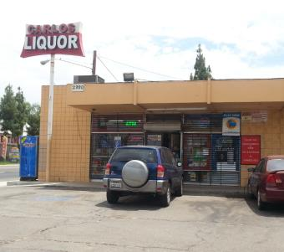

CARLOS LIQUOR at 2990 14TH STREET, RIVERSIDE, CA

How often do you go to the store at THIS ADDRESS?

Never 0

Once a month 1

2-3 times a month 2

Once a week 3

2-3 times a week 4

Almost every day 5

(picture 223-56786.jpg)

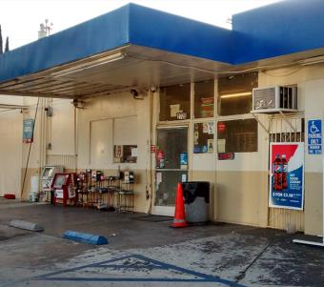

ARCO at 2720 14TH STREET, RIVERSIDE, CA

How often do you go to the store at THIS ADDRESS?

Never 0

Once a month 1

2-3 times a month 2

Once a week 3

2-3 times a week 4

Almost every day 5

(picture 223-56806.jpg)

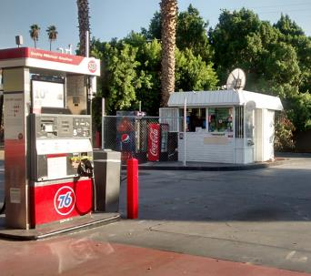

76 at 2658 UNIVERSITY AVENUE, RIVERSIDE, CA

How often do you go to the store at THIS ADDRESS?

Never 0

Once a month 1

2-3 times a month 2

Once a week 3

2-3 times a week 4

Almost every day 5

(picture 223-67635.jpg)

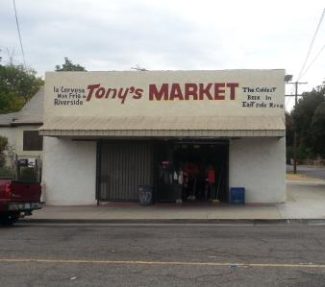

TONY'S MARKET at 4098 PARK AVENUE, RIVERSIDE, CA

How often do you go to the store at THIS ADDRESS?

Never 0

Once a month 1

2-3 times a month 2

Once a week 3

2-3 times a week 4

Almost every day 5

(picture 223-70332.jpg)

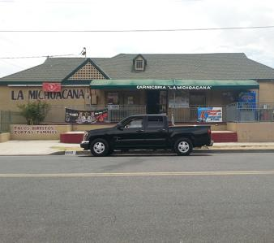

LA MICHOACANA MARKET at 4110 VICTORIA AVENUE, RIVERSIDE, CA

How often do you go to the store at THIS ADDRESS?

Never 0

Once a month 1

2-3 times a month 2

Once a week 3

2-3 times a week 4

Almost every day 5

(picture fake.jpg)

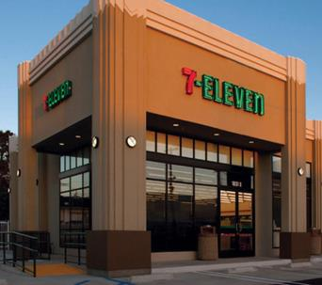

7-ELEVEN at 4495 HOWARD AVENUE, RIVERSIDE, CA

How often do you go to the store at THIS ADDRESS?

Never 0

Once a month 1

2-3 times a month 2

Once a week 3

2-3 times a week 4

Almost every day 5

**Abraxas (ID: 261)**

(picture 261-56472.jpg)

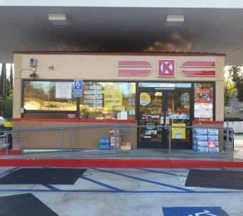

CIRCLE K at 14713 POMERADO ROAD, POWAY, CA

How often do you go to the store at THIS ADDRESS?

Never 0

Once a month 1

2-3 times a month 2

Once a week 3

2-3 times a week 4

Almost every day 5

(picture fake.jpg)

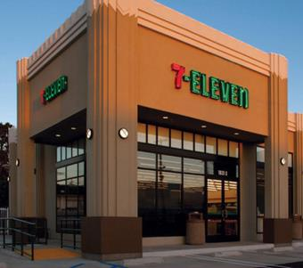

7-ELEVEN at 14551 POMERADO ROAD, POWAY, CA

How often do you go to the store at THIS ADDRESS?

Never 0

Once a month 1

2-3 times a month 2

Once a week 3

2-3 times a week 4

Almost every day 5

**Alvord (ID: 208)**

(picture 208-70116.jpg)

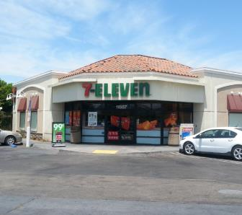

7-ELEVEN at 11887 MAGNOLIA AVENUE, RIVERSIDE, CA

How often do you go to the store at THIS ADDRESS?

Never 0

Once a month 1

2-3 times a month 2

Once a week 3

2-3 times a week 4

Almost every day 5

(picture fake.jpg)

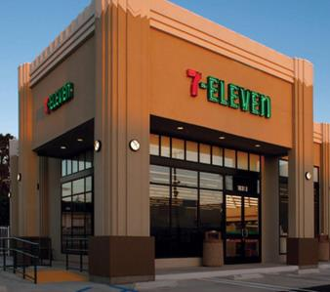

7-ELEVEN at 11860 MAGNOLIA AVENUE, RIVERSIDE, CA

How often do you go to the store at THIS ADDRESS?

Never 0

Once a month 1

2-3 times a month 2

Once a week 3

2-3 times a week 4

Almost every day 5

**Amistad (ID: 214)**

(picture fake.jpg)



7-ELEVEN at 44320 JACKSON STREET, INDIO, CA

How often do you go to the store at THIS ADDRESS?

Never 0

Once a month 1

2-3 times a month 2

Once a week 3

2-3 times a week 4

Almost every day 5

**Back Bay (ID: 197)**

(picture fake.jpg)

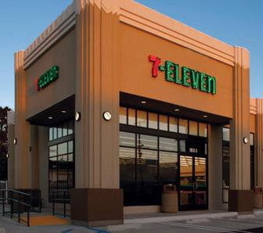

7-ELEVEN at 2651 IRVINE AVENUE, COSTA MESA, CA

How often do you go to the store at THIS ADDRESS?

Never 0

Once a month 1

2-3 times a month 2

Once a week 3

2-3 times a week 4

Almost every day 5

**Buena Park (ID: 186)**

(picture 186-58872.jpg)

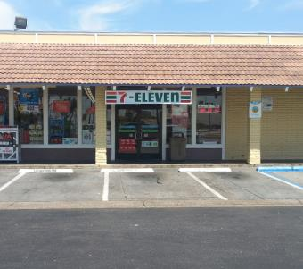

7-ELEVEN at 8725 ORANGETHORPE AVENUE, BUENA PARK, CA

How often do you go to the store at THIS ADDRESS?

Never 0

Once a month 1

2-3 times a month 2

Once a week 3

2-3 times a week 4

Almost every day 5

(picture 186-58873.jpg)

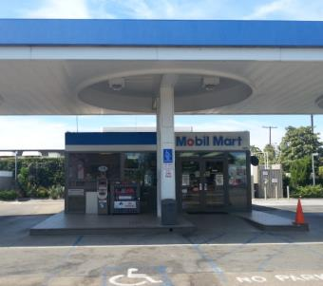

MOBIL at 8991 ORANGETHORPE AVENUE, BUENA PARK, CA

How often do you go to the store at THIS ADDRESS?

Never 0

Once a month 1

2-3 times a month 2

Once a week 3

2-3 times a week 4

Almost every day 5

(picture fake.jpg)



7-ELEVEN at 2627 WEST ORANGETHORPE AVENUE, FULLERTON, CA

How often do you go to the store at THIS ADDRESS?

Never 0

Once a month 1

2-3 times a month 2

Once a week 3

2-3 times a week 4

Almost every day 5

**Canyon Oaks (ID: 165)**

(picture 165-59571.jpg)

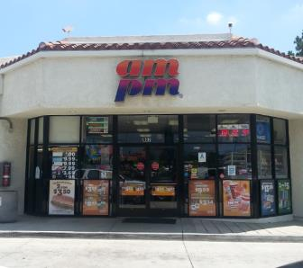

AM/PM at 902 HUNTINGTON DRIVE, DUARTE, CA

How often do you go to the store at THIS ADDRESS?

Never 0

Once a month 1

2-3 times a month 2

Once a week 3

2-3 times a week 4

Almost every day 5

(picture 165-59575.jpg)

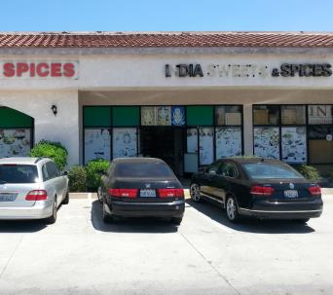

INDIA SWEETS & SPICES at 1208 HUNTINGTON DRIVE, DUARTE, CA

How often do you go to the store at THIS ADDRESS?

Never 0

Once a month 1

2-3 times a month 2

Once a week 3

2-3 times a week 4

Almost every day 5

(picture 165-62797.jpg)

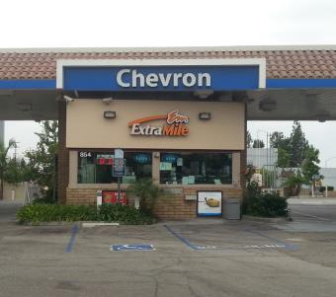

CHEVRON at 854 EAST HUNTINGTON DRIVE, MONROVIA, CA

How often do you go to the store at THIS ADDRESS?

Never 0

Once a month 1

2-3 times a month 2

Once a week 3

2-3 times a week 4

Almost every day 5

(picture 165-62798.jpg)

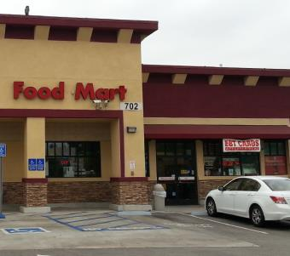

SHELL at 702 EAST HUNTINGTON DRIVE, MONROVIA, CA

How often do you go to the store at THIS ADDRESS?

Never 0

Once a month 1

2-3 times a month 2

Once a week 3

2-3 times a week 4

Almost every day 5

(picture 165-68622.jpg)

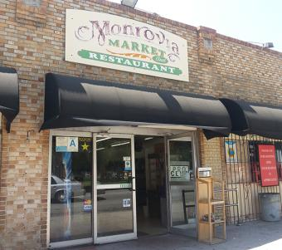

MONROVIA MARKET AND RESTAURANT at 525 SOUTH SHAMROCK AVENUE, MONROVIA, CA

How often do you go to the store at THIS ADDRESS?

Never 0

Once a month 1

2-3 times a month 2

Once a week 3

2-3 times a week 4

Almost every day 5

(picture fake.jpg)



7-ELEVEN at 831 EAST HUNTINGTON DRIVE, MONROVA, CA

How often do you go to the store at THIS ADDRESS?

Never 0

Once a month 1

2-3 times a month 2

Once a week 3

2-3 times a week 4

Almost every day 5

**Centinela Valley (ID: 115)**

(picture 115-60856.jpg)

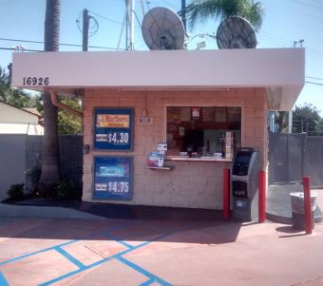

76 at 16926 HAWTHORNE BOULEVARD, LAWNDALE, CA

How often do you go to the store at THIS ADDRESS?

Never 0

Once a month 1

2-3 times a month 2

Once a week 3

2-3 times a week 4

Almost every day 5

(picture 115-60872.jpg)

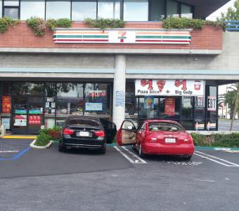

7-ELEVEN at 4401 REDONDO BEACH BOULEVARD, LAWNDALE, CA

How often do you go to the store at THIS ADDRESS?

Never 0

Once a month 1

2-3 times a month 2

Once a week 3

2-3 times a week 4

Almost every day 5

(picture fake.jpg)



7-ELEVEN at 4641 ARTESIA BOULEVARD, LAWNDALE, CA

How often do you go to the store at THIS ADDRESS?

Never 0

Once a month 1

2-3 times a month 2

Once a week 3

2-3 times a week 4

Almost every day 5

**Central (ID: 232)**

(picture 232-68687.jpg)

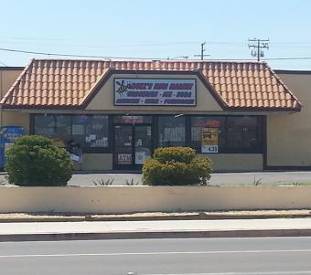

BUZZ'S MINI MARKET at 100 EAST MAIN STREET, BARSTOW, CA

How often do you go to the store at THIS ADDRESS?

Never 0

Once a month 1

2-3 times a month 2

Once a week 3

2-3 times a week 4

Almost every day 5

(picture 232-70528.jpg)

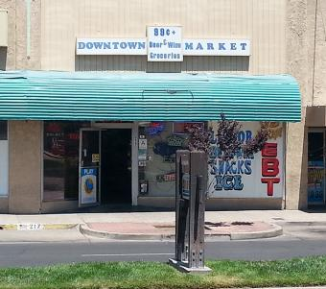

DOWNTOWN MARKET at 219 EAST MAIN STREET, BARSTOW, CA

How often do you go to the store at THIS ADDRESS?

Never 0

Once a month 1

2-3 times a month 2

Once a week 3

2-3 times a week 4

Almost every day 5

(picture 232-70809.jpg)

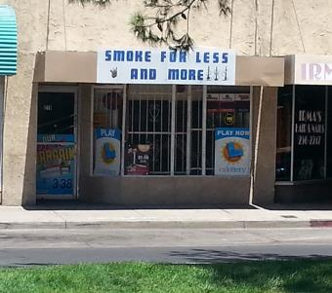

SMOKE FOR LESS AND MORE at 217 EAST MAIN STREET, BARSTOW, CA

How often do you go to the store at THIS ADDRESS?

Never 0

Once a month 1

2-3 times a month 2

Once a week 3

2-3 times a week 4

Almost every day 5

(picture fake.jpg)



7-ELEVEN at 524 EAST MAIN STREET, BARSTOW, CA

How often do you go to the store at THIS ADDRESS?

Never 0

Once a month 1

2-3 times a month 2

Once a week 3

2-3 times a week 4

Almost every day 5

**Chaparral (ID: 113)**

(picture 113-63814.jpg)

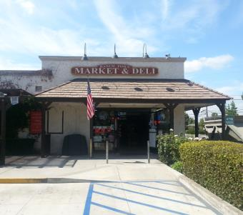

RANCH TOWN MARKET & DELI at 1112 NORTH SAN DIMAS AVENUE, SAN DIMAS, CA

How often do you go to the store at THIS ADDRESS?

Never 0

Once a month 1

2-3 times a month 2

Once a week 3

2-3 times a week 4

Almost every day 5

(picture fake.jpg)



7-ELEVEN at 409 WEST ALLEN AVENUE, SAN DIMAS, CA

How often do you go to the store at THIS ADDRESS?

Never 0

Once a month 1

2-3 times a month 2

Once a week 3

2-3 times a week 4

Almost every day 5

**Community (ID: 280)**

(picture fake.jpg)



7-ELEVEN at 6144 CONDOR DRIVE, MOORPARK, CA

How often do you go to the store at THIS ADDRESS?

Never 0

Once a month 1

2-3 times a month 2

Once a week 3

2-3 times a week 4

Almost every day 5

**Conejo Valley (ID: 278)**

(picture 278-52693.jpg)

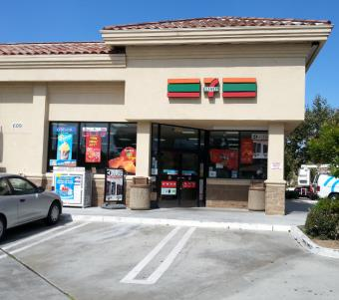

7-ELEVEN at 609 RANCHO CONEJO BOULEVARD, THOUSAND OAKS, CA

How often do you go to the store at THIS ADDRESS?

Never 0

Once a month 1

2-3 times a month 2

Once a week 3

2-3 times a week 4

Almost every day 5

(picture 278-52695.jpg)

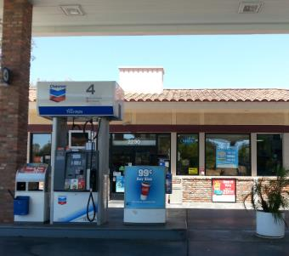

CHEVRON at 2290 BORCHARD ROAD, NEWBURY PARK, CA

How often do you go to the store at THIS ADDRESS?

Never 0

Once a month 1

2-3 times a month 2

Once a week 3

2-3 times a week 4

Almost every day 5

(picture 278-52697.jpg)

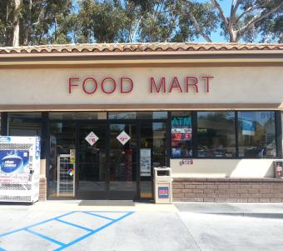

FOOD MART at 518 RANCHO CONEJO BOULEVARD, NEWBURY PARK, CA

How often do you go to the store at THIS ADDRESS?

Never 0

Once a month 1

2-3 times a month 2

Once a week 3

2-3 times a week 4

Almost every day 5

(picture 278-52700.jpg)

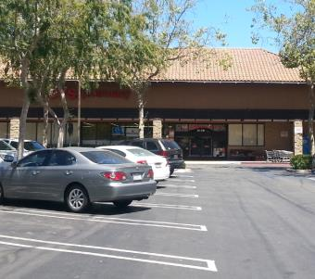

CVS at 2120 NEWBURY ROAD, NEWBURY PARK, CA

How often do you go to the store at THIS ADDRESS?

Never 0

Once a month 1

2-3 times a month 2

Once a week 3

2-3 times a week 4

Almost every day 5

(picture 278-52703.jpg)

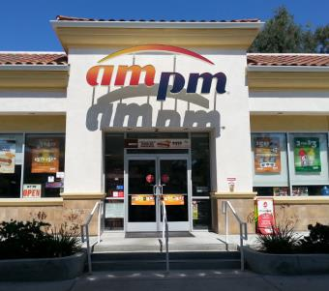

AM/PM at 2305 BORCHARD ROAD, NEWBURY PARK, CA

How often do you go to the store at THIS ADDRESS?

Never 0

Once a month 1

2-3 times a month 2

Once a week 3

2-3 times a week 4

Almost every day 5

(picture fake.jpg)



7-ELEVEN at 1620 NEWBURY ROAD, NEWBURY PARK, CA

How often do you go to the store at THIS ADDRESS?

Never 0

Once a month 1

2-3 times a month 2

Once a week 3

2-3 times a week 4

Almost every day 5

**Desert Winds (ID: 108)**

(picture 108-54276.jpg)

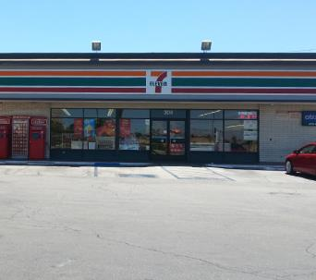

7-ELEVEN at 304 EAST AVENUE I, LANCASTER, CA

How often do you go to the store at THIS ADDRESS?

Never 0

Once a month 1

2-3 times a month 2

Once a week 3

2-3 times a week 4

Almost every day 5

(picture 108-65625.jpg)

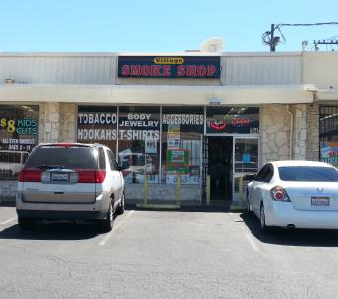

SMOKE SHOP at 326 EAST AVENUE I, LANCASTER, CA

How often do you go to the store at THIS ADDRESS?

Never 0

Once a month 1

2-3 times a month 2

Once a week 3

2-3 times a week 4

Almost every day 5

(picture 108-68457.jpg)

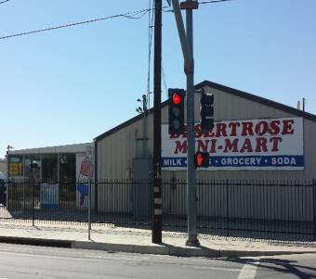

DESERT ROSE MINI MART at 106 WEST AVENUE I, LANCASTER, CA

How often do you go to the store at THIS ADDRESS?

Never 0

Once a month 1

2-3 times a month 2

Once a week 3

2-3 times a week 4

Almost every day 5

(picture 108-69149.jpg)

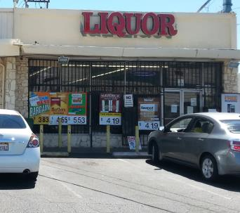

VILLAGE LIQUOR at 332 EAST AVENUE I, LANCASTER, CA

How often do you go to the store at THIS ADDRESS?

Never 0

Once a month 1

2-3 times a month 2

Once a week 3

2-3 times a week 4

Almost every day 5

(picture fake.jpg)



7-ELEVEN at 105 WEST AVENUE I, LANCASTER, CA

How often do you go to the store at THIS ADDRESS?

Never 0

Once a month 1

2-3 times a month 2

Once a week 3

2-3 times a week 4

Almost every day 5

**Fairvalley (ID: 117)**

(picture 117-53969.jpg)

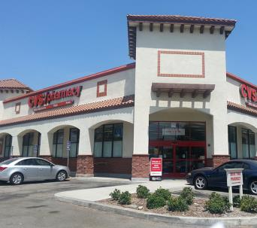

CVS at 915 EAST ARROW HIGHWAY, AZUSA, CA

How often do you go to the store at THIS ADDRESS?

Never 0

Once a month 1

2-3 times a month 2

Once a week 3

2-3 times a week 4

Almost every day 5

(picture 117-59375.jpg)

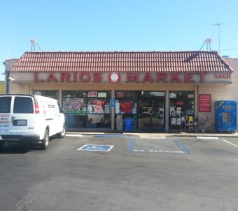

LARIOS MARKET at 19004 EAST ARROW HIGHWAY, COVINA, CA

How often do you go to the store at THIS ADDRESS?

Never 0

Once a month 1

2-3 times a month 2

Once a week 3

2-3 times a week 4

Almost every day 5

(picture 117-59383.jpg)

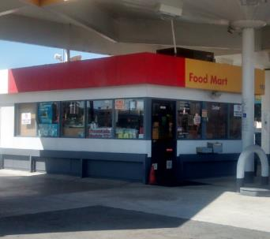

SHELL at 110 WEST ARROW HIGHWAY, COVINA, CA

How often do you go to the store at THIS ADDRESS?

Never 0

Once a month 1

2-3 times a month 2

Once a week 3

2-3 times a week 4

Almost every day 5

(picture fake.jpg)



7-ELEVEN at 1385 NORTH CITRUS AVENUE, COVINA, CA

How often do you go to the store at THIS ADDRESS?

Never 0

Once a month 1

2-3 times a month 2

Once a week 3

2-3 times a week 4

Almost every day 5

**Hillview (ID: 206)**

(picture 206-68332.jpg)

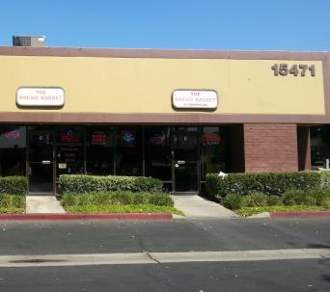

THE BREAD BASKET at 15471 RED HILL AVENUE, TUSTIN, CA

How often do you go to the store at THIS ADDRESS?

Never 0

Once a month 1

2-3 times a month 2

Once a week 3

2-3 times a week 4

Almost every day 5

(picture fake.jpg)



7-ELEVEN at 15052 RED HILL AVENUE, TUSTIN, CA

How often do you go to the store at THIS ADDRESS?

Never 0

Once a month 1

2-3 times a month 2

Once a week 3

2-3 times a week 4

Almost every day 5

**Jack London (ID: 139)**

(picture fake.jpg)



7-ELEVEN at 12500 OXNARD STREET, VAN NUYS, CA

How often do you go to the store at THIS ADDRESS?

Never 0

Once a month 1

2-3 times a month 2

Once a week 3

2-3 times a week 4

Almost every day 5

**Middle College (ID: 246)**

(picture 246-55040.jpg)

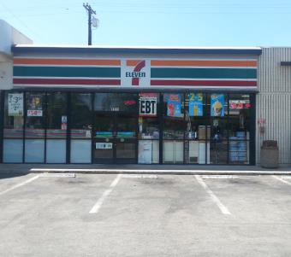

7-ELEVEN at 1511 NORTH MOUNT VERNON AVENUE, COLTON, CA

How often do you go to the store at THIS ADDRESS?

Never 0

Once a month 1

2-3 times a month 2

Once a week 3

2-3 times a week 4

Almost every day 5

(picture 246-56972.jpg)

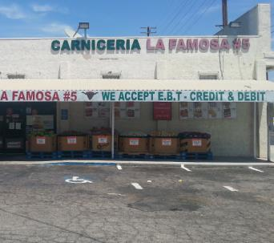

LA FAMOSA MARKET at 390 SOUTH MOUNT VERNON AVENUE, SAN BERNARDINO, CA

How often do you go to the store at THIS ADDRESS?

Never 0

Once a month 1

2-3 times a month 2

Once a week 3

2-3 times a week 4

Almost every day 5

(picture 246-67442.jpg)

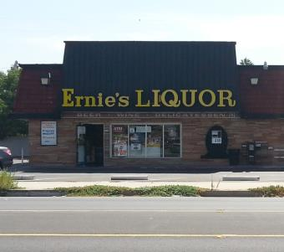

ERNIE'S LIQUOR at 539 SOUTH MOUNT VERNON AVENUE, SAN BERNARDINO, CA

How often do you go to the store at THIS ADDRESS?

Never 0

Once a month 1

2-3 times a month 2

Once a week 3

2-3 times a week 4

Almost every day 5

(picture 246-69891.jpg)

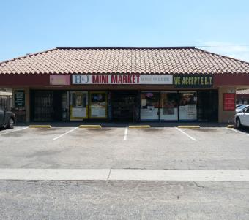

H&J MINI MARKET at 509 SOUTH MOUNT VERNON AVENUE, SAN BERNARDINO, CA

How often do you go to the store at THIS ADDRESS?

Never 0

Once a month 1

2-3 times a month 2

Once a week 3

2-3 times a week 4

Almost every day 5

(picture 246-70973.jpg)

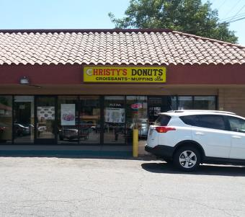

CHRISTY'S DONUTS at 1292 WEST MILL STREET, SAN BERNARDINO, CA

How often do you go to the store at THIS ADDRESS?

Never 0

Once a month 1

2-3 times a month 2

Once a week 3

2-3 times a week 4

Almost every day 5

(picture fake.jpg)



7-ELEVEN at 1791 NORTH MOUNT VERNON AVENUE, COLTON, CA

How often do you go to the store at THIS ADDRESS?

Never 0

Once a month 1

2-3 times a month 2

Once a week 3

2-3 times a week 4

Almost every day 5

**Mojave (ID: 254)**

(picture fake.jpg)



7-ELEVEN at 10924 HESPERIA ROAD, HESPERIA, CA

How often do you go to the store at THIS ADDRESS?

Never 0

Once a month 1

2-3 times a month 2

Once a week 3

2-3 times a week 4

Almost every day 5

**Monterey (ID: 114)**

(picture 114-58945.jpg)

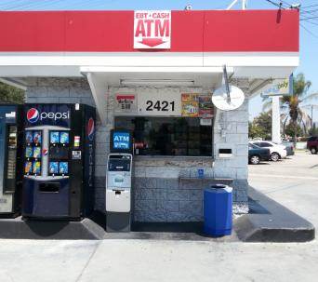

76 at 2421 WEST VICTORY BOULEVARD, BURBANK, CA

How often do you go to the store at THIS ADDRESS?

Never 0

Once a month 1

2-3 times a month 2

Once a week 3

2-3 times a week 4

Almost every day 5

(picture fake.jpg)



7-ELEVEN at 2457 WEST VICTORY BOULEVARD, BURBANK, CA

How often do you go to the store at THIS ADDRESS?

Never 0

Once a month 1

2-3 times a month 2

Once a week 3

2-3 times a week 4

Almost every day 5

**Mountain (ID: 244)**

(picture fake.jpg)



7-ELEVEN at 24835 LAKE DRIVE, CRESTLINE, CA

How often do you go to the store at THIS ADDRESS?

Never 0

Once a month 1

2-3 times a month 2

Once a week 3

2-3 times a week 4

Almost every day 5

**Mountain View (ID: 224)**

(picture 224-57859.jpg)

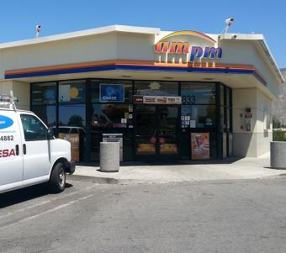

AM/PM at 833 NORTH RAMONA BOULEVARD, SAN JACINTO, CA

How often do you go to the store at THIS ADDRESS?

Never 0

Once a month 1

2-3 times a month 2

Once a week 3

2-3 times a week 4

Almost every day 5

(picture 224-57860.jpg)

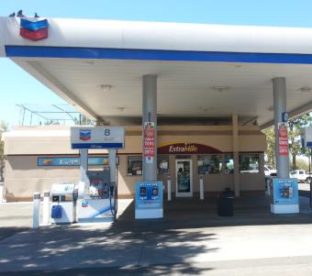

CHEVRON at 720 WEST RAMONA EXPRESSWAY, SAN JACINTO, CA

How often do you go to the store at THIS ADDRESS?

Never 0

Once a month 1

2-3 times a month 2

Once a week 3

2-3 times a week 4

Almost every day 5

(picture 224-57868.jpg)

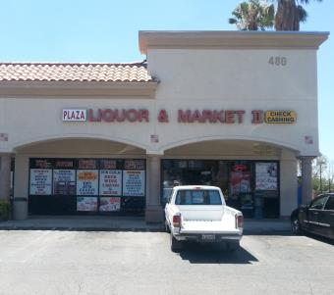

PLAZA LIQUOR & MARKET II at 480 NORTH STATE STREET, SAN JACINTO, CA

How often do you go to the store at THIS ADDRESS?

Never 0

Once a month 1

2-3 times a month 2

Once a week 3

2-3 times a week 4

Almost every day 5

(picture 224-65367.jpg)

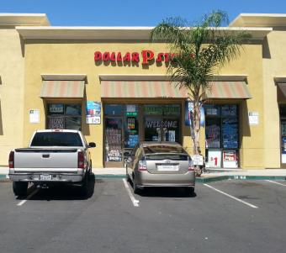

DOLLAR STORE at 651 NORTH STATE STREET, SAN JACINTO, CA

How often do you go to the store at THIS ADDRESS?

Never 0

Once a month 1

2-3 times a month 2

Once a week 3

2-3 times a week 4

Almost every day 5

(picture 224-66693.jpg)

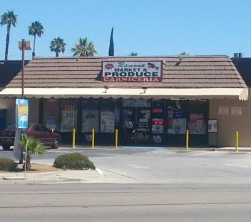

RAMONA MARKET AND PRODUCE at 794 NORTH RAMONA BOULEVARD, SAN JACINTO, CA

How often do you go to the store at THIS ADDRESS?

Never 0

Once a month 1

2-3 times a month 2

Once a week 3

2-3 times a week 4

Almost every day 5

(picture fake.jpg)



7-ELEVEN at 464 NORTH STATE STREET, SAN JACINTO, CA

How often do you go to the store at THIS ADDRESS?

Never 0

Once a month 1

2-3 times a month 2

Once a week 3

2-3 times a week 4

Almost every day 5

**North Park (ID: 111)**

(picture 111-58637.jpg)

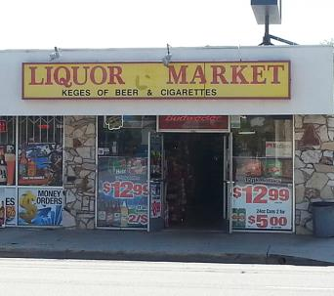

LIQUOR MARKET at 4503 MAINE AVENUE, BALDWIN PARK, CA

How often do you go to the store at THIS ADDRESS?

Never 0

Once a month 1

2-3 times a month 2

Once a week 3

2-3 times a week 4

Almost every day 5

(picture 111-58651.jpg)

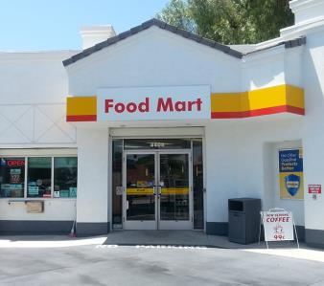

SHELL at 4405 MAINE AVENUE, BALDWIN PARK, CA

How often do you go to the store at THIS ADDRESS?

Never 0

Once a month 1

2-3 times a month 2

Once a week 3

2-3 times a week 4

Almost every day 5

(picture 111-58653.jpg)

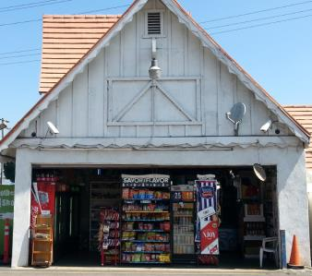

ROCKVIEW DAIRY at 4390 MAINE AVENUE, BALDWIN PARK, CA

How often do you go to the store at THIS ADDRESS?

Never 0

Once a month 1

2-3 times a month 2

Once a week 3

2-3 times a week 4

Almost every day 5

(picture 111-58681.jpg)

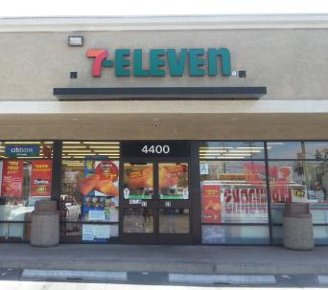

7-ELEVEN at 4400 MAINE AVENUE, BALDWIN PARK, CA

How often do you go to the store at THIS ADDRESS?

Never 0

Once a month 1

2-3 times a month 2

Once a week 3

2-3 times a week 4

Almost every day 5

(picture 111-58682.jpg)

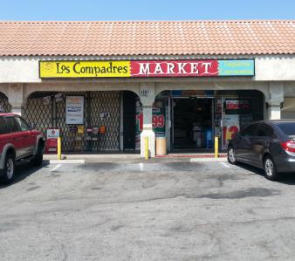

LOS COMPADRES MARKET at 4801 MAINE AVENUE, BALDWIN PARK, CA

How often do you go to the store at THIS ADDRESS?

Never 0

Once a month 1

2-3 times a month 2

Once a week 3

2-3 times a week 4

Almost every day 5

(picture 111-68637.jpg)

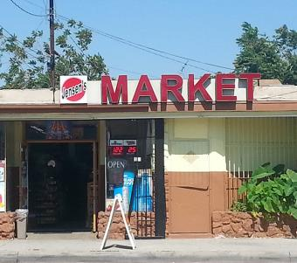

JENSEN'S MARKET at 4724 MAINE AVENUE, BALDWIN PARK, CA

How often do you go to the store at THIS ADDRESS?

Never 0

Once a month 1

2-3 times a month 2

Once a week 3

2-3 times a week 4

Almost every day 5

(picture fake.jpg)



7-ELEVEN at 14394 CLARK STREET, BALDWIN PARK, CA

How often do you go to the store at THIS ADDRESS?

Never 0

Once a month 1

2-3 times a month 2

Once a week 3

2-3 times a week 4

Almost every day 5

**Oak View (ID: 250)**

(picture fake.jpg)



7-ELEVEN at 12137 5TH STREET YUCAIPA, CA

How often do you go to the store at THIS ADDRESS?

Never 0

Once a month 1

2-3 times a month 2

Once a week 3

2-3 times a week 4

Almost every day 5

**Ortega (ID: 226)**

(picture fake.jpg)



7-ELEVEN at 31295 CHANEY STREET, LAKE ELSINORE, CA

How often do you go to the store at THIS ADDRESS?

Never 0

Once a month 1

2-3 times a month 2

Once a week 3

2-3 times a week 4

Almost every day 5

**Pacific (ID: 276)**

(picture 276-53784.jpg)

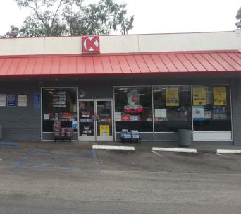

CIRCLE K at 3506 EAST MAIN STREET, VENTURA, CA

How often do you go to the store at THIS ADDRESS?

Never 0

Once a month 1

2-3 times a month 2

Once a week 3

2-3 times a week 4

Almost every day 5

(picture 276-53811.jpg)

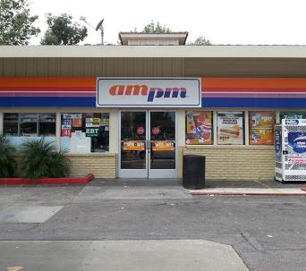

AM/PM at 605 SOUTH MILLS ROAD, VENTURA, CA

How often do you go to the store at THIS ADDRESS?

Never 0

Once a month 1

2-3 times a month 2

Once a week 3

2-3 times a week 4

Almost every day 5

(picture 276-66640.jpg)

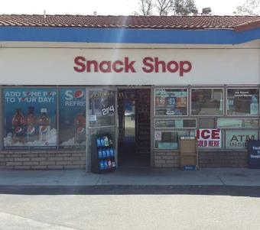

MOBIL at 3500 EAST MAIN STREET, VENTURA, CA

How often do you go to the store at THIS ADDRESS?

Never 0

Once a month 1

2-3 times a month 2

Once a week 3

2-3 times a week 4

Almost every day 5

(picture fake.jpg)



7-ELEVEN at 3748 TELEGRAPH ROAD, VENTURA, CA

How often do you go to the store at THIS ADDRESS?

Never 0

Once a month 1

2-3 times a month 2

Once a week 3

2-3 times a week 4

Almost every day 5

**Phoenix (North) (ID: 283)**

(picture fake.jpg)



7-ELEVEN at 220 WEST AVENUE H6, LANCASTER, CA

How often do you go to the store at THIS ADDRESS?

Never 0

Once a month 1

2-3 times a month 2

Once a week 3

2-3 times a week 4

Almost every day 5

**Phoenix (South) (ID: 282)**

(picture fake.jpg)



7-ELEVEN at 38815 20TH STREET EAST, PALMDALE, CA

How often do you go to the store at THIS ADDRESS?

Never 0

Once a month 1

2-3 times a month 2

Once a week 3

2-3 times a week 4

Almost every day 5

**R. K. Lloyde (ID: 116)**

(picture 116-60858.jpg)

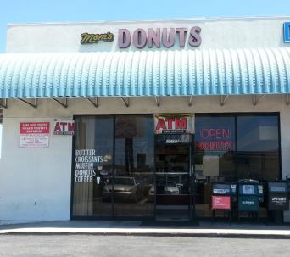

MOM'S DONUTS at 15102 INGLEWOOD AVENUE, LAWNDALE, CA

How often do you go to the store at THIS ADDRESS?

Never 0

Once a month 1

2-3 times a month 2

Once a week 3

2-3 times a week 4

Almost every day 5

(picture 116-63733.jpg)

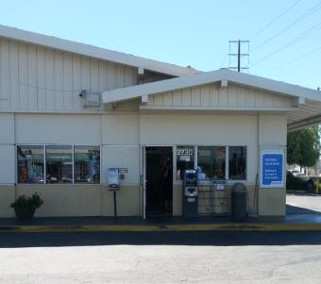

ARCO at 2730 MARINE AVENUE, REDONDO BEACH, CA

How often do you go to the store at THIS ADDRESS?

Never 0

Once a month 1

2-3 times a month 2

Once a week 3

2-3 times a week 4

Almost every day 5

(picture 116-67948.jpg)

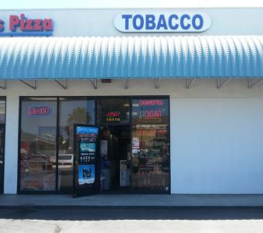

INTERNATIONAL TOBACCO at 15116 INGLEWOOD AVENUE, LAWNDALE, CA

How often do you go to the store at THIS ADDRESS?

Never 0

Once a month 1

2-3 times a month 2

Once a week 3

2-3 times a week 4

Almost every day 5

(picture fake.jpg)



7-ELEVEN at 3859 INGLEWOOD AVENUE, REDONDO BEACH, CA

How often do you go to the store at THIS ADDRESS?

Never 0

Once a month 1

2-3 times a month 2

Once a week 3

2-3 times a week 4

Almost every day 5

**Rex Parris (ID: 109)**

(picture fake.jpg)



7-ELEVEN at 38712 6TH STREET E, PALMDALE, CA

How often do you go to the store at THIS ADDRESS?

Never 0

Once a month 1

2-3 times a month 2

Once a week 3

2-3 times a week 4

Almost every day 5

**Rose City (ID: 171)**

(picture 171-63364.jpg)

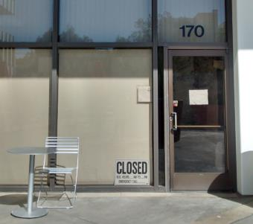

PLAZA CAFE at 251 SOUTH LAKE AVENUE, PASADENA, CA

How often do you go to the store at THIS ADDRESS?

Never 0

Once a month 1

2-3 times a month 2

Once a week 3

2-3 times a week 4

Almost every day 5

(picture 171-63365.jpg)

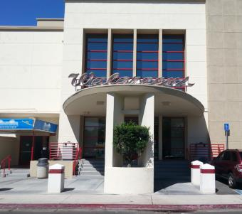

WALGREENS at 310 SOUTH LAKE AVENUE, PASADENA, CA

How often do you go to the store at THIS ADDRESS?

Never 0

Once a month 1

2-3 times a month 2

Once a week 3

2-3 times a week 4

Almost every day 5

(picture 171-63367.jpg)

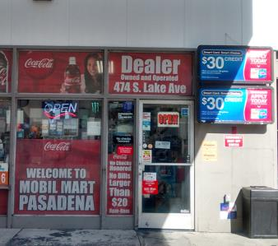

MOBIL at 474 SOUTH LAKE AVENUE, PASADENA, CA

How often do you go to the store at THIS ADDRESS?

Never 0

Once a month 1

2-3 times a month 2

Once a week 3

2-3 times a week 4

Almost every day 5

(picture 171-65547.jpg)

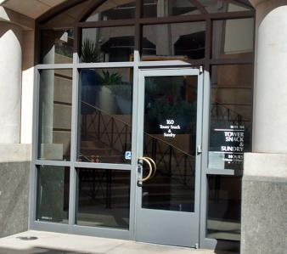

TOWER SNACK & SUNDRY at 55 SOUTH LAKE AVENUE, PASADENA, CA

How often do you go to the store at THIS ADDRESS?

Never 0

Once a month 1

2-3 times a month 2

Once a week 3

2-3 times a week 4

Almost every day 5

(picture 171-67504.jpg)

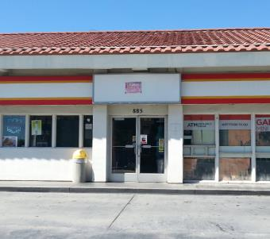

GARY'S MINI MART at 885 EAST CALIFORNIA BOULEVARD, PASADENA, CA

How often do you go to the store at THIS ADDRESS?

Never 0

Once a month 1

2-3 times a month 2

Once a week 3

2-3 times a week 4

Almost every day 5

(picture fake.jpg)

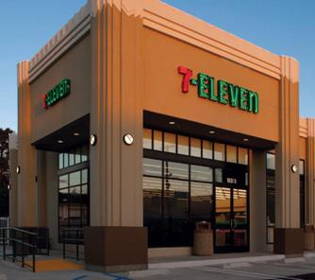

7-ELEVEN at 805 EAST COLORADO BOULEVARD, PASADENA, CA

How often do you go to the store at THIS ADDRESS?

Never 0

Once a month 1

2-3 times a month 2

Once a week 3

2-3 times a week 4

Almost every day 5

**Santana (ID: 181)**

(picture fake.jpg)



7-ELEVEN at 627 LA SEDA ROAD, LA PUENTE, CA

How often do you go to the store at THIS ADDRESS?

Never 0

Once a month 1

2-3 times a month 2

Once a week 3

2-3 times a week 4

Almost every day 5

**Sherry (ID: 174)**

(picture fake.jpg)



7-ELEVEN at 22511 CRENSHAW BOULEVARD, TORRANCE, CA

How often do you go to the store at THIS ADDRESS?

Never 0

Once a month 1

2-3 times a month 2

Once a week 3

2-3 times a week 4

Almost every day 5

**Somerset (ID: 112)**

(picture 112-58780.jpg)

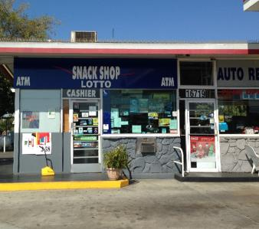

76 at 16719 LAKEWOOD BOULEVARD, BELLFLOWER, CA

How often do you go to the store at THIS ADDRESS?

Never 0

Once a month 1

2-3 times a month 2

Once a week 3

2-3 times a week 4

Almost every day 5

(picture 112-65767.jpg)

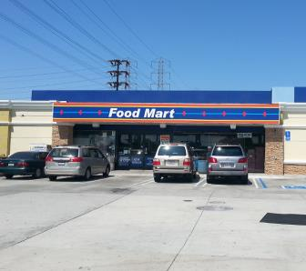

ARCO at 17020 LAKEWOOD BOULEVARD, BELLFLOWER, CA

How often do you go to the store at THIS ADDRESS?

Never 0

Once a month 1

2-3 times a month 2

Once a week 3

2-3 times a week 4

Almost every day 5

(picture 112-70582.jpg)

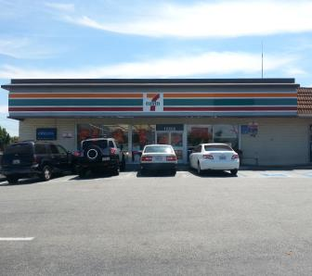

7-ELEVEN at 16852 LAKEWOOD BOULEVARD, BELLFLOWER, CA

How often do you go to the store at THIS ADDRESS?

Never 0

Once a month 1

2-3 times a month 2

Once a week 3

2-3 times a week 4

Almost every day 5

(picture fake.jpg)



7-ELEVEN at 16917 LAKEWOOD BOULEVARD, BELLFLOWER, CA

How often do you go to the store at THIS ADDRESS?

Never 0

Once a month 1

2-3 times a month 2

Once a week 3

2-3 times a week 4

Almost every day 5

**Tracy (ID: 105)**

(picture 105-59005.jpg)

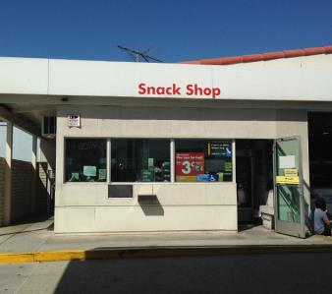

SHELL at 16821 NORWALK BOULEVARD, CERRITOS, CA

How often do you go to the store at THIS ADDRESS?

Never 0

Once a month 1

2-3 times a month 2

Once a week 3

2-3 times a week 4

Almost every day 5

(picture 105-59012.jpg)

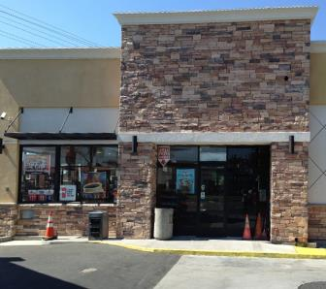

ARCO at 12157 ARTESIA BOULEVARD, CERRITOS, CA

How often do you go to the store at THIS ADDRESS?

Never 0

Once a month 1

2-3 times a month 2

Once a week 3

2-3 times a week 4

Almost every day 5

(picture 105-59021.jpg)

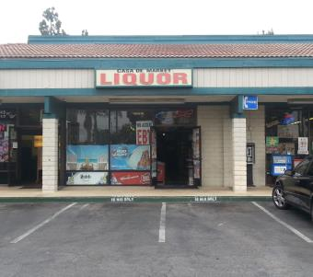

CASA DE MARKET at 16432 NORWALK BOULEVARD, CERRITOS, CA

How often do you go to the store at THIS ADDRESS?

Never 0

Once a month 1

2-3 times a month 2

Once a week 3

2-3 times a week 4

Almost every day 5

(picture 105-68957.jpg)

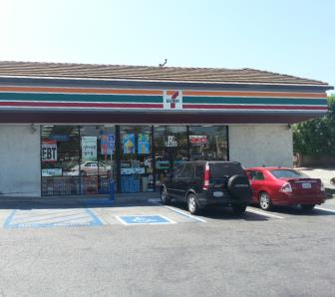

7-ELEVEN at 12200 ARTESIA BOULEVARD, ARTESIA, CA

How often do you go to the store at THIS ADDRESS?

Never 0

Once a month 1

2-3 times a month 2

Once a week 3

2-3 times a week 4

Almost every day 5

(picture fake.jpg)



7-ELEVEN at 17198 NORWALK BOULEVARD, CERRITOS, CA

How often do you go to the store at THIS ADDRESS?

Never 0

Once a month 1

2-3 times a month 2

Once a week 3

2-3 times a week 4

Almost every day 5

**Val Verde (ID: 229)**

(picture fake.jpg)



7-ELEVEN at 3601 BRENNAN AVENUE, PERRIS, CA

How often do you go to the store at THIS ADDRESS?

Never 0

Once a month 1

2-3 times a month 2

Once a week 3

2-3 times a week 4

Almost every day 5

**Valley Vista (ID: 195)**

(picture 195-59665.jpg)

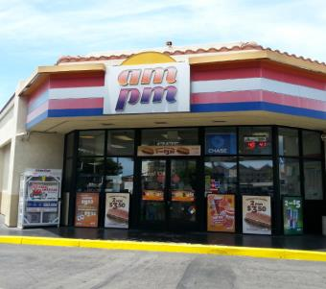

AM/PM at 17475 BROOKHURST STREET, FOUNTAIN VALLEY, CA

How often do you go to the store at THIS ADDRESS?

Never 0

Once a month 1

2-3 times a month 2

Once a week 3

2-3 times a week 4

Almost every day 5

(picture 195-59666.jpg)



ARCO at 17520 BROOKHURST STREET, FOUNTAIN VALLEY, CA

How often do you go to the store at THIS ADDRESS?

Never 0

Once a month 1

2-3 times a month 2

Once a week 3

2-3 times a week 4

Almost every day 5

(picture fake.jpg)



7-ELEVEN at 10000 SLATER AVENUE, FOUNTAIN VALLEY, CA

How often do you go to the store at THIS ADDRESS?

Never 0

Once a month 1

2-3 times a month 2

Once a week 3

2-3 times a week 4

Almost every day 5

**Youth Opportunities (ID: 161)**

(picture 161-62403.jpg)

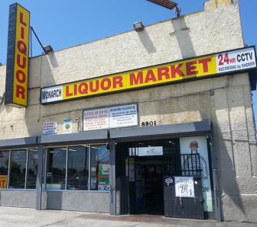

LIQUOR MARKET at 8801 SOUTH VERMONT AVENUE, LOS ANGELES, CA

How often do you go to the store at THIS ADDRESS?

Never 0

Once a month 1

2-3 times a month 2

Once a week 3

2-3 times a week 4

Almost every day 5

(picture 161-62407.jpg)

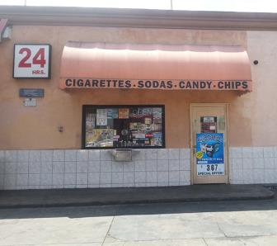

ARCO at 800 WEST MANCHESTER AVENUE, LOS ANGELES, CA

How often do you go to the store at THIS ADDRESS?

Never 0

Once a month 1

2-3 times a month 2

Once a week 3

2-3 times a week 4

Almost every day 5

(picture 161-67145.jpg)

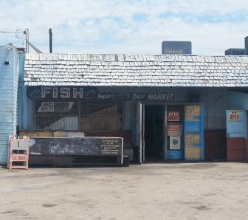

MANCHESTER FISH at 1059 WEST MANCHESTER AVENUE, LOS ANGELES, CA

How often do you go to the store at THIS ADDRESS?

Never 0

Once a month 1

2-3 times a month 2

Once a week 3

2-3 times a week 4

Almost every day 5

(picture 161-67603.jpg)

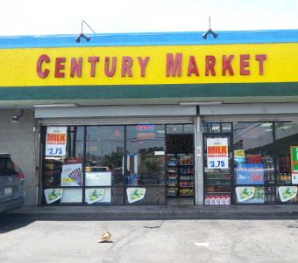

CENTURY MARKET at 8453 SOUTH FIGUEROA STREET, LOS ANGELES, CA

How often do you go to the store at THIS ADDRESS?

Never 0

Once a month 1

2-3 times a month 2

Once a week 3

2-3 times a week 4

Almost every day 5

(picture 161-67613.jpg)

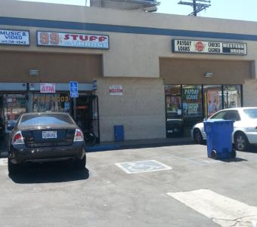

99 CENT STUFF & THANGS at 8608 SOUTH VERMONT AVENUE, LOS ANGELES, CA

How often do you go to the store at THIS ADDRESS?

Never 0

Once a month 1

2-3 times a month 2

Once a week 3

2-3 times a week 4

Almost every day 5

(picture 161-67932.jpg)

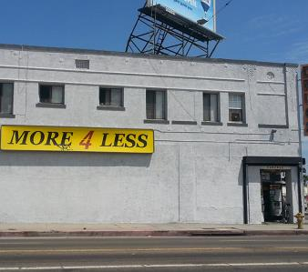

MORE 4 LESS at 1011 WEST MANCHESTER AVENUE, LOS ANGELES, CA

How often do you go to the store at THIS ADDRESS?

Never 0

Once a month 1

2-3 times a month 2

Once a week 3

2-3 times a week 4

Almost every day 5

(picture 161-68042.jpg)

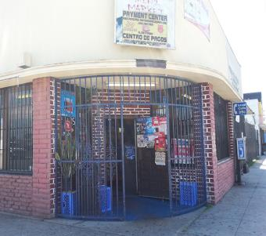

ANGELS MINI-MARKET at 8500 SOUTH HOOVER STREET, LOS ANGELES, CA

How often do you go to the store at THIS ADDRESS?

Never 0

Once a month 1

2-3 times a month 2

Once a week 3

2-3 times a week 4

Almost every day 5

(picture 161-68422.jpg)

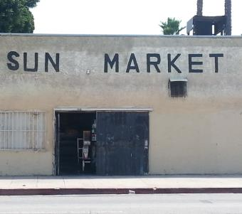

SUN MARKET at 8107 SOUTH HOOVER STREET, LOS ANGELES, CA

How often do you go to the store at THIS ADDRESS?

Never 0

Once a month 1

2-3 times a month 2

Once a week 3

2-3 times a week 4

Almost every day 5

(picture 161-69978.jpg)

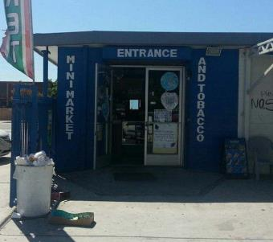

LUCKY MINI MARKET & TOBACCO at 1111 WEST MANCHESTER AVENUE, LOS ANGELES, CA

How often do you go to the store at THIS ADDRESS?

Never 0

Once a month 1

2-3 times a month 2

Once a week 3

2-3 times a week 4

Almost every day 5

(picture 161-70307.jpg)

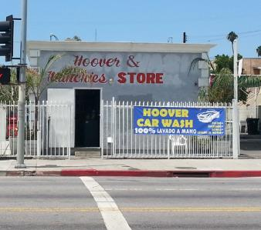

HOOVER & MUNCHIES STORE at 803 WEST 83RD STREET, LOS ANGELES, CA

How often do you go to the store at THIS ADDRESS?

Never 0

Once a month 1

2-3 times a month 2

Once a week 3

2-3 times a week 4

Almost every day 5

(picture 161-70361.jpg)

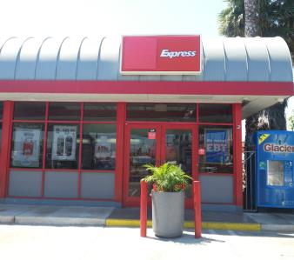

76 at 400 WEST MANCHESTER AVENUE, LOS ANGELES, CA

How often do you go to the store at THIS ADDRESS?

Never 0

Once a month 1

2-3 times a month 2

Once a week 3

2-3 times a week 4

Almost every day 5

(picture 161-70615.jpg)

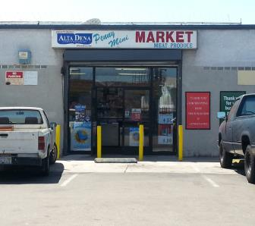

PENNY MINI MARKET at 1001-1023 WEST 89TH STREET, LOS ANGELES, CA

How often do you go to the store at THIS ADDRESS?

Never 0

Once a month 1

2-3 times a month 2

Once a week 3

2-3 times a week 4

Almost every day 5

(picture 161-72452.jpg)

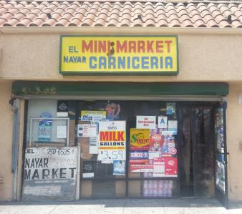

EL NAYAR MINI MARKET at 8301 SOUTH VERMONT AVENUE, LOS ANGELES, CA

How often do you go to the store at THIS ADDRESS?

Never 0

Once a month 1

2-3 times a month 2

Once a week 3

2-3 times a week 4

Almost every day 5

(picture fake.jpg)



7-ELEVEN at 8310 SOUTH VERMONT AVENUE, LOS ANGELES, CA

How often do you go to the store at THIS ADDRESS?

Never 0

Once a month 1

2-3 times a month 2

Once a week 3

2-3 times a week 4

Almost every day 5

**Tobacco Initiation - Part 1**

**Source:** Adapted from Centers for Disease Control and Prevention (CDC). (2014a). 2012 National youth tobacco survey (NYTS). Retrieved from: <http://www.cdc.gov/TOBACCO/data_statistics/surveys/NYTS/index.htm>

**Designed For:** Adolescents

**Psychometrics**: Not reported

**Codebook**:

1. Which of the following tobacco products have you ever tried, even just one time? (Check all that apply) W1AMQ1, W1TobEverUse1, 0 When Not Selected, 1 When Selected

Cigarettes (Marlboro, Camel, Newport, American Spirit, etc.) W1AMQ1option1 W1TobEverUseCig1

Electronic Cigarettes (Blu, NJOY, MarkTen, etc.) W1AMQ1option2 W1TobEverUseECig1

Cigars, Cigarillos, or Little Cigars (Black and Mild, Swisher Sweets, Dutch Masters, etc.)

W1AMQ1option3 W1TobEverUseCigar1

Chewing Tobacco, Snuff, or Dip (Copenhagen, Grizzly, Skoal, etc.) W1AMQ1option4 W1TobEverUseChew1

Tobacco smoked out of a traditional pipe (Captain Black, Lane Limited, etc.)

W1AMQ1option5 W1TobEverUsePipe1

Hookah or Shisha (Starbuzz, Fantasia, Fumari, etc.) W1AMQ1option6 W1TobEverUseHookah1

I have never tried any of these tobacco products W1AMQ1option7 W1TobEverUseNever1

**Cigarette Use**

**Source:** Adapted from:

Centers for Disease Control and Prevention (CDC). (2014a). 2012 National youth tobacco survey (NYTS). Retrieved from: <http://www.cdc.gov/TOBACCO/data_statistics/surveys/NYTS/index.htm>

Centers for Disease Control and Prevention (CDC). (2014b). 2011 Youth tobacco survey (YTS). Retrieved from: <http://www.cdc.gov/tobacco/data_statistics/surveys/yts/index.htm>

Methods for classifying the various smoker types are depicted in IARC Working Group on Methods for Evaluating Tobacco Control Policies. (2008). Methods for evaluating tobacco control policies. International Agency for Research on Cancer.

Additional classification information is also provided in Mayhew, K.P., Flay, B.R., Mott J.A. (2000). Stages in the development of adolescent smoking. *Drug and Alcohol Dependence, 1* (59), S61-81.

**Designed For:** Adolescents

**Psychometrics**: Not reported

**Codebook**:

1. About how many cigarettes have you smoked in your entire life? W1ANQ1 W1CigUseLife1

None 0

1 or more puffs but never a whole cigarette 1

1 cigarette 2

2 to 5 cigarettes 3

6 to 15 cigarettes 4

16 to 25 cigarettes (about 1 pack) 5

26 to 99 cigarettes (more than 1 pack, but less than 5 packs) 6

100 or more cigarettes (5 or more packs) 7

1. Have you ever smoked cigarettes daily, that is, at least one cigarette every day for 30 days? W1ANQ2 W1CigUseDaily2

Yes 1

No 0

1. During the past 30 days, how many cigarettes did you smoke per day? W1ANQ3 W1CigUsePastMonth3

I did not smoke cigarettes during the past 30 days 0

Less than 1 cigarette per day 1

1 cigarette per day 2

2 to 5 cigarettes per day 3

6 to 10 cigarettes per day 4

11 to 20 cigarettes per day 5

More than 20 cigarettes per day 6

**Tobacco Initiation - Part 2**

**Source:** Adapted from Centers for Disease Control and Prevention (CDC). (2014a). 2012 National youth tobacco survey (NYTS). Retrieved from: <http://www.cdc.gov/TOBACCO/data_statistics/surveys/NYTS/index.htm>

**Designed For:** Adolescents

**Psychometrics**: Not reported

**Codebook**:

1. How old were you when you first smoked a cigarette? W1AOQ1 W1TobFirstUseCig1

Never tried 0

8 years old or younger 8

9 years old 9

10 years old 10

11 years old 11

12 years old 12

13 years old 13

14 years old 14

15 years old 15

16 years old 16

17 years old 17

18 years old 18

19 years old or older 19

1. How old were you when you first smoked a WHOLE cigarette? W1AOQ2 W1TobFirstUseWholeCig2

Never tried 0

8 years old or younger 8

9 years old 9

10 years old 10

11 years old 11

12 years old 12

13 years old 13

14 years old 14

15 years old 15

16 years old 16

17 years old 17

18 years old 18

19 years old or older 19

1. How old were you when you first smoked an electronic cigarette, vaporizer, or vape pen? W1AOQ3 W1TobFirstUseECig3

Never tried 0

8 years old or younger 8

9 years old 9

10 years old 10

11 years old 11

12 years old 12

13 years old 13

14 years old 14

15 years old 15

16 years old 16

17 years old 17

18 years old 18

19 years old or older 19

1. How old were you when you smoked a cigar, cigarillo, or little cigar? W1AOQ4 W1TobFirstUseCigar4

Never tried 0

8 years old or younger 8

9 years old 9

10 years old 10

11 years old 11

12 years old 12

13 years old 13

14 years old 14

15 years old 15

16 years old 16

17 years old 17

18 years old 18

19 years old or older 19

1. How old were you when you first had chewing tobacco, snuff, or dip? W1AOQ5 W1TobFirstUseChew5

Never tried 0

8 years old or younger 8

9 years old 9

10 years old 10

11 years old 11

12 years old 12

13 years old 13

14 years old 14

15 years old 15

16 years old 16

17 years old 17

18 years old 18

19 years old or older 19

**Tobacco Initiation - Part 3**

**Source:** Adapted from Centers for Disease Control and Prevention (CDC). (2014a). 2012 National youth tobacco survey (NYTS). Retrieved from: <http://www.cdc.gov/TOBACCO/data_statistics/surveys/NYTS/index.htm>

**Designed For:** Adolescents

**Psychometrics**: Not reported

**Codebook**:

1. What was the first brand of cigarettes you tried? W1APQ1 W1TobFirstBrandCig1

Never tried cigarettes 0

American Spirit 1

Camel 2

GPC, Basic, or Doral 3

Kool 4

Lucky Strike 5

Marlboro 6

Newport 7

Parliament 8

Summit -5

Virginia Slims 9

I don’t know -7

Another brand (please specify): 10 _________ W1APQ1other W1TobFirstBrandCigOther1

1. What was the first brand of electronic cigarettes, vaporizers, or vape pens you tried? W1APQ2 W1TobFirstBrandECig2

Never tried electronic cigarettes, vaporizers, or vape pens 0

Blu 1

Green Smart Living 2

MarkTen 3

NJOY 4

Xcite* -5

Square 5

Vuse 6

V2 7

I don’t know -7

Another brand (please specify): 8 ___________ W1APQ2other W1TobFirstBrandECigOther2

1. What was the first brand of cigars, cigarillos, or little cigars you tried? W1APQ3 W1TobFirstBrandCigar3

Never tried cigars, cigarillos, or little cigars 0

Al Capone 1

Backwoods 2

Black and Mild 3

Colonials -5

Dutch Masters 4

Phillies 5

Prime Time 6

Royal Comfort 7

Splitarillos 8

Swisher Sweets 9

White Owl 10

I don’t know -7

Another brand (please specify): 11 ___________ W1APQ3other W1TobFirstBrandCigarOther3

1. What was the first brand of chewing tobacco, snuff, or dip you tried? W1APQ4 W1TobFirstBrandChew4

Never tried chewing tobacco, snuff, or dip 0

Beechnut 1

Back Country -5

Copenhagen 2

Grizzly 3

Kodiak 4

Levi Garrett 5

Longhorn 6

Red Man 7

Skoal 8

I don’t know -7

Another brand (please specify): 9 ___________ W1APQ4other W1TobFirstBrandChewOther4

**Recent Tobacco Use - Part 1**

**Source:** Adapted from Centers for Disease Control and Prevention (CDC). (2014a). 2012 National youth tobacco survey (NYTS). Retrieved from: <http://www.cdc.gov/TOBACCO/data_statistics/surveys/NYTS/index.htm>

Methods for classifying the various smoker types are depicted in IARC Working Group on Methods for Evaluating Tobacco Control Policies. (2008). Methods for evaluating tobacco control policies. International Agency for Research on Cancer.

Additional classification information is also provided in Mayhew, K.P., Flay, B.R., Mott J.A. (2000). Stages in the development of adolescent smoking. *Drug and Alcohol Dependence, 1* (59), S61-81.

**Designed For:** Adolescents

**Psychometrics**: Not reported

**Codebook**:

When was the last time you used…

1. Cigarettes W1AQQ1 W1TobLastUseCig1

Never tried 0

Earlier today 7

1 to 6 days ago 6

7 to 30 days ago 5

1 to 5 months ago 4

6 to 11 months ago 3

1 to 4 years ago 2

5 or more years ago 1

1. Electronic Cigarettes, Vaporizers, or Vape Pens W1AQQ2 W1TobLastUseEcig2

Never tried 0

Earlier today 7

1 to 6 days ago 6

7 to 30 days ago 5

1 to 5 months ago 4

6 to 11 months ago 3

1 to 4 years ago 2

5 or more years ago 1

1. Cigars, Cigarillos, or Little Cigars W1AQQ3 W1TobLastUseCigar3

Never tried 0

Earlier today 7

1 to 6 days ago 6

7 to 30 days ago 5

1 to 5 months ago 4

6 to 11 months ago 3

1 to 4 years ago 2

5 or more years ago 1

1. Chewing Tobacco, Snuff, or Dip W1AQQ4 W1TobLastUseChew4

Never tried 0

Earlier today 7

1 to 6 days ago 6

7 to 30 days ago 5

1 to 5 months ago 4

6 to 11 months ago 3

1 to 4 years ago 2

5 or more years ago 1

1. Pipe Tobacco W1AQQ5 W1TobLastUsePipe5

Never tried 0

Earlier today 7

1 to 6 days ago 6

7 to 30 days ago 5

1 to 5 months ago 4

6 to 11 months ago 3

1 to 4 years ago 2

5 or more years ago 1

1. Hookah or Shisha W1AQQ6 W1TobLastUseHookah6

Never tried 0

Earlier today 7

1 to 6 days ago 6

7 to 30 days ago 5

1 to 5 months ago 4

6 to 11 months ago 3

1 to 4 years ago 2

5 or more years ago 1

**Recent Tobacco Use - Part 2**

**Source:** Adapted from Centers for Disease Control and Prevention (CDC). (2014a). 2012 National youth tobacco survey (NYTS). Retrieved from: <http://www.cdc.gov/TOBACCO/data_statistics/surveys/NYTS/index.htm>

Methods for classifying the various smoker types are depicted in IARC Working Group on Methods for Evaluating Tobacco Control Policies. (2008). Methods for evaluating tobacco control policies. International Agency for Research on Cancer.

Additional classification information is also provided in Mayhew, K.P., Flay, B.R., Mott J.A. (2000). Stages in the development of adolescent smoking. *Drug and Alcohol Dependence, 1* (59), S61-81.

**Designed For:** Adolescents

**Psychometrics**: Not reported

**Codebook**:

During the past 30 days, on how many days did you use each of the tobacco products below?

|  |  |  |  |  |  |  |  |
| --- | --- | --- | --- | --- | --- | --- | --- |
|  | 0  days | 1 or 2  days | 3 to 5  days | 6 to 9  days | 10 to 19  days | 20 to 29  days | All 30 days |
| ***Cigarettes***  W1ARQ1 W1Tob30DayUseCig1 | ❑0 | ❑1 | ❑2 | ❑3 | ❑4 | ❑5 | ❑6 |
| ***Electronic Cigarettes, Vaporizers, or Vape Pens***  W1ARQ2 W1Tob30DayUseEcig2 | ❑0 | ❑1 | ❑2 | ❑3 | ❑4 | ❑5 | ❑6 |
| ***Cigars, Cigarillos, or Little Cigars***  W1ARQ3 W1Tob30DayUseCigar3 | ❑0 | ❑1 | ❑2 | ❑3 | ❑4 | ❑5 | ❑6 |
| ***Chewing Tobacco, Snuff, or Dip***  W1ARQ4 W1Tob30DayUseChew4 | ❑0 | ❑1 | ❑2 | ❑3 | ❑4 | ❑5 | ❑6 |
| ***Pipe Tobacco***  W1ARQ5 W1Tob30DayUsePipe5 | ❑0 | ❑1 | ❑2 | ❑3 | ❑4 | ❑5 | ❑6 |
| ***Hookah or Shisha***  W1ARQ6 W1Tob30DayUseHookah6 | ❑0 | ❑1 | ❑2 | ❑3 | ❑4 | ❑5 | ❑6 |

**Tobacco Quantity - Part 1**

**Source:** Adapted from Centers for Disease Control and Prevention (CDC). (2014a). 2012 National youth tobacco survey (NYTS). Retrieved from: <http://www.cdc.gov/TOBACCO/data_statistics/surveys/NYTS/index.htm>

**Designed For:** Adolescents

**Psychometrics**: Not reported

**Codebook**:

1. On a typical day, which tobacco products do you use? (Check all that apply) W1ASQ1, W1TobConcurrentUse1, 0 When Not Selected, 1 When Selected

Cigarettes W1ASQ1option1 W1TobConcurrentUseCig1

Electronic Cigarettes, Vaporizers, or Vape Pens W1ASQ1option2 W1TobConcurrentUseEcig1

Cigars, Cigarillos, or Little Cigars W1ASQ1option3 W1TobConcurrentUseCigar1

Chewing Tobacco, Snuff, or Dip W1ASQ1option4 W1TobConcurrentUseChew1

Pipe Tobacco W1ASQ1option5 W1TobConcurrentUsePipe1

Hookah or Shisha W1ASQ1option6 W1TobConcurrentUseHookah1

None of the above W1ASQ1option7 W1TobConcurrentUseNone1

**Modified Fagerstrom Tolerance Questionnaire (mFTQ) for Adolescents**

**Source:** Prokhorov, A.V., Pallonen, U.E., Fava, J.L., Ding, L., & Niaura, R. (1996). Measuring nicotine dependence among high-risk adolescent smokers. *Addictive Behaviors*, *21*(1), 117-127.

Prokhorov, A.V., De Moor, C., Pallonen, U.E., Suchanek Hudmon, K., Koehly, L., & Hu, S. (2000). Validation of the modified Fagerström Tolerance Questionnaire with salivary cotinine among adolescents. *Addictive Behaviors, 25*(3), 429-433.

**Designed For:** Adolescents

**Psychometrics**: Not reported

**Codebook**:

1. How many cigarettes a day do you smoke? W1ATQ1 W1FagerCigs1

Over 26 cigarettes a day 4

About 16-25 cigarettes a day 3

About 1-15 cigarettes a day 2

Less than 1 a day 1

1. Do you inhale? W1ATQ2 W1FagerInhale2

Always 4

Quite often 3

Seldom 2

Never 1

1. How soon after you wake up do you smoke your first cigarette? W1ATQ3 W1FagerWakeUp3

Within the first 30 minutes 4

More than 30 minutes after waking but before noon 3

In the afternoon 2

In the evening 1

I currently don’t smoke cigarettes 0

1. Which cigarette would you hate to give up? W1ATQ4 W1FagerHateToGiveUp4

First cigarette in the morning 4

Any other cigarette before noon 3

Any other cigarette after noon 2

Any other cigarette in the evening 1

I currently don’t smoke cigarettes 0

1. Do you find it difficult to refrain from smoking in places where it is forbidden (church, library, movies etc.)? W1ATQ5 W1FagerRefrainSmoking5

Yes, very difficult 4

Yes, somewhat difficult 3

No, not usually difficult 2

No, not at all difficult 1

1. Do you smoke if you are so ill that you are in bed most of the day? W1ATQ6 W1FagerSmokeIll6

Yes, always 4

Yes, quite often 3

No, not usually 2

No, never 1

1. Do you smoke more during the first 2 hours than during the rest of the day? W1ATQ7 W1FagerFirst2Hours7

Yes 1

No 0

**Tobacco Quantity - Part 2**

**Source:** Adapted from Centers for Disease Control and Prevention (CDC). (2014a). 2012 National youth tobacco survey (NYTS). Retrieved from: <http://www.cdc.gov/TOBACCO/data_statistics/surveys/NYTS/index.htm>

**Designed For:** Adolescents

**Psychometrics**: Not reported

**Codebook**:

On a typical day when you smoke, how many puffs do you take from each tobacco product?

|  |  |  |  |  |  |
| --- | --- | --- | --- | --- | --- |
|  | 0 | 1-10 puffs | 11-50 puffs | 51-200 puffs | 201+ puffs |
| ***Cigarettes***  W1AUQ1 W1TobQuantCig1 | ❑0 | ❑1 | ❑2 | ❑3 | ❑4 |
| ***Electronic Cigarettes, Vaporizers, or Vape Pens***  W1AUQ2 W1TobQuantEcig2 | ❑0 | ❑1 | ❑2 | ❑3 | ❑4 |
| ***Cigars, Cigarillos, or Little Cigars***  W1AUQ3 W1TobQuantCigar3 | ❑0 | ❑1 | ❑2 | ❑3 | ❑4 |

On a typical day when you have chewing tobacco, snuff, or dip, how much do you use? W1AUQ4 W1TobQuantChew4

None 0

About 10% of a tin 1

About a quarter of a tin 2

About half of a tin 3

About three-quarters of a tin 4

A full tin 5

More than one tin 6

**Access to Tobacco Products - Part 1**

**Source:** Adapted from:

Centers for Disease Control and Prevention (CDC). (2014a). 2012 National youth tobacco survey (NYTS). Retrieved from: <http://www.cdc.gov/TOBACCO/data_statistics/surveys/NYTS/index.htm>

Centers for Disease Control and Prevention (CDC). (2014b). 2011 Youth tobacco survey (YTS). Retrieved from: http://www.cdc.gov/tobacco/data_statistics/surveys/yts/index.htm

**Designed For:** Adolescents

**Psychometrics**: Not reported

**Codebook**:

1. During the past 30 days, where did you get your own tobacco products? (Check all that apply) W1AVQ1, W1TobAccessLocation1, 0 When Not Selected, 1 When Selected

I did not buy tobacco products during the past 30 days W1AVQ1option1 W1TobAccessLocationNoBuy1

A gas station W1AVQ1option2 W1TobAccessLocationGas1

A convenience store W1AVQ1option3 W1TobAccessLocationConvenience1

A grocery store W1AVQ1option4 W1TobAccessLocationGrocery1

A drugstore or pharmacy W1AVQ1option5 W1TobAccessDrug1

A vending machine W1AVQ1option6 W1TobAccessVending1

Over the Internet W1AVQ1option7 W1TobAccessInternet1

Through the mail W1AVQ1option8 W1TobAccessMail1

A friend W1AVQ1option9 W1TobAccessFriend1

A family member W1AVQ1option10 W1TobAccessFamily1

None of the above W1AVQ1option11 W1TobAccessNone1

Other (please specify) W1AVQ1option12 W1TobAccessOther1 ____________ W1AVQ1other W1TobAccessOtherSpecify1

1. During the past 30 days, did anyone ever refuse to sell you a tobacco product (cigarettes, cigars, electronic cigarettes, chewing tobacco, etc.) because of your age? W1AVQ2 W1TobAccessRefuseSale2

I did not try to buy a tobacco product in a store during the past 30 days -1

Yes, someone refused to sell me a tobacco product because of my age 1

No, no one refused to sell me a tobacco product because of my age 0

1. If you bought or tried to buy a tobacco product in a store during the past 30 days, were you ever asked to show proof of age? W1AVQ3 W1TobAccessProofAge3

I did not try to buy a tobacco product in a store during the past 30 days -1

Yes, I was asked to show proof of age 1

No, I was not asked to show proof of age 0

**Tobacco Cessation**

**Source:** Adapted from Centers for Disease Control and Prevention (CDC). (2014a). 2012 National youth tobacco survey (NYTS). Retrieved from: <http://www.cdc.gov/TOBACCO/data_statistics/surveys/NYTS/index.htm>

**Designed For:** Adolescents

**Psychometrics**: Not reported

**Codebook**:

1. Have you ever thought about quitting or planning to quit using tobacco? W1AWQ1 W1TobQuitThought1

No 0

I thought about it but did not want to 1

I thought about it but have not made up my mind 2

I plan to quit in the next 30 days 4

I plan to quit in the next 6 months 3

1. How many times during the past 12 months have you stopped using tobacco for one day or longer because you were trying to quit? W1AWQ2 W1TobQuitTimes2

I have not tried to quit 0

1 time 1

2 times 2

3 to 5 times 3

6 to 9 times 4

10 or more times 5

1. When you last tried to quit tobacco, how long did you last? W1AWQ3 W1TobQuitDaysLast3

Less than a day 1

1 to 7 days 2

More than 7 days but less than 30 days 3

30 days or more but less than 6 months 4

6 months or more but less than a year 5

1 year or more 6

**Tobacco Use Willingness**

**Source:** Adapted from Gerrard, M., Gibbons, F.X., Houlihan, A.E., Stock, M.L., & Pomery, E.A. (2008). A dual-process approach to health risk decision making: The prototype willingness model. *Developmental Review, 28*(1), 29-61.

Response options adapted from Centers for Disease Control and Prevention (CDC). (2014) 2012 National youth tobacco survey (NYTS). Retrieved from <http://www.cdc.gov/TOBACCO/data_statistics/surveys/NYTS/index.htm>.

**Designed For:** Adolescents

**Psychometrics**: Not reported

**Codebook**:

Suppose you were with a group of friends at a party and there were tobacco products there that you could try if you wanted.

If it were offered by one of your friends, how willing would you be to try…

|  |  |  |  |  |
| --- | --- | --- | --- | --- |
|  | Definitely  Yes | Probably  Yes | Probably  No | Definitely  No |
| ***Cigarettes***  W1AXQ1 W1TobWillingCig1 | ❑4 | ❑3 | ❑2 | ❑1 |
| ***Electronic Cigarettes, Vaporizers, or Vape Pens***  W1AXQ2 W1TobWillingEcig2 | ❑4 | ❑3 | ❑2 | ❑1 |
| ***Cigars, Cigarillos, or Little Cigars***  W1AXQ3 W1TobWillingCigar3 | ❑4 | ❑3 | ❑2 | ❑1 |
| ***Chewing Tobacco, Snuff, or Dip***  W1AXQ4 W1TobWillingChew4 | ❑4 | ❑3 | ❑2 | ❑1 |
| ***Pipe Tobacco***  W1AXQ5 W1TobWillingPipe5 | ❑4 | ❑3 | ❑2 | ❑1 |
| ***Hookah or Shisha***  W1AXQ6 W1TobWillingHookah6 | ❑4 | ❑3 | ❑2 | ❑1 |

**Tobacco Initiation - Part 4**

**Source:** Adapted from Centers for Disease Control and Prevention (CDC). (2014a). 2012 National youth tobacco survey (NYTS). Retrieved from: <http://www.cdc.gov/TOBACCO/data_statistics/surveys/NYTS/index.htm>

**Designed For:** Adolescents

**Psychometrics**: Not reported

**Codebook**:

1. Which of the following tobacco products have you ever tried, even just one time? (Check all that apply) W1AYQ1, W1TobOtherTry1, 0 When Not Selected, 1 When Selected

Roll-your-own cigarettes, such as Bugler, American Spirit, and BaliShag W1AYQ1option1 W1TobOtherTryRYO1

Bidis (small brown cigarettes wrapped in a leaf) W1AYQ1option2 W1TobOtherTryBidis1

Clove cigarettes (kreteks) W1AYQ1option3 W1TobOtherTryClove1

Snus, such as Camel, Marlboro, or Skoal Snus W1AYQ1option4 W1TobOtherTrySnus1

Dissolvable tobacco products, such as Ariva, Stonewall, Camel orbs, Camel sticks, Marlboro sticks, or Camel strips W1AYQ1option5 W1TobOtherTryDissolvable1

Some other new tobacco product not listed here W1AYQ1option6 W1TobOtherTryNew1

I have never tried any of the products listed above or any new tobacco product

W1AYQ1option7 W1TobOtherTryNever1

**Access to Tobacco Products - Part 2**

**Source:** Adapted from:

Centers for Disease Control and Prevention (CDC). (2014a). 2012 National youth tobacco survey (NYTS). Retrieved from: <http://www.cdc.gov/TOBACCO/data_statistics/surveys/NYTS/index.htm>

Centers for Disease Control and Prevention (CDC). (2014b). 2011 Youth tobacco survey (YTS). Retrieved from: http://www.cdc.gov/tobacco/data_statistics/surveys/yts/index.htm

**Designed For:** Adolescents

**Psychometrics**: Not reported

**Codebook**:

1. If you wanted to, how easy or hard do you think it would be for you to purchase tobacco products in a store? W1AZQ1 W1TobPurchaseEase1

Very easy 4

Sort of easy 3

Sort of hard 2

Very hard 1

**Perception of Peer Tobacco Use**

**Source:** Adapted from Johnston, L.D., O’Malley, P.M., Bachman, J.G., & Schulenberg, J.E. (2014) 2011 Monitoring the future survey (MTF). Retrieved from <http://www.monitoringthefuture.org/>. Ann Arbor: Institute for Social Research, The University of Michigan.

**Designed For:** Adolescents

**Psychometrics**: Not reported

**Codebook**:

1. These days, how many students in your school would you guess are regular CIGARETTE smokers? W1BAQ1 W1TobEstPeerUseCig1

0% to 10% 0

11% to 30% 1

31% to 50% 2

51% to 70% 3

71% to 90% 4

91% to 100% 5

Have no idea -7

1. These days, how many students in your school would you guess are regular smokers of electronic cigarettes, vaporizers, or vape pens? W1BAQ2 W1TobEstPeerUseECig2

0% to 10% 0

11% to 30% 1

31% to 50% 2

51% to 70% 3

71% to 90% 4

91% to 100% 5

Have no idea -7

**Tobacco Brand Preference**

**Source:** Adapted from:

Centers for Disease Control and Prevention (CDC). (2014a). 2012 National youth tobacco survey (NYTS). Retrieved from: <http://www.cdc.gov/TOBACCO/data_statistics/surveys/NYTS/index.htm>

Centers for Disease Control and Prevention (CDC). (2014b). 2011 Youth tobacco survey (YTS). Retrieved from: <http://www.cdc.gov/tobacco/data_statistics/surveys/yts/index.htm>

**Designed For:** Adolescents

**Psychometrics**: Not reported

**Codebook**:

1. If you were going to have a tobacco product, would you prefer… W1BBQ1 W1TobPreference1

Regular 1

Menthol 2

Flavored (chocolate, mint, cherry, etc.) 3

1. If you were going to smoke a cigarette, what brand would you choose? W1BBQ2 W1TobBrandPrefCig2

American Spirit 1

Camel 2

GPC, Basic, or Doral 3

Kool 4

Lucky Strike 5

Marlboro 6

Newport 7

Parliament 8

Summit -5

Virginia Slims 9

I would never choose any brand -7

Another brand (please specify): 10 _________ W1BBQ2other W1TobBrandPrefCigOther2

1. If you were going to smoke an electronic cigarette, vaporizer, or vape pen, what brand would you choose? W1BBQ3 W1TobBrandPrefEcig3

Blu 1

Green Smart Living 2

MarkTen 3

NJOY 4

Xcite* -5

Square 5

Vuse 6

V2 7

I would never choose any brand -7

Another brand (please specify): 8 ___________ W1BBQ3other W1TobBrandPrefEcigOther3

1. If you were going to smoke a cigar, cigarillo, or little cigar, what brand would you choose? W1BBQ4 W1TobBrandPrefCigar4

Al Capone 1

Backwoods 2

Black and Mild 3

Colonials -5

Dutch Masters 4

Phillies 5

Prime Time 6

Royal Comfort 7

Splitarillos 8

Swisher Sweets 9

White Owl 10

I would never choose any brand -7

Another brand (please specify): 11 ___________ W1BBQ4other W1TobBrandPrefCigarOther4

1. If you were going to use chewing tobacco, snuff, or dip what brand would you choose? W1BBQ5 W1TobBrandPrefChew5

Beechnut 1

Back Country -5

Copenhagen 2

Grizzly 3

Kodiak 4

Levi Garrett 5

Longhorn 6

Red Man 7

Skoal 8

I would never choose any brand -7

Another brand (please specify): 9 ___________ W1BBQ5other W1TobBrandPref4ChewOther5

**Second-Hand Smoke Exposure**

**Source:** Adapted from Centers for Disease Control and Prevention (CDC). (2014b). 2011 Youth tobacco survey (YTS). Retrieved from: <http://www.cdc.gov/tobacco/data_statistics/surveys/yts/index.htm>

**Designed For:** Adolescents

**Psychometrics**: Not reported

**Codebook**:

1. During the past 7 days, on how many days were you in the same room or vehicle with someone who was smoking tobacco? W1BCQ1 W1TobExposureSamePlace1

0 days 0

1 or 2 days 1

3 or 4 days 2

5 or 6 days 3

7 days 4

1. Which of these best describes the rules about smoking in your family? Smoking is… W1BCQ2 W1TobExposureRules2

Never allowed inside my home or inside the car 0

Allowed only at some times or in some places 1

Always allowed inside my home or inside the car 2

There are no rules about smoking 3

**Health Professional Warnings**

**Source:** Adapted from Centers for Disease Control and Prevention (CDC). (2014b). 2011 Youth tobacco survey (YTS). Retrieved from: <http://www.cdc.gov/tobacco/data_statistics/surveys/yts/index.htm>

**Designed For:** Adolescents

**Psychometrics**: Not reported

**Codebook**:

1. During the past 12 months, did any doctor, dentist, nurse, or other health professional ask you if you smoke or use tobacco products? W1BDQ1 W1TobHealthWarnAsk1

Yes 1

No 0

Don’t know / not sure -7

1. During the past 12 months, did any doctor, dentist, nurse, or other health professional advise you not to smoke or use tobacco products? W1BDQ2 W1TobHealthWarnAdvise2

Yes 1

No 0

Don’t know / not sure -7

**General Health Perceptions**

**Source:** Modeled on Popova, L., & Ling, P.M. (2013). Perceptions of relative risk of snus and cigarettes among US smokers. *American Journal of Public Health*, *103*(11), 21-23.

Response options adapted from Centers for Disease Control and Prevention (CDC). (2014). 2012 National youth tobacco survey (NYTS). Retrieved from: <http://www.cdc.gov/TOBACCO/data_statistics/surveys/NYTS/index.htm>.

**Designed For:** Adult

**Psychometrics**: Not reported

**Codebook**:

In your opinion, how harmful are using the following tobacco products to your health?

1. Cigarettes W1BEQ1 W1TobHarmfulCig1

Not Harmful 1 A Little Harmful 2 Somewhat Harmful 3 Very Harmful 4

1. Electronic Cigarettes, Vaporizers, or Vape Pens W1BEQ2 W1TobHarmfulEcig2

Not Harmful 1 A Little Harmful 2 Somewhat Harmful 3 Very Harmful 4

1. Cigars, Cigarillos, or Little Cigars W1BEQ3 W1TobHarmfulCigar3

Not Harmful 1 A Little Harmful 2 Somewhat Harmful 3 Very Harmful 4

1. Chewing Tobacco, Snuff, or Dip W1BEQ4 W1TobHarmfulChew4

Not Harmful 1 A Little Harmful 2 Somewhat Harmful 3 Very Harmful 4

**Symmetry Span Task**

**Source:** Kane, M.J., Hambrick, D.Z., Tuholski, S.W., Wilhelm, O., Payne, T.W., & Engle, R.W. (2004). The generality of working memory capacity: A latent variable approach to verbal and visuospatial memory span and reasoning. *Journal of Experimental Psychology: General, 133*, 189-217.

Heitz, R.P. & Engle, R.W. (2007). Focusing the spotlight: Individual differences in visual attention control. *Journal of Experimental Psychology: General, 136*, 217 - 240.

Redick, T.S., Broadway, J.M., Meier, M.E., Kuriakose, P.S., Unsworth, N., Kane, M.J., Engle, R.W. (2012). Measuring working memory capacity with automated complex span tasks. *European Journal of Psychological Assessment, 28*(3), 164-171.

**Designed For:** Adolescents

**Psychometrics:** Cronbach’s alpha = .76 and test-retest reliability r = .77

**Items:**

W1BFQ

**Scoring:** The program reports five values at the conclusion of the experiment.

The first, SSPAN score, uses the traditional "absolute sspan" scoring method. It is the sum of all perfectly recalled sets. So, for example, if an individual recalled correctly 2 squares in a set size of 2, 3 squares in a set size of 3, and 3 squares in a set size of 4, their SSPAN score would be 5 (2 + 3 + 0).

Total number correct is the total number of squares recalled in the correct position (2 + 3 + 3 = 8 in the above example).

Symmetry errors are reported as total number of errors, accuracy errors where the subject solved the operation incorrectly, and speed errors in which the subject ran out of time in attempting to solve a given operation.

**Instructions:**

#### *Screen One*

In this task, squares will appear on the screen one at a time. Try to remember where each square is on the screen.

FIRST SCREEN SECOND SCREEN

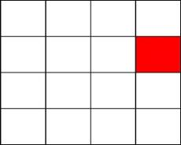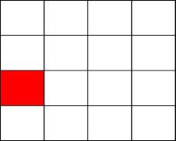

Your job is to select each square in the order it appears.

Click NEXT at the bottom right of the screen when you finish selecting the squares.

If you forget one, click BLANK to mark that position.

Click CLEAR if you need to start over.

It is very important to select the squares in the same order you saw them.

Click the mouse button to try some practice problems.

#### *Screen Two*

Now you will have to decide if different pictures are symmetrical. A picture is symmetrical if you can fold it in half and the picture on the left lines up with the picture on the right. Below are two examples.

SYMMETRICAL NOT SYMMETRICAL

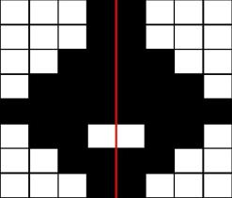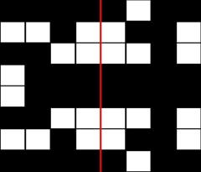

If the picture is symmetrical click YES.

If the picture is NOT symmetrical click NO.

The computer will tell you if you made the right choice.

Click the mouse button to try some practice problems.

#### *Screen Three*

Now you will practice doing both parts of the task at the same time.

The computer will automatically move to the next screen if you take too long.

It is VERY important to solve the problems as quickly and as accurately as possible.

A red number will appear in the top right of the screen. This indicates your percent correct on the symmetry part of the task. Keep this percentage as high as possible while doing your best to get the squares in the correct order.

Click the mouse to try some practice problems.

#### *Screen Four*

That is the end of the practice.

The real task will be just like the practice, but it will be longer and may be harder.

It is important that you do your best.

Click the mouse to begin the task.

#### *Final Screen*

This concludes this task.

Click the mouse to continue.

#### Example:

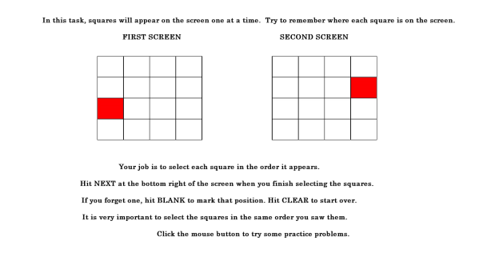

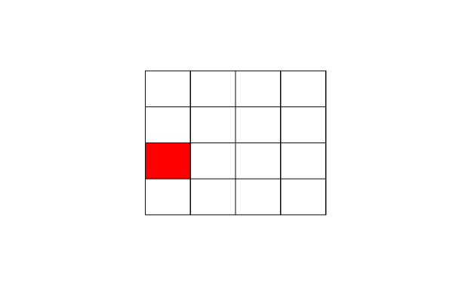

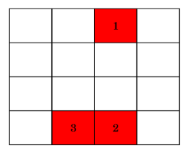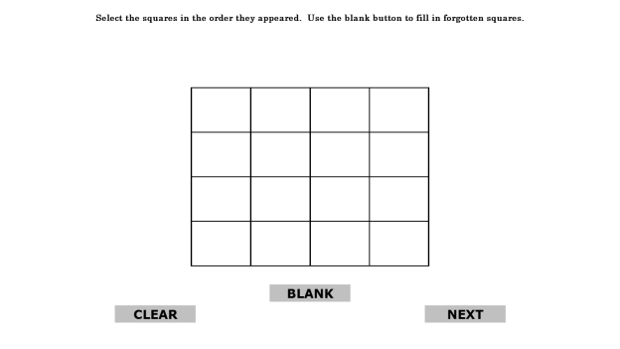

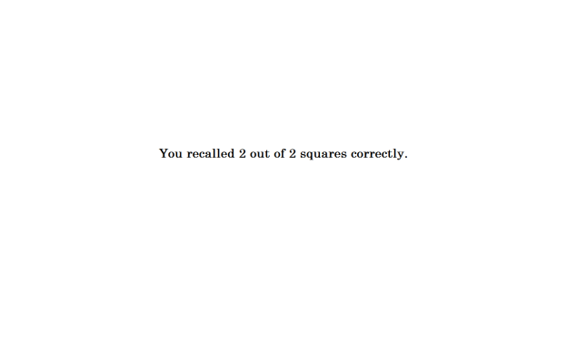

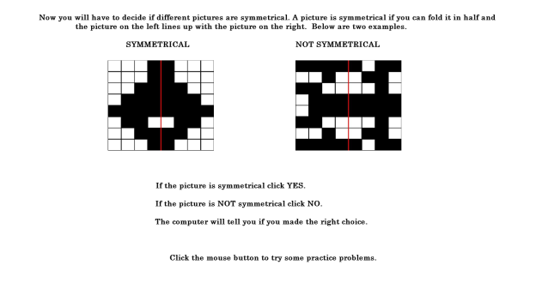

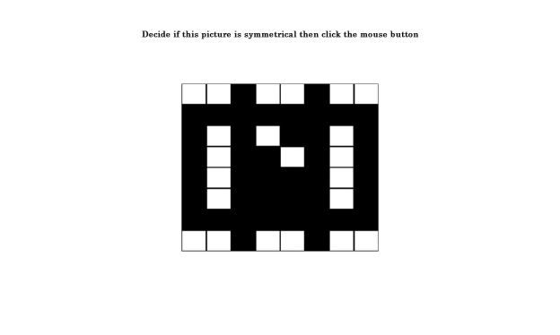

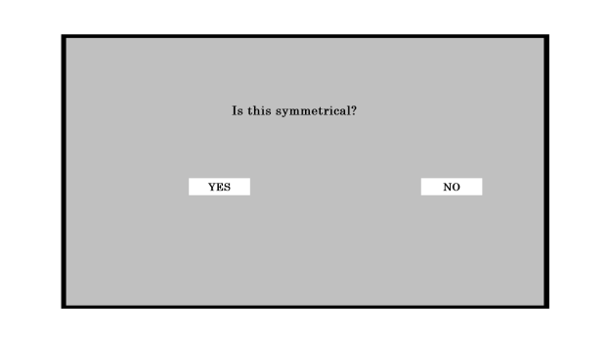

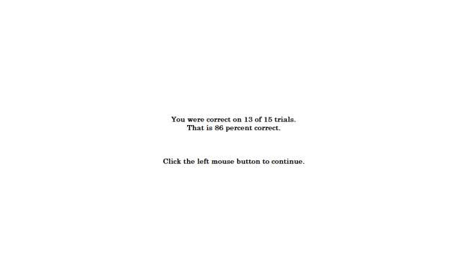

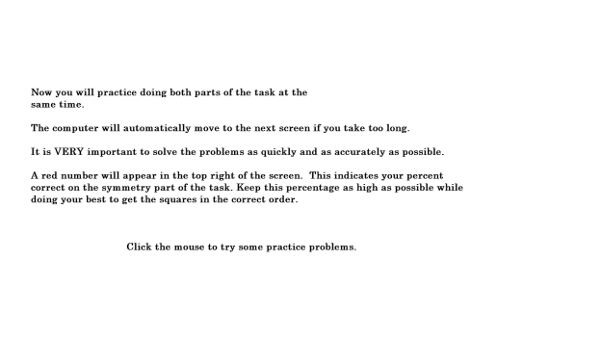

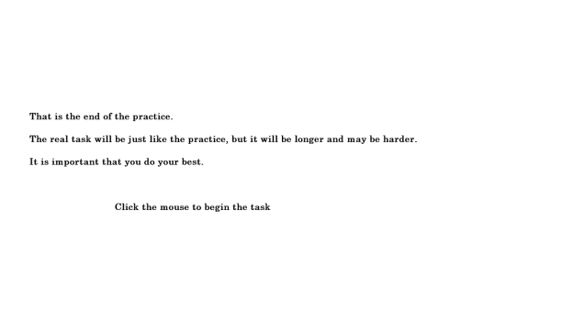

**Go/No-Go Task**

**Source:** Fillmore, M.T., Ostling, E.W., Martin, C.A., Kelly, T.H. (2009). Acute effects of alcohol on inhibitory control and information processing in high and low sensation-seekers. *Drug and Alcohol Dependence, 100*(1-2), 91-99.

Fillmore, M.T., Rush, C.R., and Hays, L. (2006). Acute effects of cocaine in two models of inhibitory control: Implications of non-linear dose effects. Addiction, 101, 1323-1332.

Finn, P.R., Justus, A., Mazas, C., Steinmetz, J.E. (1999). Working memory, executive processes and the effects of alcohol on Go/No-go learning: Testing a model of behavioral regulation and impulsivity. *Psychopharmacology, 146*(4), 465-472.

Mostofsky, S.H., Simmonds, D.J. (2008). Response inhibition and response selection: Two sides of the same coin. *Journal of Cognitive Neuroscience, 20*(5), 751-761.

Simmonds, D.J., Pekar, J.J., Mostofsky, S.H. (2008).Meta-analysis of go/no-go tasks demonstrating that fMRI activation associated with response inhibition is task-dependent. *Neuropsychologia, 46*(1), 224-232.

Weafer, J., Fillmore, M.T., & Milich, R. (2009). Increased sensitivity to the disinhibiting effects of alcohol in adults with ADHD. *Experimental And Clinical Psychopharmacology*, *17*(2), 113-121.

Little, T.D., Cunningham, W.A., Shahar, G., & Widaman, K.F. (2002). To parcel or not to parcel: Exploring the question, weighing the merits. *Structural Equation Modeling*, *9*(2), 151-173.

**Designed For:** Adults and Adolescents

**Items:**

W1BGQ

**Instructions:**

The next task will ask you to respond as quickly as possible while making as few errors as possible.

Please do the best that you can.

Please place your finger on the spacebar.

First, you will see a plus sign in the middle of the screen.

Then you will see an empty rectangle.

Next the rectangle will fill with a color.

When you see the color GREEN, press the spacebar.

When you see the color BLUE, DO NOT press the spacebar.

Respond as quickly as possible and make as few errors as possible.

If you make a mistake the screen will say ‘Incorrect’.

The task takes about 10 minutes to complete.

**Additional Information:**

* There will be 0 practice trials.
* There will be 160 trials for the main task.
* The fixation point, i.e. the plus sign, will be displayed for 500 milliseconds.
* The cue, a blank rectangle, will be displayed for 100 milliseconds, 200 milliseconds, 300 milliseconds, 400 milliseconds, or 500 milliseconds.
* A Go cue, i.e. a green rectangle, will be displayed for 1000 milliseconds 70% of the time.
* A No-Go cue, i.e. a blue rectangle, will be displayed for 1000 milliseconds 30% of the time.
* The orientation of the rectangle, i.e. horizontal or vertical, will signal the probability that a go or no-go cue will be displayed.
  + Vertical rectangles precede a Go cue 70% of the time.
  + Horizontal rectangles precede a No-Go cue 70% of the time.
  + Vertical rectangles were presented 50% of the time.
  + Horizontal rectangles were presented 50% of the time.
* After the trial is complete, a blank screen will be displayed for 300 milliseconds.
* There will be no breaks.
* If a participant presses a key in response to a Go cue, the reaction time in milliseconds will be displayed for 500 milliseconds.
* If a study participant presses a key in response to a No Go cue, the word ‘Incorrect’ will appear for 500 milliseconds.
* If a study participant does not respond after 1000 milliseconds, the word ‘Incorrect’ will appear for 500 milliseconds.

**65% Update**

[*A 65% Progress Bar Will Be Shown Here*]

Your Progress

Nice work! You have completed all of the tasks in the survey. From here, all you have to do is answer a series of questions.

Remember that your opinion matters. Be as honest as possible. Your answers will be kept confidential.

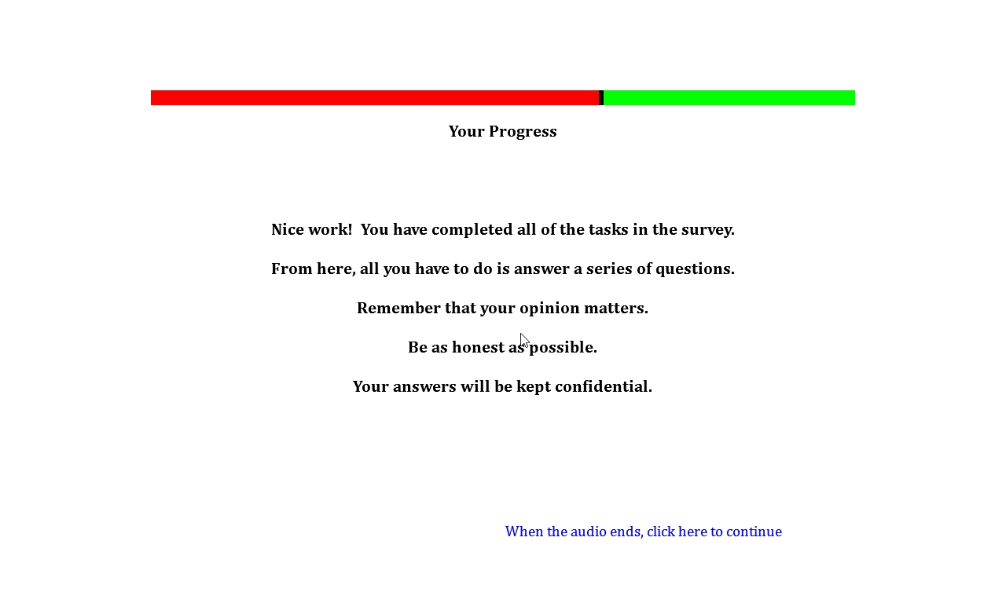

**Short Form Smoking Consequences Questionnaire (S-SCQ)**

**Source:** Myers, M.G., MacPherson, L., McCarthy, D.M., & Brown, S.A. (2003). Constructing a short form of the Smoking Consequences Questionnaire with adolescents and young adults. *Psychological* *Assessment*, *15*(2), 163-172.

Penzes, M., Czégledi, E., Balázs, P., & Foley, K.L. (2012). Factors associated with tobacco smoking and the belief about weight control effect of smoking among hungarian adolescents. *Cent Eur J Public Health, 20*, 11-17.

Urbán, R., & Demetrovics, Z. (2010). Smoking outcome expectancies: A multiple indicator and multiple cause (MIMIC) model. *Addictive Behaviors*, *35*(6), 632-635.

Urbán, R. (2010). Smoking outcome expectancies mediate the association between sensation seeking, peer smoking, and smoking among young adolescents. *Nicotine & Tobacco Research*, *12*(1), 59-68.

Response options are based on Ajzen, I. & Fishbein, M. (1980). *Understanding Attitudes and Predicting Social Behavior.* Englewood Cliffs, NJ: Prentice-Hall, Inc.

**Designed For:** Use with adolescents and young adults, derived from Smoking Consequences Questionnaire (Brandon & Baker, 1991)

**Psychometrics:** Internal consistencies for four-factor model solution: Negative Consequences (.84), Negative Reinforcement (.92), Positive Reinforcement (.95), and Appetite-Weight Control (.93)

**Codebook:**For each statement, please indicate how LIKELY or UNLIKELY you believe each statement is for you when you smoke. If you have never smoked, answer according to your personal beliefs, regardless of what other people might think.

1. Cigarettes taste good. W1BHQ1 W1OutExpecPosRe1

Extremely Likely 5 Somewhat Likely 4 Neutral 3 Somewhat Unlikely 2 Extremely Unlikely1

2. Smoking controls my appetite. W1BHQ2 W1OutExpecAppWeight2

Extremely Likely 5 Somewhat Likely 4 Neutral 3 Somewhat Unlikely 2 Extremely Unlikely1

3. Cigarettes help me deal with anxiety or worry. W1BHQ3 W1OutExpecNegRe3

Extremely Likely 5 Somewhat Likely 4 Neutral 3 Somewhat Unlikely 2 Extremely Unlikely1

4. I enjoy the taste sensations while smoking. W1BHQ4 W1OutExpecPosRe4

Extremely Likely 5 Somewhat Likely 4 Neutral 3 Somewhat Unlikely 2 Extremely Unlikely1

5. Smoking helps me deal with depression. W1BHQ5 W1OutExpecNegRe5

Extremely Likely 5 Somewhat Likely 4 Neutral 3 Somewhat Unlikely 2 Extremely Unlikely1

6. Cigarettes keep me from overeating. W1BHQ6 W1OutExpecAppWeight6

Extremely Likely 5 Somewhat Likely 4 Neutral 3 Somewhat Unlikely 2 Extremely Unlikely1

7. Cigarettes help me deal with anger. W1BHQ7 W1OutExpecNegRe7

Extremely Likely 5 Somewhat Likely 4 Neutral 3 Somewhat Unlikely 2 Extremely Unlikely1

8. When I smoke the taste is pleasant. W1BHQ8 W1OutExpecPosRe8

Extremely Likely 5 Somewhat Likely 4 Neutral 3 Somewhat Unlikely 2 Extremely Unlikely1

9. I will enjoy the flavor of a cigarette. W1BHQ9 W1OutExpecPosRe9

Extremely Likely 5 Somewhat Likely 4 Neutral 3 Somewhat Unlikely 2 Extremely Unlikely1

10. I will enjoy feeling a cigarette on my tongue and lips. W1BHQ10 W1OutExpecPosRe10

Extremely Likely 5 Somewhat Likely 4 Neutral 3 Somewhat Unlikely 2 Extremely Unlikely1

11. By smoking I risk heart disease and lung cancer. W1BHQ11 W1OutExpecNegCon11

Extremely Likely 5 Somewhat Likely 4 Neutral 3 Somewhat Unlikely 2 Extremely Unlikely1

12. Cigarettes help me reduce or handle tension. W1BHQ12 W1OutExpecNegRe12

Extremely Likely 5 Somewhat Likely 4 Neutral 3 Somewhat Unlikely 2 Extremely Unlikely1

13. Smoking helps me control my weight. W1BHQ13 W1OutExpecAppWeight13

Extremely Likely 5 Somewhat Likely 4 Neutral 3 Somewhat Unlikely 2 Extremely Unlikely1

14. When I'm upset with someone, a cigarette helps me cope. W1BHQ14 W1OutExpecNegRe14

Extremely Likely 5 Somewhat Likely 4 Neutral 3 Somewhat Unlikely 2 Extremely Unlikely1

15. The more I smoke, the more I risk my health. W1BHQ15 W1OutExpecNegCon15

Extremely Likely 5 Somewhat Likely 4 Neutral 3 Somewhat Unlikely 2 Extremely Unlikely1

16. Cigarettes keep me from eating more than I should. W1BHQ16 W1OutExpecAppWeight16

Extremely Likely 5 Somewhat Likely 4 Neutral 3 Somewhat Unlikely 2 Extremely Unlikely1

17. Smoking keeps my weight down. W1BHQ17 W1OutExpecAppWeight17

Extremely Likely 5 Somewhat Likely 4 Neutral 3 Somewhat Unlikely 2 Extremely Unlikely1

18. Smoking is hazardous to my health. W1BHQ18 W1OutExpecNegCon18

Extremely Likely 5 Somewhat Likely 4 Neutral 3 Somewhat Unlikely 2 Extremely Unlikely1

19. Smoking calms me down when I feel nervous. W1BHQ19 W1OutExpecNegRe19

Extremely Likely 5 Somewhat Likely 4 Neutral 3 Somewhat Unlikely 2 Extremely Unlikely1

20. When I'm angry a cigarette can calm me down. W1BHQ20 W1OutExpecNegRe20

Extremely Likely 5 Somewhat Likely 4 Neutral 3 Somewhat Unlikely 2 Extremely Unlikely1

21. Smoking is taking years off my life. W1BHQ21 W1OutExpecNegCon21

Extremely Likely 5 Somewhat Likely 4 Neutral 3 Somewhat Unlikely 2 Extremely Unlikely1

**Family and Peer Smoking**

**Source:** Items 1-3 are optional questions from:

Centers for Disease Control and Prevention (CDC). (2014a). 2012 National youth tobacco survey (NYTS). Retrieved from: <http://www.cdc.gov/TOBACCO/data_statistics/surveys/NYTS/index.htm>

Centers for Disease Control and Prevention (CDC). (2014b). 2011 Youth tobacco survey (YTS). Retrieved from: <http://www.cdc.gov/tobacco/data_statistics/surveys/yts/index.htm>

Item 1 was expanded to assess tobacco use by older brothers, older sisters, younger brothers, and younger sisters. Item 2 was added to assess the use of smokeless tobacco. Item 3 was expanded to include electronic cigarettes, hookah/shisha, pipe tobacco, and cigarettes combined with marijuana.

Items 4-7 are from the California Department of Public Health (CDPH). (2014). 2011-2012 California Student Tobacco Survey (CSTS). Retrieved from: <http://www.cdph.ca.gov/programs/tobacco/Pages/default.aspx>.

Item 5 was added to assess the use of smokeless tobacco. Item 6 was added to assess the use of electronic cigarettes. Item 7 was expanded to include hookah/shisha, pipe tobacco, and cigarettes combined with marijuana.

**Designed For:** Adolescents

**Psychometrics**: Not reported

**Codebook:**

[*Family*]

Please answer the following questions about your family.

1. Who in your home smokes? (check all that apply) W1BIQ1, W1FamSmoke1, 0 When Not Selected, 1 When Selected

No one smokes in my home W1BIQ1option1 W1FamSmokeNoOne1

I am the only one who smokes in my home W1BIQ1option2 W1FamSmokeOnlyMe1

Father (Male Guardian) W1BIQ1option3 W1FamSmokeDad1

Mother (Female Guardian) W1BIQ1option4 W1FamSmokeMom1

Older Brother W1BIQ1option5 W1FamSmokeOldBro1

Older Sister W1BIQ1option6 W1FamSmokeOldSis1

Younger Brother W1BIQ1option7 W1FamSmokeYoungBro1

Younger Sister W1BIQ1option8 W1FamSmokeYoungSis1

Grandmother / Grandfather W1BIQ1option9 W1FamSmokeGrandparent1

Other (please specify) W1BIQ1option10 W1FamSmokeOther1 ____________ W1BIQ1other W1FamSmokeOtherSpecify1

1. Who in your home uses chewing tobacco, snuff, or dip? (check all that apply) W1BIQ2, W1FamChew2, 0 When Not Selected, 1 When Selected

No one uses chewing tobacco, snuff, or dip in my home W1BIQ2option1 W1FamChewNoOne2

I am the only one who uses chewing tobacco, snuff, or dip in my home W1BIQ2option2 W1FamChewOnlyMe2

Father (Male Guardian) W1BIQ2option3 W1FamChewDad2

Mother (Female Guardian) W1BIQ2option4 W1FamChewMom2

Older Brother W1BIQ2option5 W1FamChewOldBro2

Older Sister W1BIQ2option6 W1FamChewOldSis2

Younger Brother W1BIQ2option7 W1FamChewYoungBro2

Younger Sister W1BIQ2option8 W1FamChewYoungSis2

Grandmother / Grandfather W1BIQ2option9 W1FamChewGrandparent2

Other (please specify) W1BIQ2option10 W1FamChewOther2 ____________ W1BIQ2other W1FamChewOtherSpecify2

[*Experience At Home*]

1. Does anyone who lives with you now…? (check all that apply) W1BIQ3, W1FamOtherTob3, 0 When Not Selected, 1 When Selected

Use electronic cigarettes, vaporizers, or vape pens W1BIQ3option1 W1FamOtherTobEcig3

Smoke cigars, cigarillos, or little cigars W1BIQ3option2 W1FamOtherTobCigar3

Smoke tobacco in a pipe W1BIQ3option3 W1FamOtherTobPipe3

Smoke cigarettes with tobacco and marijuana W1BIQ3option4 W1FamOtherTobPot3

Smoke hookah or shisha W1BIQ3option5 W1FamOtherTobHookah3

Use any other form of tobacco W1BIQ3option6 W1FamOtherNew3

No one who lives with me now uses any form of tobacco W1BIQ3option7 W1FamOtherTobNoOne3

[*Peer*]

Please answer the following questions about your friends.

1. How many of your four closest friends smoke cigarettes? W1BIQ4, W1FriendCig4

None 0

One 1

Two 2

Three 3

Four 4

Not sure -7

1. How many of your four closest friends use chewing tobacco, snuff, or dip? W1BIQ5, W1FriendChew5

None 0

One 1

Two 2

Three 3

Four 4

Not sure -7

1. How many of your four closest friends use electronic cigarettes, vaporizers, or vape pens? W1BIQ6, W1FriendECig6

None 0

One 1

Two 2

Three 3

Four 4

Not sure -7

1. Do any of your four closest friends…? (check all that apply) W1BIQ7, W1FriendOtherTob7, 0 When Not Selected, 1 When Selected

Smoke cigars, cigarillos, or little cigars W1BIQ7option1 W1FriendOtherTobCigar7

Smoke tobacco in a pipe W1BIQ7option2 W1FriendOtherTobPipe7

Smoke cigarettes with tobacco and marijuana W1BIQ7option3 W1FriendOtherTobPot7

Smoke hookah or shisha W1BIQ7option4 W1FriendOtherTobHookah7

Use any other form of tobacco W1BIQ7option5 W1FriendOtherTobNew7

My four closest friends do not use any form of tobacco W1BIQ7option6 W1FriendOtherNoOne7

**Injunctive Norms**

**Source:** Questions are based on Wilkinson, D., & Abraham, C. (2004). Constructing an integrated model of the antecedents of adolescent smoking. *British Journal Of Health Psychology, 9*(3), 315-333.

Response options are based on Ajzen, I. & Fishbein, M. (1980). *Understanding Attitudes and Predicting Social Behavior.* Englewood Cliffs, NJ: Prentice-Hall, Inc.

**Designed For:** Adolescents (Ages 13-14)

**Psychometrics:** Cronbach’s alpha = .81.

**Codebook:**

Please answer the following questions about your friends and family.

1. How likely is it that your MOTHER would NOT want you to smoke? W1BJQ1 W1InjNormMom1

Extremely Likely 1 Somewhat Likely 2 Neutral 3 Somewhat Unlikely 4 Extremely Unlikely 5

1. How likely is it that your FATHER would NOT want you to smoke? W1BJQ2 W1InjNormDad2

Extremely Likely 1 Somewhat Likely 2 Neutral 3 Somewhat Unlikely 4 Extremely Unlikely 5

1. How likely is it that your SISTER(S) would NOT want you to smoke? W1BJQ3 W1InjNormSis3

Extremely Likely 1 Somewhat Likely 2 Neutral 3 Somewhat Unlikely 4 Extremely Unlikely 5

1. How likely is it that your BROTHER(S) would NOT want you to smoke? W1BJQ4 W1InjNormBro4

Extremely Likely 1 Somewhat Likely 2 Neutral 3 Somewhat Unlikely 4 Extremely Unlikely 5

1. How likely is it that your RELATIVES would NOT want you to smoke? W1BJQ5 W1InjNormRelatives5

Extremely Likely 1 Somewhat Likely 2 Neutral 3 Somewhat Unlikely 4 Extremely Unlikely 5

1. How likely is it that your FRIENDS would NOT want you to smoke? W1BJQ6 W1InjNormFriends6

Extremely Likely 1 Somewhat Likely 2 Neutral 3 Somewhat Unlikely 4 Extremely Unlikely 5

1. How likely is it that your PEERS would NOT want you to smoke? W1BJQ7 W1InjNormPeers7

Extremely Likely 1 Somewhat Likely 2 Neutral 3 Somewhat Unlikely 4 Extremely Unlikely 5

**Media Exposure**

**Source:** Item 9 was adapted from Eynon, R., & Malmberg, L-E. (2011). A typology of young people's Internet use: Implications for education. *Computers & Education*, 585-595.

Items 15 and 16 was adapted from Unger, J.B., Cruz, T., Schuster, D., Flora, J.A., & Johnson, C. (2001). Measuring exposure to pro- and anti-tobacco marketing among adolescents: Intercorrelations among measures and associations with smoking status. *Journal Of Health Communication, 6*(1), 11-29.

All other items were adapted from:

Centers for Disease Control and Prevention (CDC). (2014a). 2012 National youth tobacco survey (NYTS). Retrieved from: <http://www.cdc.gov/TOBACCO/data_statistics/surveys/NYTS/index.htm>

Centers for Disease Control and Prevention (CDC). (2014b). 2011 Youth tobacco survey (YTS). Retrieved from: <http://www.cdc.gov/tobacco/data_statistics/surveys/yts/index.htm>

**Designed For:** Adolescents

**Psychometrics**: No psychometrics were reported

**Codebook:**

Please answer the following questions.

1. During the past 30 days, about how often have you seen ADS OR PROMOTIONS FOR tobacco products at convenience stores, supermarkets, or gas stations? W1BKQ1 W1MediaPOSAds1

None 0

1-3 times in the past 30 days 1

1-3 times per week 2

Daily or almost daily 3

More than once a day 4

1. During the past 30 days, about how often have you seen WARNING SIGNS ABOUT UNDERAGE PURCHASES of tobacco products at convenience stores, supermarkets, or gas stations? W1BKQ2 W1MediaPOSPurchaseWarning2

None 0

1-3 times in the past 30 days 1

1-3 times per week 2

Daily or almost daily 3

More than once a day 4

1. During the past 30 days, about how often have you seen ADS, COMMERCIALS, OR SIGNS ABOUT NOT using tobacco products? W1BKQ3 W1MediaAnti3

None 0

1-3 times in the past 30 days 1

1-3 times per week 2

Daily or almost daily 3

More than once a day 4

1. During the past 30 days, about how often have you seen POSTERS OR SIGNS FOR tobacco products (cigarettes, electronic cigarettes, vape pens, cigars, chewing tobacco, etc.)? W1BKQ4 W1MediaProPoster4

None 0

1-3 times in the past 30 days 1

1-3 times per week 2

Daily or almost daily 3

More than once a day 4

1. During the past 30 days, about how often have you seen ads in NEWSPAPERS OR MAGAZINES FOR tobacco products? W1BKQ5 W1MediaProMag5

None 0

1-3 times in the past 30 days 1

1-3 times per week 2

Daily or almost daily 3

More than once a day 4

1. During the past 30 days, about how often have you seen TELEVISION ADS FOR tobacco products? W1BKQ6 W1MediaProTV6

None 0

1-3 times in the past 30 days 1

1-3 times per week 2

Daily or almost daily 3

More than once a day 4

1. During the past 30 days, about how often have you heard RADIO ADS FOR tobacco products? W1BKQ7 W1MediaProRadio7

None 0

1-3 times in the past 30 days 1

1-3 times per week 2

Daily or almost daily 3

More than once a day 4

1. During the past 30 days, about how often have you seen ADS ONLINE FOR tobacco products? W1BKQ8 W1MediaProWeb8

None 0

1-3 times in the past 30 days 1

1-3 times per week 2

Daily or almost daily 3

More than once a day 4

1. During the past 30 days, where did you see ADS ONLINE FOR tobacco products? (Check all that apply) W1BKQ9 W1MediaProWeb9, 0 When Not Selected, 1 When Selected

Social Networks (Facebook, myspace, Instagram, etc.) W1BKQ9option1 W1MediaProWebSocialNet9

Email (Gmail, Yahoo mail, Hotmail, etc.) W1BKQ9option2 W1MediaProWebEmail9

Forums (Xual, Ultimate Teen Forums, All About Goldfish, etc.) W1BKQ9option3 W1MediaProWebForums9

Search Engine (Google, Yahoo, Ask, etc.) W1BKQ9option4 W1MediaProWebSearch9

Online Shopping (Amazon, Ebay, Overstock, etc.) W1BKQ9option5 W1MediaProWebShopping9

Video Streaming (YouTube, Vimeo, DailyMotion, etc.) W1BKQ9option6 W1MediaProWebVideo9

Music Streaming (Pandora, Spotify, Grooveshark, etc.) W1BKQ9option7 W1MediaProWebMusic9

Download sites (Vertor, Take.FM, ThePirateBay, etc.) W1BKQ9option8 W1MediaProWebDownload9

Blogs (Blog.com, Wordpress, Blogger, etc.) W1BKQ9option9 W1MediaProWebBlog9

Wikis (Wikipedia, Wiktionary, ZineWiki, etc.) W1BKQ9option10 W1MediaProWebWiki9

Podcasts (Teen Talk, TBTL, NLCast, etc.) W1BKQ9option11 W1MediaProWebPodcast9

None of the above W1BKQ9option12 W1MediaProWebNone9

1. During the past 30 days, did you receive coupons from a tobacco company through… (Check all that apply) W1BKQ10 W1MediaCoupons10, 0 When Not Selected, 1 When Selected

The mail W1BKQ10option1 W1MediaCouponsMail10

E-mail W1BKQ10option2 W1MediaCouponsEmail10

The Internet W1BKQ10option3 W1MediaCouponsInternet10

A text message W1BKQ10option4 W1MediaCouponsText10

A cigarette pack or other tobacco product W1BKQ10option5 W1MediaCouponsCigPack10

I did not receive coupons from a tobacco company W1BKQ10option6 W1MediaCouponsNever10

1. How often do you see celebrities (movie stars, musicians, athletes, etc.) using tobacco products in the media or face-to-face? W1BKQ11 W1MediaCeleb11

Never 0

Less than half the time 1

About half the time 2

More than half the time 3

All the time 4

1. What are the brand names of your favorite cigarette ads? (Check all that apply) W1BKQ12 W1MediaCigBrand12, 0 When Not Selected, 1 When Selected

American Spirit W1BKQ12option1 W1MediaCigBrandSpirit12

Camel W1BKQ12option2 W1MediaCigBrandCamel12

GPC, Basic, or Doral W1BKQ12option3 W1MediaCigBrandGPC12

Kool W1BKQ12option4 W1MediaCigBrandKool12

Lucky Strike W1BKQ12option5 W1MediaCigBrandLucky12

Marlboro W1BKQ12option6 W1MediaCigBrandMarlboro12

Newport W1BKQ12option7 W1MediaCigBrandNewport12

Parliament W1BKQ12option8 W1MediaCigBrandParliament12

Summit W1BKQ12option9 W1MediaCigBrandFake12

Virginia Slims W1BKQ12option10 W1MediaCigBrandVirginia12

I don’t have any favorite cigarette ads W1BKQ12option11 W1MediaCigBrandNone12

Another brand (please specify): W1BKQ12option12 W1MediaCigBrandOther12__________ W1BKQ12other W1MediaCigBrandOtherSpecify12

1. What are the brand names of your favorite electronic cigarette ads? (Check all that apply) W1BKQ13 W1MediaECigBrand13, 0 When Not Selected, 1 When Selected

Blu W1BKQ13option1 W1MediaECigBrandBlu13

Green Smart Living W1BKQ13option2 W1MediaECigBrandGreen13

MarkTen W1BKQ13option3 W1MediaECigBrandMarkTen13

NJOY W1BKQ13option4 W1MediaECigBrandNJOY13

Xcite W1BKQ13option5 W1MediaECigBrandFake13

Square W1BKQ13option6 W1MediaECigBrandSquare13

Vuse W1BKQ13option7 W1MediaECigBrandVuse13

V2 W1BKQ13option8 W1MediaECigBrandVTwo13

I don’t have any favorite electronic cigarette ads W1BKQ13option9 W1MediaECigBrandNone13

Another brand (please specify): W1BKQ13option10 W1MediaECigBrandOther13 _______ W1BKQ13other W1MediaECigBrandOtherSpecify13

1. What are the brand names of your favorite chewing tobacco, snuff, or dip ads? (Check all that apply) W1BKQ14 W1MediaChewBrand14, 0 When Not Selected, 1 When Selected

Beechnut W1BKQ14option1 W1MediaChewBrandBeechnut14

Back Country W1BKQ14option2 W1MediaChewBrandFake14

Copenhagen W1BKQ14option3 W1MediaChewBrandCopen14

Grizzly W1BKQ14option4 W1MediaChewBrandGrizzly14

Kodiak W1BKQ14option5 W1MediaChewBrandKodiak14

Levi Garrett W1BKQ14option6 W1MediaChewBrandLevi14

Longhorn W1BKQ14option7 W1MediaChewBrandLonghorn14

Red Man W1BKQ14option8 W1MediaChewBrandRedman14

Skoal W1BKQ14option9 W1MediaChewBrandSkoal14

I don’t have any favorite chewing tobacco, snuff, or dip ads W1BKQ14option10 W1MediaChewBrandNone14

Another brand (please specify): W1BKQ14option11 W1MediaChewBrandOther14

_______ W1BKQ14other W1MediaChewBrandOtherSpecify14

1. How often do you see other young people wearing clothing or carrying gear, like t-shirts, lighters, gym bags, hats, or sunglasses that have a tobacco company name or picture on it? W1BKQ15 W1MediaWearBrand15

Never 0

Less than half the time 1

About half the time 2

More than half the time 3

All the time 4

1. How many items do you own that have a tobacco company name or picture on it? W1BKQ16 W1MediaOwnBrand16

___________

**Prevention Program Exposure**

**Source:** Item 1 is adapted from the California Healthy Kids Resource Center (2014). Research Validated Programs: R-V Tobacco. Retrieved From: <http://www.californiahealthykids.org/rvtobacco>.

Item 2 is from Centers for Disease Control and Prevention (CDC). (2014). 2012 National youth tobacco survey (NYTS). Retrieved from: <http://www.cdc.gov/TOBACCO/data_statistics/surveys/NYTS/index.htm>.

**Designed For:** Adolescents

**Psychometrics:** No psychometrics were reported

**Codebook:**

1. Have you received any of the following health programs in the past year? (check all that apply) W1BLQ1 W1PrevProg1

Butt Out Now W1BLQ1option1 W1PrevProgTobIndusButtOut1

DARE W1BLQ1option2 W1PrevProgNotValidDare1

Empowering Discipline W1BLQ1option3 W1PrevProgNotValidEmpower1

HERE'S LOOKING AT YOU W1BLQ1option4 W1PrevProgNotValidLookYou1

In It to Win It W1BLQ1option5 W1PrevProgFake1

Keepin’ it REAL W1BLQ1option6 W1PrevProgResValidREAL1

LifeSkills Training W1BLQ1option7 W1PrevProgResValidLifeSkills1

McGruff W1BLQ1option8 W1PrevProgNotValidMcGruff1

Minnesota Smoking Prevention Program W1BLQ1option9 W1PrevProgResValidMinn1

Project ALERT W1BLQ1option10 W1PrevProgResValidALERT1

Project Northland W1BLQ1option11 W1PrevProgResValidNorthland1

Project SUCCESS W1BLQ1option12 W1PrevProgResValidSUCCESS1

Project Towards No Drug Abuse W1BLQ1option13 W1PrevProgResValidTND1

Project Towards No Tobacco Use W1BLQ1option14 W1PrevProgResValidTNT1

QUEST W1BLQ1option15 W1PrevProgNotValidQUEST1

Reconnecting Youth W1BLQ1option16 W1PrevProgResValidReconnect1

Red Ribbon Week W1BLQ1option17 W1PrevProgNotValidRedRibbon1

Residential Student Assistance Program W1BLQ1option18 W1PrevProgResValidResStudent1

Right Decisions, Right Now W1BLQ1option19 W1PrevProgTobIndusRightNow1

State-Wide Indian Drug Prevention Program W1BLQ1option20 W1PrevProgResValidIndian1

Think. Don’t Smoke W1BLQ1option21 W1PrevProgTobIndusThink1

Tobacco is Whacko If You’re A Teen W1BLQ1option22 W1PrevProgTobIndusWhacko1

Wake Up, Live Big, Be Smoke Free W1BLQ1option23 W1PrevProgTobIndusWakeUp1

None of the above W1BLQ1option24 W1PrevProgNone1

Other (please specify) W1BLQ1option25 W1PrevProgOther1 ____________ W1BLQ1other W1PrevProgOtherSpecify1

1. In the past 12 months, did you do any of the following to help you quit using tobacco? (Check all that apply) W1BLQ2 W1PrevQuitType2

I did not use tobacco of any kind during the past 12 months W1BLQ2option1 W1PrevQuitTypeDidNotUse2

I did not try to quit during the past 12 months W1BLQ2option2 W1PrevQuitTypeDidNotTry2

Attended a program at my school W1BLQ2option3 W1PrevQuitTypeSchool2

Attended a program in the community W1BLQ2option4 W1PrevQuitTypeCommunity2

Called a telephone help line or telephone quit line W1BLQ2option5 W1PrevQuitTypePhone2

Used nicotine gum W1BLQ2option6 W1PrevQuitTypeGum2

Used nicotine patch W1BLQ2option7 W1PrevQuitTypePatch2

Used medicine to help quit W1BLQ2option8 W1PrevQuitTypeMed2

Visited an Internet quit site W1BLQ2option9 W1PrevQuitTypeInternet2

Got help from family or friends W1BLQ2option10 W1PrevQuitTypeFamily2

Used another method such as hypnosis or acupuncture W1BLQ2option11 W1PrevQuitTypeAltMed2

Tried to quit on my own or quit “cold turkey” W1BLQ2option12 W1PrevQuitTypeTurkey2

**75% Update**

[*A 75% Progress Bar Will Be Shown Here*]

Your Progress

Great job! You are getting close to the end of the survey. At that time, you will receive a code that will allow you to claim your gift card.

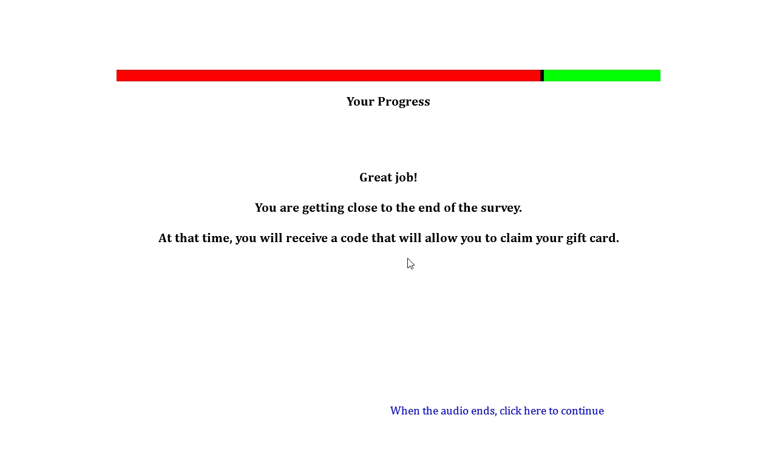

**Drug Use Frequency Scale**

**Source:** Items 17 and 18 developed based on D. Paul Moberg, Center for Health Policy and Program Evaluation, University of Wisconsin Medical School. Adapted with permission from Mayer, J., Filstead, W.J. (1979). The Adolescent Alcohol Involvement Scale. An instrument for measuring adolescents' use and misuse of alcohol. *Journal of Studies on Alcohol, 40*(3), 291-300.

The definition of drinks was provided by Johnston, L.D., O’Malley, P.M., Bachman, J.G., & Schulenberg, J.E. (2014) 2011 Monitoring the future survey (MTF). Retrieved from <http://www.monitoringthefuture.org/>. Ann Arbor: Institute for Social Research, The University of Michigan.

Items 18-20 were developed for the first time for this study.

All other items adapted from Graham, J.W., Flay B.R., Johnson, C.A., Hansen, W.B., Grossman, L., Sobel, J.L. (1984) Reliability of self-report measures of drug use in prevention research: Evaluation of the Project SMART questionnaire via the test-retest reliability matrix. *Journal of Drug Education, 14*, 75–193.

It should also be noted that this measure can be used to identify polysubstance users. Polysubstance use is typically defined as the consumption of multiple drugs in the past 30 days according to Moss, H.B., Chen, C.M., Yi, H.Y. (2014). Early adolescent patterns of alcohol, cigarettes, and marijuana polysubstance use and young adult substance use outcomes in a nationally representative sample. *Drug and Alcohol Dependence, 136*(1), 51-62.

**Designed For:** Adolescents

**Psychometrics:** Coefficient Alphas range from .60 to .86. Across Time Coefficient Alphas range from .52 to .80

**Codebook:**

Please answer each of the following questions about tobacco, alcohol, and other drug use.

About how many times have you used each of the drugs below in the PAST YEAR? (without a doctor telling you to take them, or taking more than a doctor told you to take). Select your answer for each drug.

|  |  |  |  |  |  |  |  |  |  |  |  |
| --- | --- | --- | --- | --- | --- | --- | --- | --- | --- | --- | --- |
|  | 0 | 1-10 times | 11-20 times | 21-30 times | 31-40 times | 41-50 times | 51-60 times | 61-70 times | 71-80 times | 81-90 times | 91+ times |
| *1. Cigarettes*  W1BMQ1 W1DrugYearCig1 | ❑0 | ❑1 | ❑2 | ❑3 | ❑4 | ❑5 | ❑6 | ❑7 | ❑8 | ❑9 | ❑10 |
| *2. Electronic Cigarettes, Vaporizers, or Vape Pens*  W1BMQ2 W1DrugYearEcig2 | ❑0 | ❑1 | ❑2 | ❑3 | ❑4 | ❑5 | ❑6 | ❑7 | ❑8 | ❑9 | ❑10 |
| *3. Cigars, Cigarillos, or Little Cigars*  W1BMQ3W1DrugYearCigar3 | ❑0 | ❑1 | ❑2 | ❑3 | ❑4 | ❑5 | ❑6 | ❑7 | ❑8 | ❑9 | ❑10 |
| *4. Chewing Tobacco, Snuff, or Dip*  W1BMQ4 W1DrugYearChew4 | ❑0 | ❑1 | ❑2 | ❑3 | ❑4 | ❑5 | ❑6 | ❑7 | ❑8 | ❑9 | ❑10 |
| *5. Alcohol (beer, wine, wine coolers, liquor)*  W1BMQ5 W1DrugYearAlco5 | ❑0 | ❑1 | ❑2 | ❑3 | ❑4 | ❑5 | ❑6 | ❑7 | ❑8 | ❑9 | ❑10 |
| *6. Marijuana (weed, grass, pot, chronic)*  W1BMQ6 W1DrugYearPot6 | ❑0 | ❑1 | ❑2 | ❑3 | ❑4 | ❑5 | ❑6 | ❑7 | ❑8 | ❑9 | ❑10 |
| *7. Cocaine or crack*  W1BMQ7 W1DrugYearCoke7 | ❑0 | ❑1 | ❑2 | ❑3 | ❑4 | ❑5 | ❑6 | ❑7 | ❑8 | ❑9 | ❑10 |
| *8. Caffeine (coffee, energy drinks, soda, NoDoz pills)*  W1BMQ8 W1DrugYearCaff8 | ❑0 | ❑1 | ❑2 | ❑3 | ❑4 | ❑5 | ❑6 | ❑7 | ❑8 | ❑9 | ❑10 |
| *9. Ecstasy (“E”)*  W1BMQ9 W1DrugYearE9 | ❑0 | ❑1 | ❑2 | ❑3 | ❑4 | ❑5 | ❑6 | ❑7 | ❑8 | ❑9 | ❑10 |
| *10. Hallucinogens (LSD, PCP, peyote, mushrooms)*  W1BMQ10 W1DrugYearLSD10 | ❑0 | ❑1 | ❑2 | ❑3 | ❑4 | ❑5 | ❑6 | ❑7 | ❑8 | ❑9 | ❑10 |
| *11. Methamphetamine (speed, crank, ice, crystal meth)*  W1BMQ11 W1DrugYearMeth11 | ❑0 | ❑1 | ❑2 | ❑3 | ❑4 | ❑5 | ❑6 | ❑7 | ❑8 | ❑9 | ❑10 |

|  |  |  |  |  |  |  |  |  |  |  |  |
| --- | --- | --- | --- | --- | --- | --- | --- | --- | --- | --- | --- |
| *12. Tranquilizers (valium, Xanax)*  W1BMQ12 W1DrugYearTranq12 | ❑0 | ❑1 | ❑2 | ❑3 | ❑4 | ❑5 | ❑6 | ❑7 | ❑8 | ❑9 | ❑10 |
| *13. Opiates (heroin, opium, morphine, Vicodin, OxyContin)*  W1BMQ13 W1DrugYearOpiate13 | ❑0 | ❑1 | ❑2 | ❑3 | ❑4 | ❑5 | ❑6 | ❑7 | ❑8 | ❑9 | ❑10 |
| *14. Inhalants or vapors (poppers, rush, nitrous, gas, paint, glues)*  W1BMQ14 W1DrugYearInhal14 | ❑0 | ❑1 | ❑2 | ❑3 | ❑4 | ❑5 | ❑6 | ❑7 | ❑8 | ❑9 | ❑10 |
| *15. Other club/party drugs (special K, ketamine, Rohypnol, GHB)*  W1BMQ15 W1DrugYearClub15 | ❑0 | ❑1 | ❑2 | ❑3 | ❑4 | ❑5 | ❑6 | ❑7 | ❑8 | ❑9 | ❑10 |
| *16. Ritalin/ Adderall (addy, bennies, uppers)*  W1BMQ16 W1DrugYearRita16 | ❑0 | ❑1 | ❑2 | ❑3 | ❑4 | ❑5 | ❑6 | ❑7 | ❑8 | ❑9 | ❑10 |

17. When you drink alcohol, how much do you usually drink?

(A “drink” is a bottle of beer, a glass of wine, a wine cooler, a shot glass of liquor, a mixed drink, etc.)

W1BMQ17 W1DrugQuantAlco17

1 drink 1

2 drinks 2

3-4 drinks 3

5-9 drinks 4

10 or more drinks 5

I do not drink alcohol 0

18. When you smoke pot, how many hits do you usually take?

W1BMQ18 W1DrugQuantPot18

1 hit 1

2 hits 2

3-4 hits 3

5-9 hits 4

10 or more hits 5

I do not smoke pot 0

About how many times have you used the drugs below AT THE SAME TIME in the PAST YEAR?

|  |  |  |  |  |  |  |  |  |  |  |  |
| --- | --- | --- | --- | --- | --- | --- | --- | --- | --- | --- | --- |
|  | 0 | 1-10 times | 11-20 times | 21-30 times | 31-40 times | 41-50 times | 51-60 times | 61-70 times | 71-80 times | 81-90 times | 91+ times |
| *19. Tobacco and Alcohol*  W1BMQ19 W1DrugYearSimulTobAlco19 | ❑0 | ❑1 | ❑2 | ❑3 | ❑4 | ❑5 | ❑6 | ❑7 | ❑8 | ❑9 | ❑10 |
| *20. Tobacco and Marijuana*  W1BMQ20 W1DrugYearSimulTobPot20 | ❑0 | ❑1 | ❑2 | ❑3 | ❑4 | ❑5 | ❑6 | ❑7 | ❑8 | ❑9 | ❑10 |
| *21. Tobacco and Methamphetamine (speed, crank, ice, crystal meth)*  W1BMQ21 W1DrugYearSimulTobMeth21 | ❑0 | ❑1 | ❑2 | ❑3 | ❑4 | ❑5 | ❑6 | ❑7 | ❑8 | ❑9 | ❑10 |

In the PAST YEAR, how often did you…

|  |  |  |  |  |  |
| --- | --- | --- | --- | --- | --- |
|  | **Never** | **Less than half the time** | **About half the time** | **More than half the time** | **All the time** |
| **22. Smoke cigarettes while high or drunk on alcohol**  W1BMQ22 W1DrugYearHighAlco22 | ❑0 | ❑1 | ❑2 | ❑3 | ❑4 |
| **23. Smoke cigarettes while high on marijuana**  W1BMQ23 W1DrugYearHighPot23 | ❑0 | ❑1 | ❑2 | ❑3 | ❑4 |
| **24. Smoke cigarettes while high on methamphetamine (speed, crank, meth)**  W1BMQ24 W1DrugYearHighMeth24 | ❑0 | ❑1 | ❑2 | ❑3 | ❑4 |

Please answer each of the following questions about tobacco, alcohol, and other drug use.

About how many times have you used each of the drugs below in the PAST 30 DAYS? (without a doctor telling you to take them, or taking more than a doctor told you to take). Select your answer for each drug.

|  |  |  |  |  |  |  |  |  |  |  |  |
| --- | --- | --- | --- | --- | --- | --- | --- | --- | --- | --- | --- |
|  | 0 | 1-10 times | 11-20 times | 21-30 times | 31-40 times | 41-50 times | 51-60 times | 61-70 times | 71-80 times | 81-90 times | 91+ times |
| *1. Cigarettes*  W1BNQ1 W1Drug30DayCig1 | ❑0 | ❑1 | ❑2 | ❑3 | ❑4 | ❑5 | ❑6 | ❑7 | ❑8 | ❑9 | ❑10 |
| *2. Electronic Cigarettes, Vaporizers, or Vape Pens*  W1BNQ2 W1Drug30DayEcig2 | ❑0 | ❑1 | ❑2 | ❑3 | ❑4 | ❑5 | ❑6 | ❑7 | ❑8 | ❑9 | ❑10 |
| *3. Cigars, Cigarillos, or Little Cigars*  W1BNQ3W1Drug30DayCigar3 | ❑0 | ❑1 | ❑2 | ❑3 | ❑4 | ❑5 | ❑6 | ❑7 | ❑8 | ❑9 | ❑10 |
| *4. Chewing Tobacco, Snuff, or Dip*  W1BNQ4 W1Drug30DayChew4 | ❑0 | ❑1 | ❑2 | ❑3 | ❑4 | ❑5 | ❑6 | ❑7 | ❑8 | ❑9 | ❑10 |
| *5. Alcohol (beer, wine, wine coolers, liquor)*  W1BNQ5 W1Drug30DayAlco5 | ❑0 | ❑1 | ❑2 | ❑3 | ❑4 | ❑5 | ❑6 | ❑7 | ❑8 | ❑9 | ❑10 |
| *6. Marijuana (weed, grass, pot, chronic)*  W1BNQ6 W1Drug30DayPot6 | ❑0 | ❑1 | ❑2 | ❑3 | ❑4 | ❑5 | ❑6 | ❑7 | ❑8 | ❑9 | ❑10 |
| *7. Methamphetamine (speed, crank, ice, crystal meth)*  W1BNQ7 W1Drug30DayMeth7 | ❑0 | ❑1 | ❑2 | ❑3 | ❑4 | ❑5 | ❑6 | ❑7 | ❑8 | ❑9 | ❑10 |
| *8. Ritalin/Adderall (addy, bennies, uppers)*  W1BNQ8 W1Drug30DayRita8 | ❑0 | ❑1 | ❑2 | ❑3 | ❑4 | ❑5 | ❑6 | ❑7 | ❑8 | ❑9 | ❑10 |

About how many times have you used the drugs below AT THE SAME TIME in the PAST 30 DAYS?

|  |  |  |  |  |  |  |  |  |  |  |  |
| --- | --- | --- | --- | --- | --- | --- | --- | --- | --- | --- | --- |
|  | 0 | 1-10 times | 11-20 times | 21-30 times | 31-40 times | 41-50 times | 51-60 times | 61-70 times | 71-80 times | 81-90 times | 91+ times |
| *9. Tobacco and Alcohol*  W1BNQ9 W1Drug30DaySimulTobAlco9 | ❑0 | ❑1 | ❑2 | ❑3 | ❑4 | ❑5 | ❑6 | ❑7 | ❑8 | ❑9 | ❑10 |
| *10. Tobacco and Marijuana*  W1BNQ10 W1Drug30DaySimulTobPot10 | ❑0 | ❑1 | ❑2 | ❑3 | ❑4 | ❑5 | ❑6 | ❑7 | ❑8 | ❑9 | ❑10 |
| *11. Tobacco and Methamphetamine (speed, crank, ice, crystal meth)*  W1BNQ11 W1Drug30DaySimulTobMeth11 | ❑0 | ❑1 | ❑2 | ❑3 | ❑4 | ❑5 | ❑6 | ❑7 | ❑8 | ❑9 | ❑10 |

**Sensations Seeking**

**Source:** Zuckerman, M. (1971) Dimensions of sensation seeking*. Journal of Consulting and Clinical Psychology, 1*, 45-52.

Zuckerman, M. (1993). Sensation seeking and impulsivity: A marriage of traits made in biology?. In W. G. McCown, J. L. Johnson, M. B. Shure (Eds.) , *The impulsive client: Theory, research, and treatment* (pp. 71-91). Washington, DC, US: American Psychological Association.

Zuckerman, M., Kuhlman, D.M., Joireman, J., Teta, P., Kraft, M. (1993). A comparison of three structural models for personality: the big three, the big five, and the alternative five. *Journal of Personality and Social Psychology, 65*, 757-768.

Zuckerman, M., Kuhlman, D.M., Thornquist, M. & Kiers, H. (1991) Five (or three) robust questionnaire scale factors of personality without culture. *Personality Individual Differences*, 12 (9), 929-941.

Roberti, J.W., Storch, E.A., Bravata, E. Further psychometric support for the sensation seeking scale--form V. (2003). *Journal of Personality Assessment, 81*(3), 291-292.

Cloninger, C.R. (1994). The genetic structure of personality and learning: a phylogenetic perspective. *Clinical Genetics, 46*, 124-137.

Cloninger, C., Svrakic, D. M., & Przybeck, T.R. (1993). A psychobiological model of temperament and character. *Archives Of General Psychiatry*, *50*(12), 975-990.

Hegerl, U.U., Lipperheide, K.K., Juckel, G.G., Schmidt, L.G., & Rommelspacher, H.H. (1995). Antisocial tendencies and cortical sensory-evoked responses in alcoholism. *Alcoholism: Clinical And Experimental Research*, *19*(1), 31-36.

Newcomb, M., & Earleywine, M. (1996). Intrapersonal contributors to drug use: The willing host. *American Behavioral Scientist*, *39*(7), 823-837.

Newcomb, M.D., & McGee, L. (1991). Influence of sensation seeking on general deviance and specific problem behaviors from adolescence to young adulthood. *Journal Of Personality And Social Psychology*, *61*(4), 614-628.

Ames, S. L., Sussman, S., & Dent, C. W. (1999). Pro-drug-use myths and competing constructs in the prediction of substance use among youth at continuation high schools: A one-year prospective study. *Personality And Individual Differences*, *26*(6), 987-1003.

**Designed For:** Adults

**Psychometrics:** Cronbach’s alpha = .86

**Codebook**:

On the following screens you will find a series of statements that people might use to describe themselves. Read each statement and decide whether or not it describes you. Then select the best answer.

If you agree with a statement or decide that it describes you, click TRUE. If you disagree with a statement or feel that it does not describe you, click FALSE.

1. I tend to begin a new job without much advance planning on how I will do it. W1BOQ1 W1SenSeek1

True 1

False 0

1. I usually think about what I am going to do before doing it. W1BOQ2 W1SenSeek2

True 1

False 0

1. I often do things on impulse. W1BOQ3 W1SenSeek3

True 1

False 0

1. I very seldom spend much time on the details of planning ahead. W1BOQ4 W1SenSeek4

True 1

False 0

1. I like to have new and exciting experiences and sensations even if they are a little frightening. W1BOQ5 W1SenSeek5

True 1

False 0

1. Before I begin a complicated job, I make careful plans. W1BOQ6 W1SenSeek6

True 1

False 0

1. I would like to take off on a trip with no preplanned or definite routes or timetable. W1BOQ7 W1SenSeek7

True 1

False 0

1. I enjoy getting into new situations where you can't predict how things will turn out. W1BOQ8 W1SenSeek8

True 1

False 0

1. I like doing things just for the thrill of it. W1BOQ9 W1SenSeek9

True 1

False 0

1. I tend to change interests frequently. W1BOQ10 W1SenSeek10

True 1

False 0

1. I sometimes like to do things that are a little frightening. W1BOQ11 W1SenSeek11

True 1

False 0

1. I'll try anything once. W1BOQ12 W1SenSeek12

True 1

False 0

1. I would like the kind of life where I’m on the move and traveling a lot, with lots of change and excitement. W1BOQ13 W1SenSeek13

True 1

False 0

1. I sometimes do "crazy" things just for fun. W1BOQ14 W1SenSeek14

True 1

False 0

1. I like to explore a strange city or section of town by myself, even if it means getting lost. W1BOQ15 W1SenSeek15

True 1

False 0

1. I prefer friends who are excitingly unpredictable. W1BOQ16 W1SenSeek16

True 1

False 0

1. I often get so carried away by new and exciting things and ideas that I never think of possible complications. W1BOQ17 W1SenSeek17

True 1

False 0

1. I am an impulsive person. W1BOQ18 W1SenSeek18

True 1

False 0

1. I like "wild" uninhibited parties. W1BOQ19 W1SenSeek19

True 1

False 0

**Depression Anxiety Stress Scale (DASS-21)**

**Source:** Henry, J.D., & Crawford, J.R. (2005). The short-form version of the Depression Anxiety Stress Scales (DASS-21): construct validity and normative data in a large non-clinical sample. *The* *British Journal of Clinical Psychology / the British Psychological Society*, *44(2)*, 227–239.

Szabo, M. (2010). The short version of the Depression Anxiety Stress Scales (DASS-21): Factor structure in a young adolescent sample. *Journal of Adolescence, 33*(1), 1–8.

**Designed For:** Adults, Adolescents

**Psychometrics:**

Depression = .88

Anxiety = .82

Stress = .90

Total Scale = .93

**Codebook:**

Please read each statement and select an answer to indicate how much the statement applied to you *over the past week*. There are no right or wrong answers. Do not spend too much time on any statement.

1. I found it hard to wind down. W1BPQ1 W1DASSStress1

Did not apply Applied to me to some Applied to me to a considerable Applied to me very much

to me at all degree or some of the time degree, or a good part of the time or most of the time

0 1 2 3

1. I was aware of dryness of my mouth. W1BPQ2 W1DASSAnx2

Did not apply Applied to me to some Applied to me to a considerable Applied to me very much

to me at all degree or some of the time degree, or a good part of the time or most of the time

0 1 2 3

1. I couldn't seem to experience any positive feeling at all. W1BPQ3 W1DASSDep3

Did not apply Applied to me to some Applied to me to a considerable Applied to me very much

to me at all degree or some of the time degree, or a good part of the time or most of the time

0 1 2 3

1. I experienced breathing difficulty (e.g., excessively rapid breathing, breathlessness in the absence of physical exertion). W1BPQ4 W1DASSAnx4

Did not apply Applied to me to some Applied to me to a considerable Applied to me very much

to me at all degree or some of the time degree, or a good part of the time or most of the time

0 1 2 3

1. I found it difficult to work up the initiative to do things. W1BPQ5 W1DASSDep5

Did not apply Applied to me to some Applied to me to a considerable Applied to me very much

to me at all degree or some of the time degree, or a good part of the time or most of the time

0 1 2 3

1. I tended to over-react to situations. W1BPQ6 W1DASSStress6

Did not apply Applied to me to some Applied to me to a considerable Applied to me very much

to me at all degree or some of the time degree, or a good part of the time or most of the time

0 1 2 3

1. I experienced trembling (e.g., in the hands). W1BPQ7 W1DASSAnx7

Did not apply Applied to me to some Applied to me to a considerable Applied to me very much

to me at all degree or some of the time degree, or a good part of the time or most of the time

0 1 2 3

1. I felt that I was using a lot of nervous energy. W1BPQ8 W1DASSStress8

Did not apply Applied to me to some Applied to me to a considerable Applied to me very much

to me at all degree or some of the time degree, or a good part of the time or most of the time

0 1 2 3

1. I was worried about situations in which I might panic and make a fool of myself. W1BPQ9 W1DASSAnx9

Did not apply Applied to me to some Applied to me to a considerable Applied to me very much

to me at all degree or some of the time degree, or a good part of the time or most of the time

0 1 2 3

1. I felt that I had nothing to look forward to. W1BPQ10 W1DASSDep10

Did not apply Applied to me to some Applied to me to a considerable Applied to me very much

to me at all degree or some of the time degree, or a good part of the time or most of the time

0 1 2 3

1. I found myself getting agitated. W1BPQ11 W1DASSStress11

Did not apply Applied to me to some Applied to me to a considerable Applied to me very much

to me at all degree or some of the time degree, or a good part of the time or most of the time

0 1 2 3

1. I found it difficult to relax. W1BPQ12 W1DASSStress12

Did not apply Applied to me to some Applied to me to a considerable Applied to me very much

to me at all degree or some of the time degree, or a good part of the time or most of the time

0 1 2 3

1. I felt down-hearted and blue. W1BPQ13 W1DASSDep13

Did not apply Applied to me to some Applied to me to a considerable Applied to me very much

to me at all degree or some of the time degree, or a good part of the time or most of the time

0 1 2 3

1. I was intolerant of anything that kept me from getting on with what I was doing. W1BPQ14 W1DASSStress14

Did not apply Applied to me to some Applied to me to a considerable Applied to me very much

to me at all degree or some of the time degree, or a good part of the time or most of the time

0 1 2 3

1. I felt I was close to panic. W1BPQ15 W1DASSAnx15

Did not apply Applied to me to some Applied to me to a considerable Applied to me very much

to me at all degree or some of the time degree, or a good part of the time or most of the time

0 1 2 3

1. I was unable to become enthusiastic about anything. W1BPQ16 W1DASSDep16

Did not apply Applied to me to some Applied to me to a considerable Applied to me very much

to me at all degree or some of the time degree, or a good part of the time or most of the time

0 1 2 3

1. I felt I wasn't worth much as a person. W1BPQ17 W1DASSDep17

Did not apply Applied to me to some Applied to me to a considerable Applied to me very much

to me at all degree or some of the time degree, or a good part of the time or most of the time

0 1 2 3

1. I felt that I was rather touchy. W1BPQ18 W1DASSStress18

Did not apply Applied to me to some Applied to me to a considerable Applied to me very much

to me at all degree or some of the time degree, or a good part of the time or most of the time

0 1 2 3

1. I was aware of the action of my heart in the absence of physical exertion (e.g., sense of heart rate increase, heart missing a beat). W1BPQ19 W1DASSAnx19

Did not apply Applied to me to some Applied to me to a considerable Applied to me very much

to me at all degree or some of the time degree, or a good part of the time or most of the time

0 1 2 3

1. I felt scared without any good reason. W1BPQ20 W1DASSAnx20

Did not apply Applied to me to some Applied to me to a considerable Applied to me very much

to me at all degree or some of the time degree, or a good part of the time or most of the time

0 1 2 3

1. I felt that life was meaningless. W1BPQ21 W1DASSDep21

Did not apply Applied to me to some Applied to me to a considerable Applied to me very much

to me at all degree or some of the time degree, or a good part of the time or most of the time

0 1 2 3

**Acculturation, Habits, and Interests Multicultural Scale for Adolescents**

**Source:** Items 1-8 are from Unger, J.B., Gallaher, P., Shakib, S., Ritt-Olson, A., Palmer, P., & Johnson, C.A. (2002). The AHMISA Acculturation scale: A new measure of acculturation for adolescents in a multicultural society. *The Journal of Early Adolescence, 22*, 225-251.

**Designed For:** Adolescents

**Psychometrics:** Cronbach’s alpha = 0.79

**Scoring Instructions:** Assimilation (the total number of “United States” responses), Separation (the total number of “The country my family is from” responses), Integration (the total number of “Both” responses), and Marginalization (the total number of “Neither” responses)

**Codebook:**

This next set of questions asks about your culture. For each statement think about whether you feel closer to the United States, the country that your family is from (if it isn’t the United States), both the US and the country your family is from, or neither.

|  |  |  |  |  |
| --- | --- | --- | --- | --- |
|  | The  United States1 | The country my family  is from 2 | Both 3 | Neither 4 |
| 1. I am most comfortable being with people from…  W1BQQ1 W1AcculPeopleComfort1 | ❒1 | ❒2 | ❒3 | ❒4 |
| 2. My best friends are from…  W1BQQ2 W1AcculBestFriend2 | ❒1 | ❒2 | ❒3 | ❒4 |
| 3. The people I fit in with best are from…  W1BQQ3 W1AcculPeopleFit3 | ❒1 | ❒2 | ❒3 | ❒4 |
| 4. My favorite music is from…  W1BQQ4 W1AcculMusic4 | ❒1 | ❒2 | ❒3 | ❒4 |
| 5. My favorite TV shows are from…  W1BQQ5 W1AcculTV5 | ❒1 | ❒2 | ❒3 | ❒4 |
| 6. The holidays I celebrate are from…  W1BQQ6 W1Acculholiday6 | ❒1 | ❒2 | ❒3 | ❒4 |
| 7. The food I eat at home is from…  W1BQQ7 W1AcculFood7 | ❒1 | ❒2 | ❒3 | ❒4 |
| 8. The way I do things and the way I think about things are from…  W1BQQ8 W1AcculThinkDo8 | ❒1 | ❒2 | ❒3 | ❒4 |

**Head Injury**

**Source** Suhr, J.A., & Gunstad, J. (2002). ‘Diagnosis threat’: The effect of negative expectations on cognitive performance in head injury. *Journal of Clinical and Experimental Neuropsychology, 24*, 448-457.

**Designed For:** Adolescents

**Psychometrics:** Not provided

**Codebook:**

Have you experienced a concussion or a head injury in the past year where you were knocked unconscious?

W1BRQ1 W1HeadInjury1

Yes 1

No 0

**Electronic Cigarette Commercials**

**Source:** Items 1-7 are adapted from Grube, J.W., & Wallack, L. (1994). Television beer advertising and drinking knowledge, beliefs, and intentions among schoolchildren. *American Journal of Public Health, 84*(2), 254-259.

Items 13-20 were adapted from measures used to analyze the content of individual tobacco advertisements and warning signs photographed at stores near participating schools.

Items 21-25 and 27-28 are adapted from Unger, J.B., Schuster, D., Zogg, J.B., Dent, C.W., & Stacy, A.W. (2003). Alcohol advertising exposure and adolescent alcohol use: A comparison of exposure measures. *Addiction Research & Theory, 11(3)*, 177-193.

Items 29-30 are adapted from:

* Schooler, C., Feighery, E., Flora, J.A. (1996). Seventh graders’ self-reported exposure to cigarette marketing and its relationship to their smoking behavior. *American Journal of Public Health, 86(9)*, 1216–1221.
* Stacy, A.W., Zogg, J.B., Unger, J.B., & Dent, C.W. (2004). Exposure to televised alcohol ads and subsequent adolescent alcohol use. *American Journal of Health Behavior, 28(6)*, 498-509.

**Designed For:** Adolescents

**Psychometrics**:

General Television Viewing: Cronbach’s alpha = 0.82.

Liking of Electronic Cigarette Advertisements: Cronbach’s alpha = 0.80

Pro-Electronic Cigarette Receptivity: Cronbach’s alpha = 0.77

Self-Reported Frequency of Exposure to Electronic Cigarette Commercials: Cronbach’s alpha = 0.67.

**Codebook:**

[*General Television Viewing*]

In the last month on a typical weekday (Monday through Friday), how many hours a day did you watch TV or watch videos online (YouTube, Hulu, Netflix, etc.)?

|  |  |  |  |  |  |
| --- | --- | --- | --- | --- | --- |
|  | Did not watch TV or Online Videos | Less than 1 hour | 1-2 hours | 3-4 hours | 5 hours or more |
| 1. Before school? W1BSQ1 W1ECigComTVWeekdayBeforeSchool1 | ❑0 | ❑1 | ❑2 | ❑3 | ❑4 |
| 2. After school before dinner? W1BSQ2 W1ECigComTVWeekdayAfterSchool2 | ❑0 | ❑1 | ❑2 | ❑3 | ❑4 |
| 3. From dinner until bedtime? W1BSQ3 W1ECigComTVWeekdayAfterDinner3 | ❑0 | ❑1 | ❑2 | ❑3 | ❑4 |

In the last month on a typical weekend (Saturday and Sunday), how many hours a day did you watch TV or watch videos online (YouTube, Hulu, Netflix, etc.)?

|  |  |  |  |  |  |
| --- | --- | --- | --- | --- | --- |
|  | Did not watch TV or Online Videos | Less than 1 hour | 1-2 hours | 3-4 hours | 5 hours or more |
| 4. Saturday morning until noon? W1BSQ4 W1ECigComTVSatBeforeNoon4 | ❑0 | ❑1 | ❑2 | ❑3 | ❑4 |
| 5. Saturday noon until bedtime? W1BSQ5 W1ECigComTVSatAfterNoon5 | ❑0 | ❑1 | ❑2 | ❑3 | ❑4 |
| 6. Sunday morning until noon? W1BSQ6 W1ECigComTVSunBeforeNoon6 | ❑0 | ❑1 | ❑2 | ❑3 | ❑4 |
| 7. Sunday noon until bedtime? W1BSQ7 W1ECigComTVSunAfterNoon7 | ❑0 | ❑1 | ❑2 | ❑3 | ❑4 |

[*Electronic Cigarette Commercial Viewing*]

1. Have you ever seen a commercial for electronic cigarettes on television? W1BSQ8 W1ECigComSeenOnTV8

Yes 1

No 0

1. Have you ever seen a commercial for electronic cigarettes online (YouTube, Hulu, Netflix etc.)? W1BSQ9 W1ECigComSeenOnline9

Yes 1

No 0

**Think of the last time you saw a commercial for electronic cigarettes either on TV or online. Try to form a picture of this commercial in your mind.**

1. What were you doing when you saw the electronic cigarette commercial? W1BSQ10 W1ECigComWhatDoing10

Watching television 1

Watching a video online at a website like YouTube, Hulu, Netflix, etc. 2

Using a social network like Facebook, Instagram, etc. 3

Other (please specify): 4 _____________ W1BSQ10Other W1ECigComWhatDoingOther10

1. When did you last see this electronic cigarette commercial? W1BSQ11 W1ECigComWhenSaw11

1-2 days ago 7

3-6 days ago 6

1-2 weeks ago 5

3-4 weeks ago 4

1-2 months ago 3

3-6 months ago 2

More than 6 months ago 1

1. What brand was being advertised in the electronic cigarette commercial? W1BSQ12 W1ECigComBrandSeen12

Blu 1

Green Smart Living 2

MarkTen 3

NJOY 4

Xcite* -5

Square 5

Vuse 6

V2 7

I don’t know -7

Another brand (please specify): 8 ___________ W1BSQ12Other W1ECigComBrandSeenOther12

For each numbered item below answer the following question.

How did the electronic cigarette commercial make you feel?

W1BSQ13 W1ECigComFeelHappy13

1. Very Unhappy 1 Unhappy 2 Neutral 3 Happy 4 Very Happy 5

W1BSQ14 W1ECigComFeelPleasant14

1. Very Unpleasant 1 Unpleasant 2 Neutral 3 Pleasant 4 Very Pleasant 5

W1BSQ15 W1ECigComFeelGood15

1. Very Bad 1 Bad 2 Neutral 3 Good 4 Very Good 5

W1BSQ16 W1ECigComFeelCool16

1. Very Uncool 1 Uncool 2 Neutral 3 Cool 4 Very Cool 5
2. Were there people in the electronic cigarette commercial? W1BSQ17 W1ECigComPeoplePresent17

Yes 1

No 0

1. How old were the people in the electronic cigarette commercial? (Check all that apply) W1BSQ18 W1ECigComPeopleAge18, 0 When Not Selected, 1 When Selected

Under 18 W1BSQ18option1 W1ECigComPeopleAgeUnder18_18

18 to 25 W1BSQ18option2 W1ECigComPeopleAge18_25_18

26 to 30 W1BSQ18option3 W1ECigComPeopleAge26_30_18

31 or older W1BSQ18option4 W1ECigComPeopleAge31Over18

There were no people in the advertisement W1BSQ18option5 W1ECigComPeopleAgeNone18

1. What was the gender of the people in the electronic cigarette commercial? W1BSQ19 W1ECigComPeopleGender19

One male only 1

Two or more males (no females) 2

One female only 3

Two or more females (no males) 4

A mix of males and females 5

There were no people in the advertisement 0

1. What was the race/ethnicity of the people in the electronic cigarette commercial? (Check all that apply) W1BSQ20 W1ECigComPeopleRace20

White W1BSQ20option1 W1ECigComPeopleRaceWhite20

Hispanic W1BSQ20option2 W1ECigComPeopleRaceHispanic20

Black or African American W1BSQ20option3 W1ECigComPeopleRaceBlack20

Asian W1BSQ20option4 W1ECigComPeopleRaceAsian20

Native Hawaiian or Other Pacific Islander W1BSQ20option5 W1ECigComPeopleRacePacIs20

American Indian or Alaska Native W1BSQ20option6 W1ECigComPeopleRaceNative20

There were no people in the advertisement W1BSQ20option7 W1ECigComPeopleNone20

Other (please specify): W1BSQ20option8 W1ECigComPeopleOther20__________________ W1BSQ20other W1ECigComPeopleOtherSpecify20

[*Liking of Electronic Cigarette Advertisements*]

**When you see electronic cigarettes commercials on TV or online…**

1. Do you think they are funny? W1BSQ21 W1ECigComLikeFunny21

Yes, always 3

Yes, usually 2

No, usually not 1

No, never 0

1. Do you think they are sexy? W1BSQ22 W1ECigComLikeSexy22

Yes, always 3

Yes, usually 2

No, usually not 1

No, never 0

1. Do you wish you were like the people in the commercials? W1BSQ23 W1ECigComLikeWishPeople23

Yes, always 3

Yes, usually 2

No, usually not 1

No, never 0

[*New Screen*]

1. When you see electronic cigarette commercials, how often do you pay attention to them? W1BSQ24 W1ECigComLikeAttention24

Always 3

Most of the time 2

Some of the time 1

Never 0

1. Of all the commercials you see, how much do you like electronic cigarette commercials? W1BSQ25 W1ECigComLikeMost25

I like electronic cigarette commercials the most 3

I like electronic cigarette commercials a little more than the other commercials 2

I like electronic cigarette commercials a little less than the other commercials 1

I like electronic cigarette commercials the least 0

[*Talking About Electronic Cigarette Advertisements*]

1. How often do you talk to other people about electronic cigarette commercials you saw on TV or online? W1BSQ26 W1ECigComTalkAbout26

Very Often 3

Often 2

Sometimes 1

Never 0

[*Pro-Electronic Cigarette Receptivity*]

1. Think back to the electronic cigarette commercials you have seen in the past month. What brand of electronic cigarette was advertised the most? W1BSQ27 W1ECigComBrandMostSeen27

Blu 1

Green Smart Living 2

MarkTen 3

NJOY 4

Xcite* -5

Square 5

Vuse 6

V2 7

I don’t know -7

Another brand (please specify): 8 ___________ W1BSQ27other W1ECigComBrandMostSeenOther27

1. What is the name of the brand of your favorite electronic cigarette commercial? W1BSQ28 W1ECigComBrandFav28

Blu 1

Green Smart Living 2

MarkTen 3

NJOY 4

Xcite* -5

Square 5

Vuse 6

V2 7

I don’t know -7

Another brand (please specify): 8 ___________ W1BSQ28other W1ECigComBrandFavOther28

[*Self-Reported Frequency of Exposure to Electronic Cigarette Commercials*]

1. About how often did you see an electronic cigarette commercial in the last six months? W1BSQ29 W1ECigComSeen6MonthFreq29

Every day 6

2-6 times a week 5

Once a week 4

2-3 times a month 3

Once a month 2

Less than once a month 1

Never 0

1. In the past week, how many commercials have you seen for electronic cigarettes? W1BSQ30 W1ECigComSeenWeekQuant30

0 0

1 1

2 2

3 3

4 4

5 5

6 or more 6

**Point-of-Sale Sensitivity**

**Source:** Germain, D., McCarthy, M., & Wakefield, M. (2009). Smoker sensitivity to retail tobacco displays and quitting: a cohort study. *Addiction. 105*, 159-163.

**Designed For:** Adult smokers in Australia

**Psychometrics**: Smokers who had a medium or high level of sensitivity to POS displays were significantly less likely to have quit at follow-up [odds ratio (OR) = 0.32, 95% confidence interval

(CI) = 0.14–0.74; OR = 0.27, 95% CI = 0.08–0.91, respectively].

**Codebook:**

1. When you are in a supermarket, convenience store, gas station, or tobacco store, how often do you notice the cigarette pack display near the cash register? W1BTQ1 W1POSSNoteCig1

Never 0 Less than half the time 1 About half the time 2 More than half the time 3 All the time 4

1. When shopping for something other than cigarettes, how often do you decide to buy cigarettes as a result of seeing the cigarette pack display in the store? W1BTQ2 W1POSSBuyCig2

Never 0 Less than half the time 1 About half the time 2 More than half the time 3 All the time 4

1. When buying cigarettes, how often do you decide what brand or type of cigarettes to buy based on the cigarette pack display in the store? W1BTQ3 W1POSSBrandChoice3

Never 0 Less than half the time 1 About half the time 2 More than half the time 3 All the time 4

**Sale Proneness**

**Source:** Lichtenstein, D.R., Ridgway, N.M., & Netemeyer, R.G. (1993). Price perceptions and consumer shopping behavior: A field study. *Journal of Marketing Research, 30*, 234-245.

**Designed For:** Adults

**Psychometrics**: Tested with 582 supermarket shoppers who completed an online survey at home.

Cronbach’s alpha for sub-scales ranged from .78 to .9

Composite reliability for-subscales ranged from .79 to .9

Discriminant validity among the seven scales was assessed by comparing the fit of correlated two-factor models with that of one-factor models for each possible pair of scales (21 combinations in all), by comparing the variance extracted estimates for each of the two constructs with the square of the parameter estimate between them, and by examining whether the correlation between the two constructs was significantly less than one. All three assessments supported the discriminant validity of the seven constructs.

**Codebook:**

1. If a product is on sale, that can be a reason for me to buy it. W1BUQ1 W1SaleProne1

Strongly Disagree 1 Disagree 2 Agree 3 Strongly Agree 4

1. When I buy a brand that's on sale, I feel that I am getting a good deal. W1BUQ2 W1SaleProne2

Strongly Disagree 1 Disagree 2 Agree 3 Strongly Agree 4

1. I have favorite brands, but most of the time I buy the brand that's on sale. W1BUQ3 W1SaleProne3

Strongly Disagree 1 Disagree 2 Agree 3 Strongly Agree 4

1. One should try to buy the brand that's on sale. W1BUQ4 W1SaleProne4

Strongly Disagree 1 Disagree 2 Agree 3 Strongly Agree 4

1. I am more likely to buy brands that are on sale. W1BUQ5 W1SaleProne5

Strongly Disagree 1 Disagree 2 Agree 3 Strongly Agree 4

1. Compared to most people, I am more likely to buy brands that are on special. W1BUQ6 W1SaleProne6

Strongly Disagree 1 Disagree 2 Agree 3 Strongly Agree 4

**90% Update**

[*A 90% Progress Bar Will Be Shown Here*]

Your Progress

Almost done! There are only a few more questions to answer.

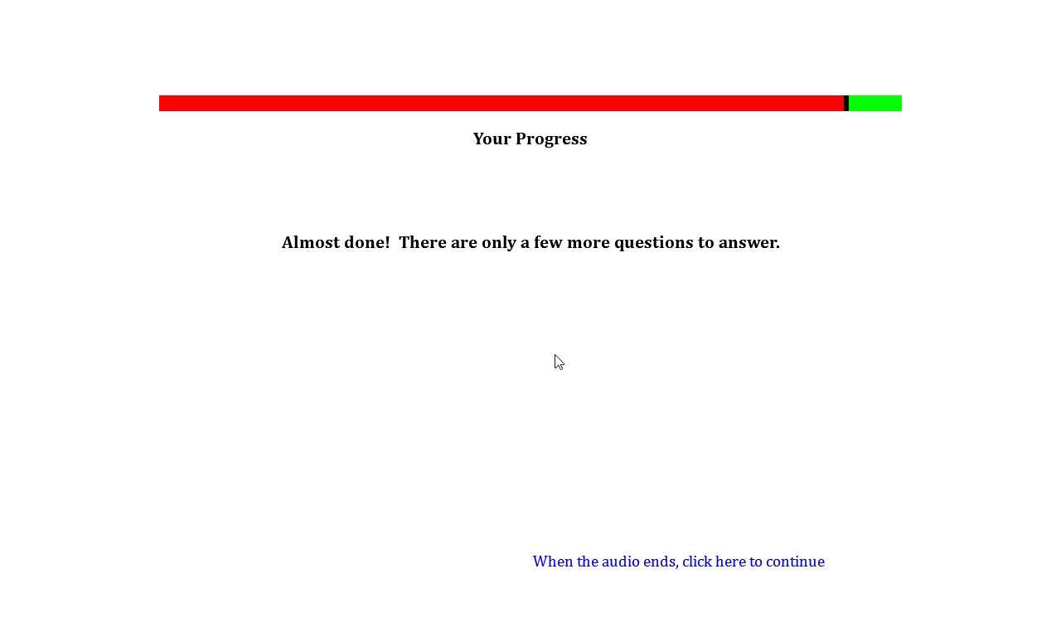

**Tobacco Pricing**

**Source:** Items 1-2, 6, and 8-9 are adapted from US Department of Commerce, Census Bureau. (2012), National Cancer Institute sponsored Tobacco Use Supplement to the Current Population Survey January 2011. Retrieved from <http://riskfactor.cancer.gov/studies/tus-cps/> and <http://www.census.gov/cps/methodology/techdocs.html>.

Items 3 and 7 are adapted from Centers for Disease Control and Prevention (CDC). (2014). 2012 National youth tobacco survey (NYTS). Retrieved from: <http://www.cdc.gov/TOBACCO/data_statistics/surveys/NYTS/index.htm>.

Items 4 and 5 are new additions designed to assess the impact of brand equity and price discounts.

**Designed For:** Adults

**Psychometrics**: Not reported

**Codebook:**

[*Page 1*]

1. Have you ever bought a pack of cigarettes from a store near your school? W1BVQ1 W1CigPrice1

Yes 1

No 0

(If Yes…) [*Page 2*]

1. How much did you pay for the last pack you bought near your school? $___________ W1BVQ2 W1CigPriceBrandPaid2
2. What brand did you buy? W1BVQ3 W1CigPriceBrand3

American Spirit 1

Camel 2

GPC, Basic, or Doral 3

Kool 4

Lucky Strike 5

Marlboro 6

Newport 7

Parliament 8

Summit -5

Virginia Slims 9

Another brand (please specify): 10 _________ W1BVQ3other W1CigPriceBrandOther3

1. What is the maximum price you would pay for your favorite brand? $___________ W1BVQ4 W1CigPriceBrandMax4
2. How much would you pay for a pack of cigarettes if it wasn’t your favorite brand? $_________ W1BVQ5 W1CigPriceGeneric5

[*Page 3*]

1. Have you ever bought electronic cigarettes, vaporizers, or vape pens from a store near your school? W1BVQ6 W1EcigPrice6

Yes 1

No 0

(If Yes…) [*Page 4*]

1. What brand did you buy? W1BVQ7 W1EcigPriceBrand7

Blu 1

Green Smart Living 2

MarkTen 3

NJOY 4

Xcite* -5

Square 5

Vuse 6

V2 7

Another brand (please specify): 8 _________ W1BVQ7other W1EcigPriceBrandOther7

[*Page 5*]

1. Have you ever bought chewing tobacco, snuff, or dip from a store near your school? W1BVQ8 W1ChewPrice8

Yes 1

No 0

1. Have you ever bought cigars, cigarillos, or little cigars from a store near your school? W1BVQ9 W1CigarPrice9

Yes 1

No 0

**Perceived Stress PSS-10**

**Source:** Cohen, S., Kamarck, T., Mermelstein, R. (1983). A global measure of perceived stress. *Journal of Health and Social Behavior, 24*, 385-396.

Cohen, S. (1988). Perceived stress in a probability sample of the United States. In S. Spacapan, S. Oskamp (Eds.), *The social psychology of health* (pp. 31-67). Thousand Oaks, CA, US: Sage Publications, Inc.

**Designed For:** Adults

**Psychometrics:** Cronbach’s alpha = .78

**Codebook:**

The following questions will ask about your stress.

1. In the last month, how often have you been upset because of something that happened unexpectedly? W1BWQ1 W1PerStress1

Never 0 Almost Never 1 Sometimes 2 Fairly Often 3 Very Often 4

1. In the last month, how often have you felt that you were unable to control the important things in life? W1BWQ2 W1PerStress2

Never 0 Almost Never 1 Sometimes 2 Fairly Often 3 Very Often 4

1. In the last month, how often have you felt nervous and “stressed”? W1BWQ3 W1PerStress3

Never 0 Almost Never 1 Sometimes 2 Fairly Often 3 Very Often 4

1. In the last month, how often have you felt confident about your ability to handle your personal problems? W1BWQ4 W1PerStress4

Never 0 Almost Never 1 Sometimes 2 Fairly Often 3 Very Often 4

1. In the last month, how often have you felt that things were going your way? W1BWQ5 W1PerStress5

Never 0 Almost Never 1 Sometimes 2 Fairly Often 3 Very Often 4

1. In the last month, how often have you found that you could not cope with all the things that you had to do? W1BWQ6 W1PerStress6

Never 0 Almost Never 1 Sometimes 2 Fairly Often 3 Very Often 4

1. In the last month, how often have you been able to control irritations in your life? W1BWQ7 W1PerStress7

Never 0 Almost Never 1 Sometimes 2 Fairly Often 3 Very Often 4

1. In the last month, how often have you felt that you were on top of things? W1BWQ8 W1PerStress8

Never 0 Almost Never 1 Sometimes 2 Fairly Often 3 Very Often 4

1. In the last month, how often have you been angered because of things that happened that were outside of your control? W1BWQ9 W1PerStress9

Never 0 Almost Never 1 Sometimes 2 Fairly Often 3 Very Often 4

1. In the last month, how often have you felt difficulties were piling up so high that you could not overcome them? W1BWQ10 W1PerStress10

Never 0 Almost Never 1 Sometimes 2 Fairly Often 3 Very Often 4

**Enrollment In The Military**

**Source:** Adapted from Johnston, L.D., O’Malley, P.M., Bachman, J.G., & Schulenberg, J.E. (2014) 2011 Monitoring the future survey (MTF). Retrieved from <http://www.monitoringthefuture.org/>. Ann Arbor: Institute for Social Research, The University of Michigan.

**Designed For:** Adolescent

**Psychometrics**: Not provided

**Codebook:**

Please answer the following questions.

1. Are you a member of the... W1BXQ1 W1MilitaryMember1, 0 When Not Selected, 1 When Selected

Army W1BXQ1option1 W1MilitaryMemberArmy1

Navy W1BXQ1option2 W1MilitaryMemberNavy1

Marine Corps W1BXQ1option3 W1MilitaryMemberMarine1

Air Force W1BXQ1option4 W1MilitaryMemberAirForce1

Coast Guard W1BXQ1option5 W1MilitaryMemberCoast1

None of the above W1BXQ1option6 W1MilitaryMemberNone1

1. Are you thinking about enlisting in the... W1BXQ2 W1MilitaryEnlist2, 0 When Not Selected, 1 When Selected

Army W1BXQ2option1 W1MilitaryEnlistArmy2

Navy W1BXQ2option2 W1MilitaryEnlistNavy2

Marine Corps W1BXQ2option3 W1MilitaryEnlistMarine2

Air Force W1BXQ2option4 W1MilitaryEnlistAirForce2

Coast Guard W1BXQ2option5 W1MilitaryEnlistCoast2

None of the above W1BXQ2option6 W1MilitaryEnlistNone2

**Attrition**

**Source:** Adapted from Ford, W. (2003). Communication practices of professional service providers: Predicting customer satisfaction and loyalty. *Journal Of Applied Communication Research, 31*(3), 189-211.

Garnefeld, I., Helm, S., & Eggert, A. (2011). Walk your talk: An experimental investigation of the relationship between word of mouth and communicators’ loyalty. *Journal Of Service* *Research, 14*(1), 93-107.

**Designed For:** Adolescents

**Psychometrics:** Not provided

**Codebook:**

Please indicate whether you disagree or agree with each statement.

I am likely to complete the next CHAMP survey a year from now. W1BYQ1 W1AttritionComplete1

Strongly Disagree 1 Disagree 2 Agree 3 Strongly Agree 4

I am likely to recommend to my friends that they participate in the CHAMP study. W1BYQ2 W1AttritionRecommend2

Strongly Disagree 1 Disagree 2 Agree 3 Strongly Agree 4

I am likely to participate in future studies by the CHAMP team. W1BYQ3 W1AttritionFuture3

Strongly Disagree 1 Disagree 2 Agree 3 Strongly Agree 4

Now imagine that you are sitting with a friend at school. Your friend tells you they heard about the CHAMP study, but didn’t sign up. What would you say to convince your friend to do this? W1BYQ4 W1AttritionFriend4

Do you think I should sign up?

[Text Field]



**Final Screen**

Congratulations! You are done with the survey.

All you have to do now is email or text the following keyword to your Study Coordinator.

[*4 Digit Code*]

In the next couple days, they will send you a Target eGiftCard.

Thank you for all the time you have given to CHAMP. If you have any questions or need any assistance, don’t hesitate to contact us or visit our website at [www.champsurvey.com](http://www.champsurvey.com).